Lesson plan

Unit 3:Time |  | School: Bogdan primary high school.
Date: |  | Teacher name: Kappassova D.S.
Grade:3 |  | Number present: | absent:
Lesson title | Times of my day
Learning objectives | 3.4.1.1- plan, write and check short sentences with considerable support on a limited range of personal, general and some curricular topics;  3.5.2.1- use cardinal numbers 1 -100 to count and ordinal numbers 1 – 10
Lesson objectives | Identify main ideas of narratives on general and some  curricular topics  Make up basic personal sentences on general topics
Stages / Time | Teachers actions | Students actions | Assessment | Resources
Beginning the  Lessom  5 min | Greeting.  Warming up: “I know…” activity. The teacher shows the wall clock and asks what the children know about the clock.  After the children answer, the teacher introduces the learner  to the objectives of the lesson. The teacher divides the pupils in two groups by “Magic box”. | Learners  respond to greeting of the teacher and take their places.  Answer the following questions. | Verbal evaluation  Excellent!  Well!  Try again! | A wall clock  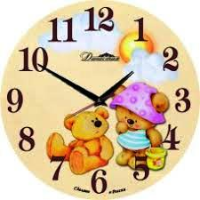
Main  Activities  20 min | Look at Gulnara’s daily routine and number.  Have a class discussion about their daily routines. Ask individual pupils what they do during the day.  Task. Listen to the text.  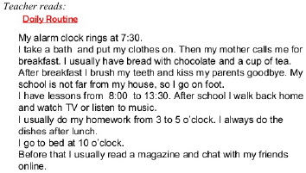  Task. Look at the picture and tell about your day. Make up 9 sentences.  Task. Look, read and say. The teacher repeats ordinal numbers and colors with the learners  Hometask: Ex;4 at page 27  Read and draw the time | Ss watch the video and answer the questions  Tick the correct item in the box next to the item.  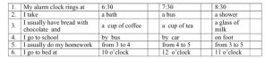  • tells about his/her day;  • uses ideas from the picture;  • makes up grammatically sentences;  • uses proper topical vocabulary;  • pronounces words clearly.  Students read the sentences and answer the questions. | Verbal evaluation  Excellent!  Well!  Try again  Identifies specific and general information and ticks the correct  item.  Formative assessment by sticker  Each correct answer 1 sticker  Self-assessment  5- points “Excellent”  4-3 – points “Good”  2-1 – points “ Try again” | 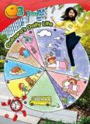  https://www.youtube.com/watch?v=eyPfpSt-SXc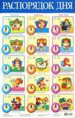
End  3min | Evaluation Final Self-Assessment: Tick “Yes” or “No”  Yes No  I can make sentences with new words  I can use new words and answer the questions  Saying goodbye | Ss reflect on the level of difficulty of the lesson. | Self-assessment | Board

