Ағылшын грамматикасы және практикалық жаттығулар жинағы
(авторлық бағдарлама)

2022

Түсінік хат

Жаңартылған білім оқушы мен мұғалімнің бірлігіне негізделген.
Елбасы Н.Ә.Назарбаев «Қазақстан -2050» Стратегиясында «Бәсекеге қабілетті, дамыған мемлекетті ел болу үшін біз сауаттылығы жоғары елге айналуымыз керек» деген болатын.
Қазақ тілінің негізгі міндеті оқушыны мәнерлі сөйлеуге үйретуден, сөздік қорды байытудан, сөзді дұрыс қолданудан, сөйлемдерді байланыстырып жазудан, білік-дағдылардан тұрады.
Ауызша сөйлеу табиғи жағдайда қалыптасады. Бала сөздердің орнын қалай ауыстыру керек, қалай байланыстыру керек деп көп ойланбайды. Ал сөйлеудің жазба түріне қойылатын талап жоғары. Жазба тілге айтайын деген ойдың түсінікті болуы, сөздерді дәл мағынасында қолдану, тілдік бейнелі құралдарды дұрыс пайдалану сияқты көптеген талаптар қойылады.
Тек өздігінен оқи алғанда ғана оқушы білімді мақсатты және нәтижелі түрде игеретіні анық. Ал өздігінен жұмыс істеу оқушы бойында оқу еңбегінің дағдысы мен икемділіктің қалыптасуын қажет етеді. Сана-сезімін және өзін-өзі бақылай білуін қалыптастырады.Танымдық қабілетті балалардың өздерінің икемі мен мінез-құлқына сай дамыту көзделеді. Ол үшін, ең бастысы, жеке-дара ойлануды әдетке айналдырып, дұрыс шешім қабылдаудың әртүрлі жолдарын іздеу керек. Бұл қасиеттердің баланың өмірінде жетістікке жетуіне көмектесері сөзсіз.
«Ағылшын тілінің грамматикасы» оқу құралы оқушылардың білімдерін тереңдетуді, ойлау, танымдық және шығармашылық қабілеттерін дамытуды қарастырады. Балаларды ізденімпаздыққа және өзінің даму деңгейіне сенімді болуға тәрбиелейді.

Мақсаты: оқушылардың сөдік қорын дамытуға, тілдің сырын ұғуға ықпал
ету.Интеллектуалды және шығармашылық мүмкіндіктерін
қалыптастырып, танымдық белсенділігін арттыру.

Бағдарламаның мазмұны барысында берілетін білім:
-өткен тақырыптарды бекіту, саралау
-танымдық тапсырмалар орындау арқылы қиялды ұштау.

Білім, білік, дағдыларына қойылатын талаптар.
-бағдарламадағы тапсырмалардың мән-мағынасын толық
түсінуге, танымдық қызығушылығын дамытуға жағдай жасау.
-ойлау қабілетіне назар аудару, елестету, есте сақтаудың түрлері
сұрыптау, зейінін дамыту және ойша тұжырымдама жасауға
көзделген.
-танымдық тапсырмалар оқушылардың шығармашылық
мүмкіндіктерін қалыптастырады
-құрылған тапсырмалар мазмұны жағынан бір-біріне ұқсамайды.

Күтілетін нәтиже:
-әртүрлі қызықты тапсырмалар қолданудың арқасында балалар өз
ойын дәлелдеуге төселді.
-өздігінен жұмыс істеуге жаттығады
-орындаған жұмысына талдау жүргізіп, өзін-өзі бақылай алады.

Ағылшын тілі пәні бойынша құралған оқу-тақырыптық жоспары
р/с | Сабақтыңтақырыбы | Cаны
1 | Alphabet | 1
2 | Articles | 1
3 | Noun | 1
4 | Countable and uncountable nouns | 1
5 | Possessive case ‘s | 1
6 | The verb «to have» | 1
7 | There is/ there are | 1
8 | Verb «to be» | 1
9 | Pronouns | 1
10 | Adjective | 1
11 | Numbers | 1
12 | The verb | 1
13 | Preposition | 1
14 | Conjunction | 1
15 | Some and any | 1
16 | Much and many | 1
17 | A few and a little | 1
18 | A lot of = Lots of | 1
19 | Question words (who, what, where,when, how old,what kind of) | 1
20 | Present Simple | 1
21 | Past simple | 1
22 | Future Simple | 1
23 | Present Continous | 1
24 | Past Continous | 1
25 | Future Continous | 1
26 | “To be going to” | 1
27 | Present Perfect | 1
28 | Past Perfect | 1
29 | Future perfect | 1
30 | FUTURE IN THE PAST | 1
31 | THE GERUND | 1
32 | PARTICIPLE | 1
33 | INFINITIVE | 1
34 | CONDITIONAL SENTENCES | 1

Lesson 1: Alphabet
Lesson 1: Alphabet(Ағылшыналфавиті) |  |  |  | School:
Date: |  |  |  | Teacher’s name:
Class: |  |  |  | Number present: | Number absent:
Lessontitle |  |  |  | Alphabet(Ағылшыналфавиті)
Learning objectives(s) that this lesson is contributing to |  | UE3 use a growing variety of adjectives and regular and irregular comparative and superlative adjectives on a limited range of familiar general and curricular topics  UE9 use simple present and simple past regular and irregular forms to describe routines, habits and states on a limited range of familiar general and curricular topics  C1 use speaking and listening skills to solve problems creatively and cooperatively in groups  C5 use feedback to set personal learning objectives
Lesson objectives |  | All students will be able to:  Revise taught material  Most students will be able to:  Demonstrate learned vocabulary about helping and heroes with sure  Some students will be able to:  - Use taught vocabulary and grammar with accuracy
Value links |  | Cooperation, respect each other's opinion, functional literacy.
Crosscurricular links |  | Social Science, Psychology, Geography,Information Technology.
Previous learning |  | Talking about trips.
Useof ICT |  | Smart board for showing a presentation, getting additional information,playing the audio files.
Intercultural awareness |  | Discuss experiences in different countries.
Health and Safety |  | Breaks and physical activities used. Everyday classroom precautions will ensure that safety measures are provided to prevent the exposure of electrical power cords.
Planned timings | Planned activities |  |  |  |  | Resources
Beginning of the lesson  7 min. | The lesson greeting.  Teacher organizes a warm-up activity for a start of the lesson. Learners look at the names of different places hung on the classroom walls. They choose the place they like and go to that place. In small groups they try to give arguments and explain why the place they have chosen is the best.  Learners are informed about the lesson objectives.    Warm up.Free talk about the best places in their city or town. The teacher asks Sts. in pairs make a list of places they are going to show to the tourists. |  |  |  |  | Pictures  PPT  Writing  Worksheet  Slide (useful phrases).
Main  Activities  15 min.  12 min | Main part  Ағылшын тілінің алфавиті 26 әріптен тұрады: 21 дауыссыз Consonants (консэнэнтс), 5 дауысты Vowels (вауэлз).  Y және W әріптері кейде дауысты кейде дауыссыз бола алады.  Бас әріптер (үлкен әріптер) – upper case немесе capital letters, ал кіші әріптер – lower caseнемесе small letters деп аталады. Letter (летэр) – әріп.Кестеде қызылмен жазылғандары – дауыстылар.  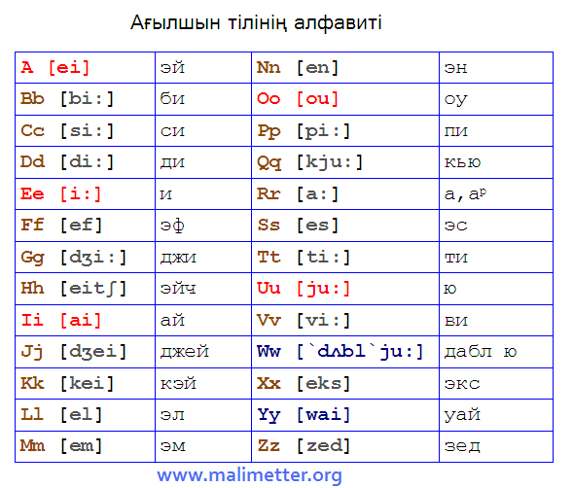  Мұндағы қос нүкте (:) қойылған әріп созылыңқы айтылады. Мысалы: bi:.dʒ деген дж қосарлы әріптерін білдіреді. Сол сияқты:ʒ – жtʃ – чʃ – шj – иʌ – а (жуан) |  |  |  |  | PPT  A whiteboard  A scheme of writing a postcard.
Ending the lesson  6 min. | Students express their attitude to the lesson and give self-assessment using the method:  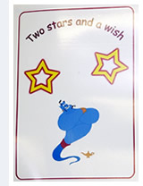
Differentiation –  how do you plan to give more support? How do you plan to challenge the more  able learners? |  |  | Assessment –  how are you planning to check learners’learning? |  |  |  | Critical thinking
Differentiation can be achieved through the selection of activities, identification of learning outcomes for a certain student, provision of individual support to learners, selection of learning materials and resources based on the individual abilities of learners. |  |  | Assessment criteria:  Identify the main idea in extended talks with little support.  Descriptor:  A learner:  - selects an appropriate answer.  - completes the task. |  |  |  | Students think critically, exploring, developing, evaluating and making choices about their own and others’ ideas

Lesson 2Articles– артикль
Lesson 2Articles– артикль |  |  |  | School:
Date: |  |  |  | Teacher’s name:
Class: |  |  |  | Number present: | Number absent:
Lessontitle |  |  |  | Articles
Learning objectives(s) that this lesson is contributing to |  | UE3 use a growing variety of adjectives and regular and irregular comparative and superlative adjectives on a limited range of familiar general and curricular topics  UE9 use simple present and simple past regular and irregular forms to describe routines, habits and states on a limited range of familiar general and curricular topics  C1 use speaking and listening skills to solve problems creatively and cooperatively in groups  C5 use feedback to set personal learning objectives
Lesson objectives |  | All students will be able to:  Revise taught material  Most students will be able to:  Demonstrate learned vocabulary about helping and heroes with sure  Some students will be able to:  - Use taught vocabulary and grammar with accuracy
Value links |  | Cooperation, respect each other's opinion, functional literacy.
Crosscurricular links |  | Social Science, Psychology, Geography,Information Technology.
Previous learning |  | Talking about trips.
Useof ICT |  | Smart board for showing a presentation, getting additional information,playing the audio files.
Intercultural awareness |  | Discuss experiences in different countries.
Health and Safety |  | Breaks and physical activities used. Everyday classroom precautions will ensure that safety measures are provided to prevent the exposure of electrical power cords.
Planned timings | Planned activities |  |  |  |  | Resources
Beginning of the lesson  7 min. | The lesson greeting.  Teacher organizes a warm-up activity for a start of the lesson. Learners look at the names of different places hung on the classroom walls. They choose the place they like and go to that place. In small groups they try to give arguments and explain why the place they have chosen is the best.  Learners are informed about the lesson objectives.  Warm up.Free talk about the best places in their city or town. The teacher asks Sts. in pairs make a list of places they are going to show to the tourists. |  |  |  |  | Pictures  PPT  Writing  Worksheet  Slide (useful phrases).
Main  Activities  15 min.  12 min | Main part  Article (артикль) – сөзтабы,затесімдердіңалдындақолданыладыжәнеоныанықтаптұрады: a table, the pen  1. Indefinite article (белгісізартикль) – a, an  Бұлартикль one (бір, біреу) санесіміненшыққан. Қолданылуы: затесімніңжекешетүрінде: Take a pen- not two pens.  көпзаттыңішіндебіреуіаталса: I am a student.  a –дауыссыз дыбыстардың алдындақолданылады: a table , a dictionary  an –дауысты дыбыстардың алдындақолданылады: an apple, an orange  2. Definite article (белгіліартикль)– the  Белгіліартикльбұлдегенсөзденшыққан. Демеккөптегензаттардыңішіненбіреуітуралыайтатынболсаcолзатесімдібелгіліартикльменайтамыз.  Белгіліжәнебелгісізартикльдердіңмағыналарынсалыстырыпкөрелік:  Take a pen. – Қаламалыңыз (кез-келген).Take the pen. – Мына қаламды  алыңыз.  Task.Crossword  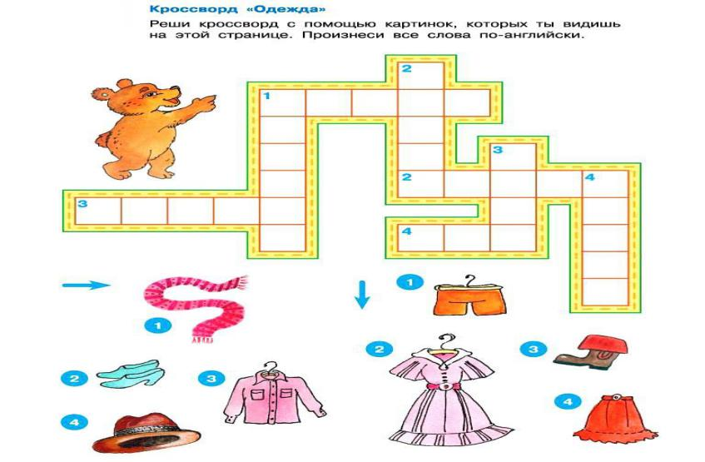  Insert definite or indefinite articles the an, a, where necessary:  1. Greeks like ...........coffee.  2. English like .......... tea.  3........... exercise he is writing is very easy.  4........... exercise is good for our health.  5. He lives in ........... Japan.  6. Is ,........ Chinese easy? |  |  |  |  | PPT  A whiteboard  A scheme of writing a postcard.
Ending the lesson  6 min. | Students express their attitude to the lesson and give self-assessment using the method: Кубизм әдісі. Кім жылдам?  1
Differentiation –  how do you plan to give more support? How do you plan to challenge the more  able learners? |  |  | Assessment –  how are you planning to check learners’learning? |  |  |  | Critical thinking
Differentiation can be achieved through the selection of activities, identification of learning outcomes for a certain student, provision of individual support to learners, selection of learning materials and resources based on the individual abilities of learners. |  |  | Assessment criteria:  Identify the main idea in extended talks with little support.  Descriptor:  A learner:  - selects an appropriate answer.  - completes the task. |  |  |  | Students think critically, exploring, developing, evaluating and making choices about their own and others’ ideas

Lesson 3 The Noun – зат есім |  |  |  | School:
Date: |  |  |  | Teacher’s name:
Class: |  |  |  | Number present: | Number absent:
Lessontitle |  |  |  | The Noun
Learning objectives(s) that this lesson is contributing to |  | UE3 use a growing variety of adjectives and regular and irregular comparative and superlative adjectives on a limited range of familiar general and curricular topics  UE9 use simple present and simple past regular and irregular forms to describe routines, habits and states on a limited range of familiar general and curricular topics  C1 use speaking and listening skills to solve problems creatively and cooperatively in groups  C5 use feedback to set personal learning objectives
Lesson objectives |  | All students will be able to:  Revise taught material  Most students will be able to:  Demonstrate learned vocabulary about helping and heroes with sure  Some students will be able to:  - Use taught vocabulary and grammar with accuracy
Value links |  | Cooperation, respect each other's opinion, functional literacy.
Crosscurricular links |  | Social Science, Psychology, Geography,Information Technology.
Previous learning |  | Talking about trips.
Useof ICT |  | Smart board for showing a presentation, getting additional information,playing the audio files.
Intercultural awareness |  | Discuss experiences in different countries.
Health and Safety |  | Breaks and physical activities used. Everyday classroom precautions will ensure that safety measures are provided to prevent the exposure of electrical power cords.
Planned timings | Planned activities |  |  |  |  | Resources
Beginning of the lesson  7 min. | The lesson greeting.  Teacher organizes a warm-up activity for a start of the lesson. Learners look at the names of different places hung on the classroom walls. They choose the place they like and go to that place. In small groups they try to give arguments and explain why the place they have chosen is the best.  Learners are informed about the lesson objectives.  Warm up.Free talk about the best places in their city or town. The teacher asks Sts. in pairs make a list of places they are going to show to the tourists. |  |  |  |  | Pictures  PPT  Writing  Worksheet  Slide (useful phrases).
Main  Activities  15 min.  12 min | Main part  The Noun (затесім) – заттыңатынбілдіріп, кім, не, кімдер, нелердегенсұрақтарғажауапберетінсөздерзатесімдепаталады.  1) Жалқыесімдер (Proper) –ат, фамилия, географиялықатаулар, аптакүндеріт. б.: John, Charles Dickens, Trafalgar Square, Moscow, the United Kingdom  2) Жалпыесімдер (Common) – заттар, құралдар, әрекеттер, күйлер, сезімдер.  дұрыс (көпшетүр–sжұрнағыарқылыжасалады):  a map (карта) – maps (карталар) a pen (қалам) – pens (қаламдар)  • егер сөз -o, -s, -ch, -sh, -x, ке аяқталатын болса -es жалғану арқылы жасалады:hero – heroes , dress – dresses  • егер сөз алдында дауыссыз тұрған -y әрпіне аяқталатын болса, -y -i болып ауысады , сөз соңы -ies болады; city – cities  • түбірдегі -f, -fe -ve ге ауысып, сөз соңында -ves болады;  leaf (жапырақ) – leaves (жапырақтар)  wife (әйел) – wives (әйелдер)  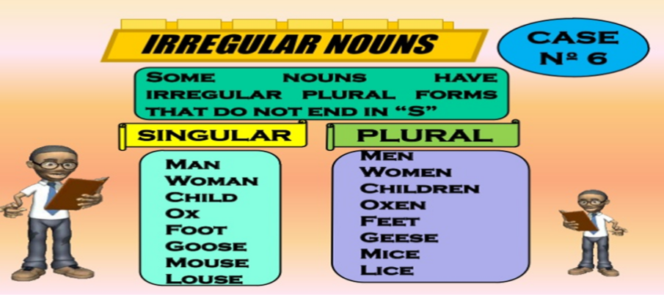  Task.Write 8 singular and plural nouns |  |  |  |  | PPT  A whiteboard  A scheme of writing a postcard.
Ending the lesson  6 min. | Students express their attitude to the lesson and give self-assessment using the method  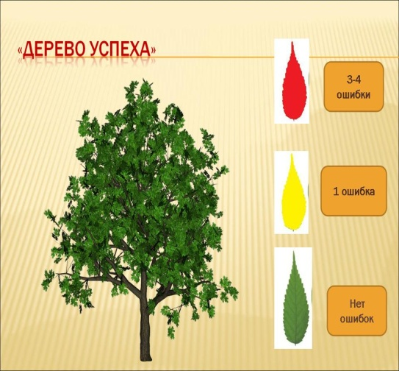
Differentiation –  How do you plan to give more support? How do you plan to challenge the more  able learners? |  |  | Assessment –  how are you planning to check learners’learning? |  |  |  | Critical thinking
Differentiation can be achieved through the selection of activities, identification of learning outcomes for a certain student, provision of individual support to learners, selection of learning materials and resources based on the individual abilities of learners. |  |  | Assessment criteria:  Identify the main idea in extended talks with little support.  Descriptor:  A learner:  - selects an appropriate answer.  - completes the task. |  |  |  | Students think critically, exploring, developing, evaluating and making choices about their own and others’ ideas

Lesson 4.Countable and uncountable nouns.
Lesson 4. Countable and uncountable nouns. |  |  |  | School:
Date: |  |  |  | Teacher’s name:
Class: |  |  |  | Number present: | Number absent:
Lessontitle |  |  |  | Countable and uncountable nouns.
Learning objectives(s) that this lesson is contributing to |  | UE3 use a growing variety of adjectives and regular and irregular comparative and superlative adjectives on a limited range of familiar general and curricular topics  UE9 use simple present and simple past regular and irregular forms to describe routines, habits and states on a limited range of familiar general and curricular topics  C1 use speaking and listening skills to solve problems creatively and cooperatively in groups  C5 use feedback to set personal learning objectives
Lesson objectives |  | All students will be able to:  Revise taught material  Most students will be able to:  Demonstrate learned vocabulary about helping and heroes with sure  Some students will be able to:  - Use taught vocabulary and grammar with accuracy
Value links |  | Cooperation, respect each other's opinion, functional literacy.
Crosscurricular links |  | Social Science, Psychology, Geography,Information Technology.
Previous learning |  | Talking about trips.
Useof ICT |  | Smart board for showing a presentation, getting additional information,playing the audio files.
Intercultural awareness |  | Discuss experiences in different countries.
Health and Safety |  | Breaks and physical activities used. Everyday classroom precautions will ensure that safety measures are provided to prevent the exposure of electrical power cords.
Planned timings | Planned activities |  |  |  |  | Resources
Beginning of the lesson  7 min. | The lesson greeting.  Teacher organizes a warm-up activity for a start of the lesson. Learners look at the names of different places hung on the classroom walls. They choose the place they like and go to that place. In small groups they try to give arguments and explain why the place they have chosen is the best.  Learners are informed about the lesson objectives.  Warm up.Free talk about the best places in their city or town. The teacher asks Sts. in pairs make a list of places they are going to show to the tourists. |  |  |  |  | Pictures  PPT  Writing  Worksheet  Slide (useful phrases).
Main  Activities  15 min.  12 min | Main part  Countable nouns are used with the article. And we can count them. Countable nouns are used with the article. And we can count them. For example: a table, an actor, a ball There is a table – There are two tables Саналатынзатесімдерартикльменқолданылады. Жәнебізолардысанайаламыз.  Uncountable nouns are not used with the article. We cant count them. For example: water, sugar, tea,onesugar,two waters, ten teas, one sugar Саналмайтынзатесімдерартикльсізқолданыладыжәнебізолардысанайалмаймыз.  5  Now you can read the rheam and find the C and UC nouns  I can’t count food  But I can count fish  I can’t count peace  But I can for all I wish  I can’t count water  But I can count glasses |  |  |  |  | PPT  A whiteboard  A scheme of writing a postcard.
Ending the lesson  6 min. | Students express their attitude to the lesson and give self-assessment using the method: “five finger”  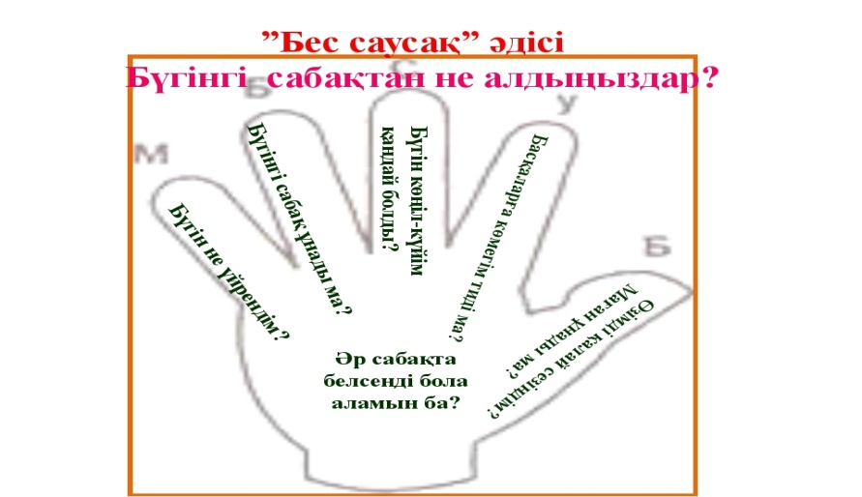
Differentiation –  how do you plan to give more support? How do you plan to challenge the more  able learners? |  |  | Assessment –  how are you planning to check learners’learning? |  |  |  | Critical thinking
Differentiation can be achieved through the selection of activities, identification of learning outcomes for a certain student, provision of individual support to learners, selection of learning materials and resources based on the individual abilities of learners. |  |  | Assessment criteria:  Identify the main idea in extended talks with little support.  Descriptor:  A learner:  - selects an appropriate answer.  - completes the task. |  |  |  | Students think critically, exploring, developing, evaluating and making choices about their own and others’ ideas

Lesson 5.The Possesive case |  |  |  | School:
Date: |  |  |  | Teacher’s name:
Class: |  |  |  | Number present: | Number absent:
Lessontitle |  |  |  | The Possesive case
Learning objectives(s) that this lesson is contributing to |  | UE3 use a growing variety of adjectives and regular and irregular comparative and superlative adjectives on a limited range of familiar general and curricular topics  UE9 use simple present and simple past regular and irregular forms to describe routines, habits and states on a limited range of familiar general and curricular topics  C1 use speaking and listening skills to solve problems creatively and cooperatively in groups  C5 use feedback to set personal learning objectives
Lesson objectives |  | All students will be able to:  Revise taught material  Most students will be able to:  Demonstrate learned vocabulary about helping and heroes with sure  Some students will be able to:  - Use taught vocabulary and grammar with accuracy
Value links |  | Cooperation, respect each other's opinion, functional literacy.
Crosscurricular links |  | Social Science, Psychology, Geography,Information Technology.
Previous learning |  | Talking about trips.
Useof ICT |  | Smart board for showing a presentation, getting additional information,playing the audio files.
Intercultural awareness |  | Discuss experiences in different countries.
Health and Safety |  | Breaks and physical activities used. Everyday classroom precautions will ensure that safety measures are provided to prevent the exposure of electrical power cords.
Planned timings | Planned activities |  |  |  |  | Resources
Beginning of the lesson  7 min. | The lesson greeting.  Teacher organizes a warm-up activity for a start of the lesson. Learners look at the names of different places hung on the classroom walls. They choose the place they like and go to that place. In small groups they try to give arguments and explain why the place they have chosen is the best.  Learners are informed about the lesson objectives.  Warm up.Free talk about the best places in their city or town. The teacher asks Sts. in pairs make a list of places they are going to show to the tourists. |  |  |  |  | Pictures  PPT  Writing  Worksheet  Slide (useful phrases).
Main  Activities  15 min.  12 min | Main part  Тәуелді септіктегі зат есім сөйлемде өзінен кейінгі зат есімнің анықтауышы болып келіп, whose? – кімдікі?, кімнің?, кімдердің? деген сұрақтарға жауап береді.Бұл септік дәйекші (апостроф) – ‘ және – s жалғауы арқылы жасалады. e.g. Samal’s sister. The cow’s legs.  Егер затқа екі адам иелік ететін болса, тәуелді септіктің дәйекшісі – ‘ және – s жалғауы соңғы зат есімге жалғанады. e.g.Marat and Kasym’s flat.  Егер көптік жалғаулы зат есім тәуелді септікте тұрса, оған тек дәйекші қойыладыда, анықталушы зат есім артикльсіз жазылады. e.g. The students’ tests are good.  Көпше түрде қолданылатын көптік жалғаусыз зат есімдерге тәуелді септікте дәйекші және – s жалғанады. e.g.Children’s mother.  Task . Use the words in brackets in the possessive case  a)1. Last week was my (daughter) sixth birthday. 2. (Children) toys are very attractive these days. 3. Have you ever met (Denis) wife? 4. I'll see you in an (hour) time. 5. The house will be sold in two (week) time.  b) 1. The plant of my sister is one of the best. 2. Take the book of Mr. Brown and read it. 3. The work of that man is very interesting. 4. The children of these women want to know English. 5. The room of my brother is large.  2. Transform the following sentences using possessive case of nouns where possible.  1 I’m a great lover of the music of Mozart and Chopin.  2 The house of my Aunt Mary was surrounded by a beautiful old garden.  3 Manchester United Club spends millions of pounds on the wages of its players.  4 What do you think of the recent article on the problems of education? |  |  |  |  | PPT  A whiteboard  A scheme of writing a postcard.
Ending the lesson  6 min. | Students express their attitude to the lesson and give self-assessment using the method:  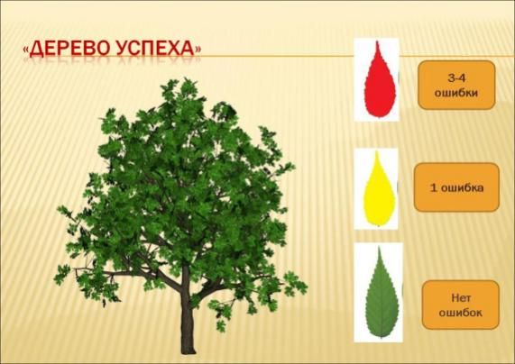
Differentiation –  how do you plan to give more support? How do you plan to challenge the more  able learners? |  |  | Assessment –  how are you planning to check learners’learning? |  |  |  | Critical thinking
Differentiation can be achieved through the selection of activities, identification of learning outcomes for a certain student, provision of individual support to learners, selection of learning materials and resources based on the individual abilities of learners. |  |  | Assessment criteria:  Identify the main idea in extended talks with little support.  Descriptor:  A learner:  - selects an appropriate answer.  - completes the task. |  |  |  | Students think critically, exploring, developing, evaluating and making choices about their own and others’ ideas

Lesson 6 Verb «Have» |  |  |  | School:
Date: |  |  |  | Teacher’s name:
Class: |  |  |  | Number present: | Number absent:
Lessontitle |  |  |  | Verb «Have»
Learning objectives(s) that this lesson is contributing to |  | UE3 use a growing variety of adjectives and regular and irregular comparative and superlative adjectives on a limited range of familiar general and curricular topics  UE9 use simple present and simple past regular and irregular forms to describe routines, habits and states on a limited range of familiar general and curricular topics  C1 use speaking and listening skills to solve problems creatively and cooperatively in groups  C5 use feedback to set personal learning objectives
Lesson objectives |  | All students will be able to:  Revise taught material  Most students will be able to:  Demonstrate learned vocabulary about helping and heroes with sure  Some students will be able to:  - Use taught vocabulary and grammar with accuracy
Value links |  | Cooperation, respect each other's opinion, functional literacy.
Crosscurricular links |  | Social Science, Psychology, Geography,Information Technology.
Previous learning |  | Talking about trips.
Useof ICT |  | Smart board for showing a presentation, getting additional information,playing the audio files.
Intercultural awareness |  | Discuss experiences in different countries.
Health and Safety |  | Breaks and physical activities used. Everyday classroom precautions will ensure that safety measures are provided to prevent the exposure of electrical power cords.
Planned timings | Planned activities |  |  |  |  | Resources
Beginning of the lesson  7 min. | The lesson greeting.  Teacher organizes a warm-up activity for a start of the lesson. Learners look at the names of different places hung on the classroom walls. They choose the place they like and go to that place. In small groups they try to give arguments and explain why the place they have chosen is the best.  Learners are informed about the lesson objectives.  Warm up.Free talk about the best places in their city or town. The teacher asks Sts. in pairs make a list of places they are going to show to the tourists. |  |  |  |  | Pictures  PPT  Writing  Worksheet  Slide (useful phrases).
Main  Activities  15 min.  12 min | Main part  Have’ етістігі “бар” деген мағынада қолданылады да, баршылықты білдіреді.Үшінші жақтың жеке түрінде ‘have’ етістігінің формасы ‘has’ етістігіне айналады. Қалған жақтар үшін ‘have’болып қалады.  Positive Negative Question  I /You/We/They have He/She/It has I /You/We/ They have not He/She/It has not have I /you/we/they? Has he/she/it?  Task .Write in have got, has got, haven't got or hasn't got.  I _________ long fair hair. My mum _________ big blue eyes. My dad ________ short dark hair.  I _________a little mouth. My brother ______ little ears. My friend __________a big nose.  My granny __________ a small face. My teacher __________ short hair.  Have or has.  1 We _____ got a green parrot. 2 She _____ got seven games. 3 They _____ n’t got a kite.  4 I _____ got a big bag. 5_____ you got a blue pen? 6 _____it got a funny face? 7 He _____ n’t got a bike. |  |  |  |  | PPT  A whiteboard  A scheme of writing a postcard.
Ending the lesson  6 min. | Students express their attitude to the lesson and give self-assessment using the method:  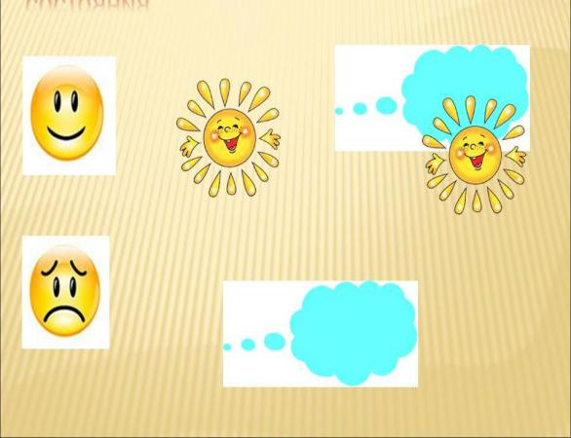
Differentiation –  how do you plan to give more support? How do you plan to challenge the more  able learners? |  |  | Assessment –  how are you planning to check learners’learning? |  |  |  | Critical thinking
Differentiation can be achieved through the selection of activities, identification of learning outcomes for a certain student, provision of individual support to learners, selection of learning materials and resources based on the individual abilities of learners. |  |  | Assessment criteria:  Identify the main idea in extended talks with little support.  Descriptor:  A learner:  - selects an appropriate answer.  - completes the task. |  |  |  | Students think critically, exploring, developing, evaluating and making choices about their own and others’ ideas

Lesson 8 Verb «to be» |  |  |  | School:
Date: |  |  |  | Teacher’s name:
Class: |  |  |  | Number present: | Number absent:
Lessontitle |  |  |  | Verb «to be»
Learning objectives(s) that this lesson is contributing to |  | UE3 use a growing variety of adjectives and regular and irregular comparative and superlative adjectives on a limited range of familiar general and curricular topics  UE9 use simple present and simple past regular and irregular forms to describe routines, habits and states on a limited range of familiar general and curricular topics  C1 use speaking and listening skills to solve problems creatively and cooperatively in groups  C5 use feedback to set personal learning objectives
Lesson objectives |  | All students will be able to:  Revise taught material  Most students will be able to:  Demonstrate learned vocabulary about helping and heroes with sure  Some students will be able to:  - Use taught vocabulary and grammar with accuracy
Value links |  | Cooperation, respect each other's opinion, functional literacy.
Crosscurricular links |  | Social Science, Psychology, Geography,Information Technology.
Previous learning |  | Talking about trips.
Useof ICT |  | Smart board for showing a presentation, getting additional information,playing the audio files.
Intercultural awareness |  | Discuss experiences in different countries.
Health and Safety |  | Breaks and physical activities used. Everyday classroom precautions will ensure that safety measures are provided to prevent the exposure of electrical power cords.
Planned timings | Planned activities |  |  |  |  | Resources
Beginning of the lesson  7 min. | The lesson greeting.  Teacher organizes a warm-up activity for a start of the lesson. Learners look at the names of different places hung on the classroom walls. They choose the place they like and go to that place. In small groups they try to give arguments and explain why the place they have chosen is the best.  Learners are informed about the lesson objectives.  Warm up.Free talk about the best places in their city or town. The teacher asks Sts. in pairs make a list of places they are going to show to the tourists. |  |  |  |  | Pictures  PPT  Writing  Worksheet  Slide (useful phrases).
Main  Activities  15 min.  12 min | Main part  To be етістігінің мағынасы «болу, табылу» деген ұғымдарға келеді.Ағылшын тіліндегі өзгеде етістіктерден ерекшелігі to be етістігі жіктеледі және көптеледі.  To be  I Am You,are,they  He,she,it is are  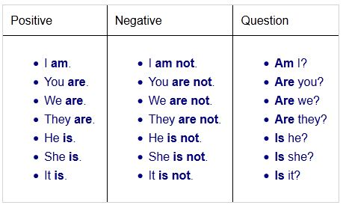  COMPLETE THE SENTENCES WITH ¨TO BE¨  1. I _____ a girl.  2. My father_____ at work.  3. Alex and Dino _____ my cats.  4. Alex _____ in the garden.  5. Dino _____ on the floor.  6. My red pencil _____ on the floor, too. |  |  |  |  | PPT  A whiteboard  A scheme of writing a postcard.
Ending the lesson  6 min. | Students express their attitude to the lesson and give self-assessment using the method: “Six thinking hats”:  - Green: How can you use today's learning in different subjects?  - Red: How do you feel about your work today?  - White: What have you leant today?  - Black: What were the weaknesses of your work?  - Blue: How much progress have you made in this lesson? (Now I can, I still need to work on, I've improved in, Today I learnt... )  Yellow: What did you like about today's lesson?  Slide (Homework)  Slide "Six thinking hats"  
Differentiation –  how do you plan to give more support? How do you plan to challenge the more  able learners? |  |  | Assessment –  how are you planning to check learners’learning? |  |  |  | Critical thinking
Differentiation can be achieved through the selection of activities, identification of learning outcomes for a certain student, provision of individual support to learners, selection of learning materials and resources based on the individual abilities of learners. |  |  | Assessment criteria:  Identify the main idea in extended talks with little support.  Descriptor:  A learner:  - selects an appropriate answer.  - completes the task. |  |  |  | Students think critically, exploring, developing, evaluating and making choices about their own and others’ ideas

Lesson 9 Pronoun – есімдік |  |  |  | School:
Date: |  |  |  | Teacher’s name:
Class: |  |  |  | Number present: | Number absent:
Lessontitle |  |  |  | Pronoun – есімдік
Learning objectives(s) that this lesson is contributing to |  | UE3 use a growing variety of adjectives and regular and irregular comparative and superlative adjectives on a limited range of familiar general and curricular topics  UE9 use simple present and simple past regular and irregular forms to describe routines, habits and states on a limited range of familiar general and curricular topics  C1 use speaking and listening skills to solve problems creatively and cooperatively in groups  C5 use feedback to set personal learning objectives
Lesson objectives |  | All students will be able to:  Revise taught material  Most students will be able to:  Demonstrate learned vocabulary about helping and heroes with sure  Some students will be able to:  - Use taught vocabulary and grammar with accuracy
Value links |  | Cooperation, respect each other's opinion, functional literacy.
Crosscurricular links |  | Social Science, Psychology, Geography,Information Technology.
Previous learning |  | Talking about trips.
Useof ICT |  | Smart board for showing a presentation, getting additional information,playing the audio files.
Intercultural awareness |  | Discuss experiences in different countries.
Health and Safety |  | Breaks and physical activities used. Everyday classroom precautions will ensure that safety measures are provided to prevent the exposure of electrical power cords.
Planned timings | Planned activities |  |  |  |  | Resources
Beginning of the lesson  7 min. | The lesson greeting.  Teacher organizes a warm-up activity for a start of the lesson. Learners look at the names of different places hung on the classroom walls. They choose the place they like and go to that place. In small groups they try to give arguments and explain why the place they have chosen is the best.  Learners are informed about the lesson objectives.  Warm up.Free talk about the best places in their city or town. The teacher asks Sts. in pairs make a list of places they are going to show to the tourists. |  |  |  |  | Pictures  PPT  Writing  Worksheet  Slide (useful phrases).
Main  Activities  15 min.  12 min | Main part  Pronoun – есімдік  Есім сөздердің орнына жүретін сөз табы есімдік деп аталады.  1. Personal pronouns – жіктеуесімдіктері  I – мен we – біз  you – сен you – сендер  he – ол (ер адам) they – олар  she – ол (әйел адам)  it – ол (жансыз зат)  2. Possessive pronouns – тәуелдік есімдіктері  my – менің our – біздің  your – сенің your – сендердің  his – оның their – олардың  her – оның  its – оның  my book – менің кітабым |  |  |  |  | PPT  A whiteboard  A scheme of writing a postcard.
Ending the lesson  6 min. | Students express their attitude to the lesson and give self-assessment using the method: “Six thinking hats”:  - Green: How can you use today's learning in different subjects?  - Red: How do you feel about your work today?  - White: What have you leant today?  - Black: What were the weaknesses of your work?  - Blue: How much progress have you made in this lesson? (Now I can, I still need to work on, I've improved in, Today I learnt... )  Yellow: What did you like about today's lesson?  Slide (Homework)  Slide "Six thinking hats"
Differentiation –  how do you plan to give more support? How do you plan to challenge the more  able learners? |  |  | Assessment –  how are you planning to check learners’learning? |  |  |  | Critical thinking
Differentiation can be achieved through the selection of activities, identification of learning outcomes for a certain student, provision of individual support to learners, selection of learning materials and resources based on the individual abilities of learners. |  |  | Assessment criteria:  Identify the main idea in extended talks with little support.  Descriptor:  A learner:  - selects an appropriate answer.  - completes the task. |  |  |  | Students think critically, exploring, developing, evaluating and making choices about their own and others’ ideas

Lesson 10 (The Adjective) Сын есім |  |  |  | School:
Date: |  |  |  | Teacher’s name:
Class: |  |  |  | Number present: | Number absent:
Lessontitle |  |  |  | (The Adjective) Сын есім
Learning objectives(s) that this lesson is contributing to |  | UE3 use a growing variety of adjectives and regular and irregular comparative and superlative adjectives on a limited range of familiar general and curricular topics  UE9 use simple present and simple past regular and irregular forms to describe routines, habits and states on a limited range of familiar general and curricular topics  C1 use speaking and listening skills to solve problems creatively and cooperatively in groups  C5 use feedback to set personal learning objectives
Lesson objectives |  | All students will be able to:  Revise taught material  Most students will be able to:  Demonstrate learned vocabulary about helping and heroes with sure  Some students will be able to:  - Use taught vocabulary and grammar with accuracy
Value links |  | Cooperation, respect each other's opinion, functional literacy.
Crosscurricular links |  | Social Science, Psychology, Geography,Information Technology.
Previous learning |  | Talking about trips.
Useof ICT |  | Smart board for showing a presentation, getting additional information,playing the audio files.
Intercultural awareness |  | Discuss experiences in different countries.
Health and Safety |  | Breaks and physical activities used. Everyday classroom precautions will ensure that safety measures are provided to prevent the exposure of electrical power cords.
Planned timings | Planned activities |  |  |  |  | Resources
Beginning of the lesson  7 min. | The lesson greeting.  Teacher organizes a warm-up activity for a start of the lesson. Learners look at the names of different places hung on the classroom walls. They choose the place they like and go to that place. In small groups they try to give arguments and explain why the place they have chosen is the best.  Learners are informed about the lesson objectives.  Warm up.Free talk about the best places in their city or town. The teacher asks Sts. in pairs make a list of places they are going to show to the tourists. |  |  |  |  | Pictures  PPT  Writing  Worksheet  Slide (useful phrases).
Main  Activities  15 min.  12 min | Main part  (The Adjective) Сын есім  Ағылшын тіліндегі сын есім (the Adjective) де қазақ тіліндегі секілді анықтамаға ие, яғни, заттың сипатын, сынын, сапасын білдіреді. Мысалы: deep sea – терең теңіз, fresh air – таза ауа.Cын есім: big – үлкен, tall – биік, small – кішкентай, т.с.с.  Сын есімдер жай шырайда, салыстырмалы шырайда және күшейтпелі шырайда болады. Мысалы: big (үлкен) – bigger (үлкенірек) – the biggest (ең үлкен).  Соңы -y әрпіне бітетін бір буынды сын есімнің соңындағы -y әрпі -i әрпіне өзгереді.  Жай шырай (Normal form) Салыс-лы шырай (Comparative form) Күшейтпелішырай (Superlativeform)  small Smaller (the) smallest  clean Cleaner (the) cleanest  new Newer (the) newest  dry Drier (the) driest  old Older Elder (the) oldest (the) eldest  long Longer (the) longest  big Bigger (the) biggest  fat Fatter (the) fattest  Task.Complete the sentences  Old  Longer  the fattest  clean  Bigger  the smallest  dry  Newer |  |  |  |  | PPT  A whiteboard  A scheme of writing a postcard.
Ending the lesson  6 min. | Students express their attitude to the lesson and give self-assessment using the method: «ВЕЕР»  
Differentiation –  how do you plan to give more support? How do you plan to challenge the more  able learners? |  |  | Assessment –  how are you planning to check learners’learning? |  |  |  | Critical thinking
Differentiation can be achieved through the selection of activities, identification of learning outcomes for a certain student, provision of individual support to learners, selection of learning materials and resources based on the individual abilities of learners. |  |  | Assessment criteria:  Identify the main idea in extended talks with little support.  Descriptor:  A learner:  - selects an appropriate answer.  - completes the task. |  |  |  | Students think critically, exploring, developing, evaluating and making choices about their own and others’ ideas

Lesson 11 The Numeral – cан есім |  |  |  | School:
Date: |  |  |  | Teacher’s name:
Class: |  |  |  | Number present: | Number absent:
Lessontitle |  |  |  | The Numeral – cан есім
Learning objectives(s) that this lesson is contributing to |  | UE3 use a growing variety of adjectives and regular and irregular comparative and superlative adjectives on a limited range of familiar general and curricular topics  UE9 use simple present and simple past regular and irregular forms to describe routines, habits and states on a limited range of familiar general and curricular topics  C1 use speaking and listening skills to solve problems creatively and cooperatively in groups  C5 use feedback to set personal learning objectives
Lesson objectives |  | All students will be able to:  Revise taught material  Most students will be able to:  Demonstrate learned vocabulary about helping and heroes with sure  Some students will be able to:  - Use taught vocabulary and grammar with accuracy
Value links |  | Cooperation, respect each other's opinion, functional literacy.
Crosscurricular links |  | Social Science, Psychology, Geography,Information Technology.
Previous learning |  | Talking about trips.
Useof ICT |  | Smart board for showing a presentation, getting additional information,playing the audio files.
Intercultural awareness |  | Discuss experiences in different countries.
Health and Safety |  | Breaks and physical activities used. Everyday classroom precautions will ensure that safety measures are provided to prevent the exposure of electrical power cords.
Planned timings | Planned activities |  |  |  |  | Resources
Beginning of the lesson  7 min. | The lesson greeting.  Teacher organizes a warm-up activity for a start of the lesson. Learners look at the names of different places hung on the classroom walls. They choose the place they like and go to that place. In small groups they try to give arguments and explain why the place they have chosen is the best.  Learners are informed about the lesson objectives.  Warm up.Free talk about the best places in their city or town. The teacher asks Sts. in pairs make a list of places they are going to show to the tourists. |  |  |  |  | Pictures  PPT  Writing  Worksheet  Slide (useful phrases).
Main  Activities  15 min.  12 min | Main part  The Numeral – cан есім  The Numeral – заттың санын, ретін білідіретін сөз табы:  1. Cardinal Numerals – есептік сан есімдер;  2. Ordinal Numerals – реттік сан есімдер;  Cardinal Numerals  Есептік сан есімдер how many? (неше?) сұрағына жауап береді.  0 zero,1 one , 2 two  1. 13-тен 19-ғадейін -teen жұрнағы арқылы жасалады.  13 thirteen ,14 fourteen  2. (20 – 90) ондықтары -tу жұрнағы арқылы жасалады.  20 twenty  3. Ондықтар бірліктермен дефис арқылы жазылады.  21 twenty-one ,22 twenty-two  Ordinal Numerals  1. Реттік сан есімдердің алдында the белгілі артиклі тұрады.  2. Біріншіүшреттіксанесімдердіңжасалужолыерекше.  1st the first,2nd the second,3rd the third  3. Төртіншіреттіксанесімненбастап –th жұрнағыжалғанады.  4th the fourth, 5th the fifth  4. Ондықтарда -y -ie-геөзгереді (-ieth).  20th the twentieth  5. Реттіксанесімдерде 20-данкейінтек соңғы бөлігіөзгереді.  22nd the twenty-second, 30th the thirtieth  Task.Complete the sentences  Cardinal Numerals Ordinal Numerals  One first |  |  |  |  | PPT  A whiteboard  A scheme of writing a postcard.
Ending the lesson  6 min. | Students express their attitude to the lesson and give self-assessment using the method:  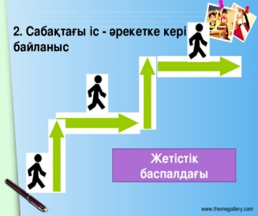
Differentiation –  how do you plan to give more support? How do you plan to challenge the more  able learners? |  |  | Assessment –  how are you planning to check learners’learning? |  |  |  | Critical thinking
Differentiation can be achieved through the selection of activities, identification of learning outcomes for a certain student, provision of individual support to learners, selection of learning materials and resources based on the individual abilities of learners. |  |  | Assessment criteria:  Identify the main idea in extended talks with little support.  Descriptor:  A learner:  - selects an appropriate answer.  - completes the task. |  |  |  | Students think critically, exploring, developing, evaluating and making choices about their own and others’ ideas

Lesson 12 Verb – етістік |  |  |  | School:
Date: |  |  |  | Teacher’s name:
Class: |  |  |  | Number present: | Number absent:
Lessontitle |  |  |  | Verb – етістік
Learning objectives(s) that this lesson is contributing to |  | UE3 use a growing variety of adjectives and regular and irregular comparative and superlative adjectives on a limited range of familiar general and curricular topics  UE9 use simple present and simple past regular and irregular forms to describe routines, habits and states on a limited range of familiar general and curricular topics  C1 use speaking and listening skills to solve problems creatively and cooperatively in groups  C5 use feedback to set personal learning objectives
Lesson objectives |  | All students will be able to:  Revise taught material  Most students will be able to:  Demonstrate learned vocabulary about helping and heroes with sure  Some students will be able to:  - Use taught vocabulary and grammar with accuracy
Value links |  | Cooperation, respect each other's opinion, functional literacy.
Crosscurricular links |  | Social Science, Psychology, Geography,Information Technology.
Previous learning |  | Talking about trips.
Useof ICT |  | Smart board for showing a presentation, getting additional information,playing the audio files.
Intercultural awareness |  | Discuss experiences in different countries.
Health and Safety |  | Breaks and physical activities used. Everyday classroom precautions will ensure that safety measures are provided to prevent the exposure of electrical power cords.
Planned timings | Planned activities |  |  |  |  | Resources
Beginning of the lesson  7 min. | The lesson greeting.  Teacher organizes a warm-up activity for a start of the lesson. Learners look at the names of different places hung on the classroom walls. They choose the place they like and go to that place. In small groups they try to give arguments and explain why the place they have chosen is the best.  Learners are informed about the lesson objectives.  Warm up.Free talk about the best places in their city or town. The teacher asks Sts. in pairs make a list of places they are going to show to the tourists. |  |  |  |  | Pictures  PPT  Writing  Worksheet  Slide (useful phrases).
Main  Activities  15 min.  12 min | Main part  Verb – етістік  Verb (етістік) – заттың қимылын, іс-әрекетін, жай-күйін білдіретін сөз табы.  1. мағыналы етістіктер (Main verbs);  work – жұмыс істеу  speak – сөйлеу  be – болу  believe – сену  2. көмекші етістіктер (Auxiliary verbs);  be, do, have, shall, will;  1) дұрысетістіктер (Regular verbs)  answer Answered  act Acted  ask Asked  2) бұрыс етістіктер (Irregular verbs)  make-made  Do-did  Task. Write sentences using the verbs |  |  |  |  | PPT  A whiteboard  A scheme of writing a postcard.
Ending the lesson  6 min. |   Students express their attitude to the lesson and give self-assessment using the method «Мадақтау сэндвичі»
Differentiation –  how do you plan to give more support? How do you plan to challenge the more  able learners? |  |  | Assessment –  how are you planning to check learners’learning? |  |  |  | Critical thinking
Differentiation can be achieved through the selection of activities, identification of learning outcomes for a certain student, provision of individual support to learners, selection of learning materials and resources based on the individual abilities of learners. |  |  | Assessment criteria:  Identify the main idea in extended talks with little support.  Descriptor:  A learner:  - selects an appropriate answer.  - completes the task. |  |  |  | Students think critically, exploring, developing, evaluating and making choices about their own and others’ ideas

Lesson 13 Preposition – предлог |  |  |  | School:
Date: |  |  |  | Teacher’s name:
Class: |  |  |  | Number present: | Number absent:
Lessontitle |  |  |  | Preposition – предлог
Learning objectives(s) that this lesson is contributing to |  | UE3 use a growing variety of adjectives and regular and irregular comparative and superlative adjectives on a limited range of familiar general and curricular topics  UE9 use simple present and simple past regular and irregular forms to describe routines, habits and states on a limited range of familiar general and curricular topics  C1 use speaking and listening skills to solve problems creatively and cooperatively in groups  C5 use feedback to set personal learning objectives
Lesson objectives |  | All students will be able to:  Revise taught material  Most students will be able to:  Demonstrate learned vocabulary about helping and heroes with sure  Some students will be able to:  - Use taught vocabulary and grammar with accuracy
Value links |  | Cooperation, respect each other's opinion, functional literacy.
Crosscurricular links |  | Social Science, Psychology, Geography,Information Technology.
Previous learning |  | Talking about trips.
Useof ICT |  | Smart board for showing a presentation, getting additional information,playing the audio files.
Intercultural awareness |  | Discuss experiences in different countries.
Health and Safety |  | Breaks and physical activities used. Everyday classroom precautions will ensure that safety measures are provided to prevent the exposure of electrical power cords.
Planned timings | Planned activities |  |  |  |  | Resources
Beginning of the lesson  7 min. | The lesson greeting.  Teacher organizes a warm-up activity for a start of the lesson. Learners look at the names of different places hung on the classroom walls. They choose the place they like and go to that place. In small groups they try to give arguments and explain why the place they have chosen is the best.  Learners are informed about the lesson objectives.  Warm up.Free talk about the best places in their city or town. The teacher asks Sts. in pairs make a list of places they are going to show to the tourists. |  |  |  |  | Pictures  PPT  Writing  Worksheet  Slide (useful phrases).
Main  Activities  15 min.  12 min | Main part  Preposition – предлог  Preposition (предлог) – зат есімнің, есімдіктің сөйлемнің басқа сөздеріне қатысын білдіретін көмекші сөз табы.  1. Жай – бір түбірден ғана тұратын: in, with, for  2. Туынды – құрамында префикс және суффикс бар: across, along  3. Күрделі – бірнеше түбірден тұратын:into ,outside ,through out  4. Құрамдас – бірнеше сөзден тұратын: because of  Мағынасына қарай үстеулер бөлінеді:  1. Мезгілді білдіретін предлогтар (at, on, in, by, since, for, before, after, during, until):  at three o’clock – сағат үште  on Sunday – жексенбіде  in September – қыркүйекте, in 1980 – 1980 жылы  in the summer – жазда  in a week – бір аптадан кейін  2. Мекен және бағыт предлогтары (at, on, in, behind, in front of, off, near, inside, outside, along, across, to, through, into, around, between, from, up, down, over, under):  at the theater – театрда  on the wall – қабырғада  in the south – оңтүстікте  He took a book from the table.  3. Байланыс және себеп предлогтары (with, without, against, for, because of, in view of):  to buy with money – ақшаға сатып алу  without end – шексіз  for sale – сатуға арналған  Task.Write short story with this preposition  From on at in about into of than  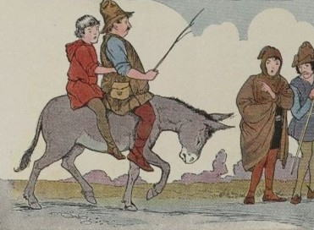 |  |  |  |  | PPT  A whiteboard  A scheme of writing a postcard.
Ending the lesson  6 min. | Students express their attitude to the lesson and give self-assessment using the method: “Six thinking hats”:  - Green: How can you use today's learning in different subjects?  - Red: How do you feel about your work today?  - White: What have you leant today?  - Black: What were the weaknesses of your work?  - Blue: How much progress have you made in this lesson? (Now I can, I still need to work on, I've improved in, Today I learnt... )  Yellow: What did you like about today's lesson?  Slide (Homework)  Slide "Six thinking hats"
Differentiation –  how do you plan to give more support? How do you plan to challenge the more  able learners? |  |  | Assessment –  how are you planning to check learners’learning? |  |  |  | Critical thinking
Differentiation can be achieved through the selection of activities, identification of learning outcomes for a certain student, provision of individual support to learners, selection of learning materials and resources based on the individual abilities of learners. |  |  | Assessment criteria:  Identify the main idea in extended talks with little support.  Descriptor:  A learner:  - selects an appropriate answer.  - completes the task. |  |  |  | Students think critically, exploring, developing, evaluating and making choices about their own and others’ ideas

Lesson 14 Conjunction – жалғаулық |  |  |  | School:
Date: |  |  |  | Teacher’s name:
Class: |  |  |  | Number present: | Number absent:
Lessontitle |  |  |  | Conjunction – жалғаулық
Learning objectives(s) that this lesson is contributing to |  | UE3 use a growing variety of adjectives and regular and irregular comparative and superlative adjectives on a limited range of familiar general and curricular topics  UE9 use simple present and simple past regular and irregular forms to describe routines, habits and states on a limited range of familiar general and curricular topics  C1 use speaking and listening skills to solve problems creatively and cooperatively in groups  C5 use feedback to set personal learning objectives
Lesson objectives |  | All students will be able to:  Revise taught material  Most students will be able to:  Demonstrate learned vocabulary about helping and heroes with sure  Some students will be able to:  - Use taught vocabulary and grammar with accuracy
Value links |  | Cooperation, respect each other's opinion, functional literacy.
Crosscurricular links |  | Social Science, Psychology, Geography,Information Technology.
Previous learning |  | Talking about trips.
Useof ICT |  | Smart board for showing a presentation, getting additional information,playing the audio files.
Intercultural awareness |  | Discuss experiences in different countries.
Health and Safety |  | Breaks and physical activities used. Everyday classroom precautions will ensure that safety measures are provided to prevent the exposure of electrical power cords.
Planned timings | Planned activities |  |  |  |  | Resources
Beginning of the lesson  7 min. | The lesson greeting.  Teacher organizes a warm-up activity for a start of the lesson. Learners look at the names of different places hung on the classroom walls. They choose the place they like and go to that place. In small groups they try to give arguments and explain why the place they have chosen is the best.  Learners are informed about the lesson objectives.  Warm up.Free talk about the best places in their city or town. The teacher asks Sts. in pairs make a list of places they are going to show to the tourists. |  |  |  |  | Pictures  PPT  Writing  Worksheet  Slide (useful phrases).
Main  Activities  15 min.  12 min | Main part  Conjunction – жалғаулық  Conjunction (жалғаулық) – көмекші сөз табы, сөйлемдегі сөздерді және сөйлемдерді бір-бірімен байланыстыру қызметін атқарады.  Құрамы жағынан жалғаулықтар:  1. Дара, біртүбірден тұратын:  and – және or – немесе but – бірақ if – егер  Task. Fill in the blanks.  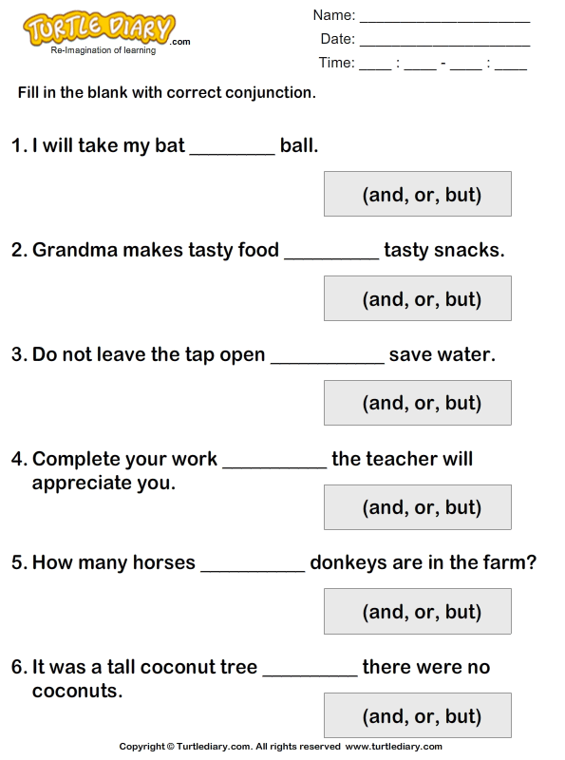 |  |  |  |  | PPT  A whiteboard  A scheme of writing a postcard.
Ending the lesson  6 min. | Students express their attitude to the lesson and give self-assessment using the method:  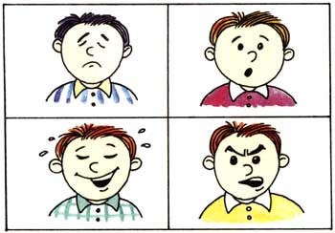
Differentiation –  how do you plan to give more support? How do you plan to challenge the more  able learners? |  |  | Assessment –  how are you planning to check learners’learning? |  |  |  | Critical thinking
Differentiation can be achieved through the selection of activities, identification of learning outcomes for a certain student, provision of individual support to learners, selection of learning materials and resources based on the individual abilities of learners. |  |  | Assessment criteria:  Identify the main idea in extended talks with little support.  Descriptor:  A learner:  - selects an appropriate answer.  - completes the task. |  |  |  | Students think critically, exploring, developing, evaluating and making choices about their own and others’ ideas

Lesson 15 Some және any |  |  |  | School:
Date: |  |  |  | Teacher’s name:
Class: |  |  |  | Number present: | Number absent:
Lessontitle |  |  |  | Some және any
Learning objectives(s) that this lesson is contributing to |  | UE3 use a growing variety of adjectives and regular and irregular comparative and superlative adjectives on a limited range of familiar general and curricular topics  UE9 use simple present and simple past regular and irregular forms to describe routines, habits and states on a limited range of familiar general and curricular topics  C1 use speaking and listening skills to solve problems creatively and cooperatively in groups  C5 use feedback to set personal learning objectives
Lesson objectives |  | All students will be able to:  Revise taught material  Most students will be able to:  Demonstrate learned vocabulary about helping and heroes with sure  Some students will be able to:  - Use taught vocabulary and grammar with accuracy
Value links |  | Cooperation, respect each other's opinion, functional literacy.
Crosscurricular links |  | Social Science, Psychology, Geography,Information Technology.
Previous learning |  | Talking about trips.
Useof ICT |  | Smart board for showing a presentation, getting additional information,playing the audio files.
Intercultural awareness |  | Discuss experiences in different countries.
Health and Safety |  | Breaks and physical activities used. Everyday classroom precautions will ensure that safety measures are provided to prevent the exposure of electrical power cords.
Planned timings | Planned activities |  |  |  |  | Resources
Beginning of the lesson  7 min. | The lesson greeting.  Teacher organizes a warm-up activity for a start of the lesson. Learners look at the names of different places hung on the classroom walls. They choose the place they like and go to that place. In small groups they try to give arguments and explain why the place they have chosen is the best.  Learners are informed about the lesson objectives.  Warm up.Free talk about the best places in their city or town. The teacher asks Sts. in pairs make a list of places they are going to show to the tourists. |  |  |  |  | Pictures  PPT  Writing  Worksheet  Slide (useful phrases).
Main  Activities  15 min.  12 min | Main part  Some және any  Some есімдігі болымды сөйлемдерде, ал any есімдігі болымсыз, шартты және сұраулы сөйлемдерде қолданылады.Бұлар “бірнеше”, “кез-келген”, “қандайда бір” деген мағыналарды береді.  Мысалы:  Sara has some difficult questions — Сараның бірнеше қиын сұрақтары бар.  Do you have any questions — (Қандайдабір) сұрақтарыңыз бар ма?  My brother don’t like any meat — Менің ағам ешқандай етті ұнатпайды.  Task.Some or any  ______Pens  ______Sugar  ______Water  ______ Glasses |  |  |  |  | PPT  A whiteboard  A scheme of writing a postcard.
Ending the lesson  6 min. | Students express their attitude to the lesson and give self-assessment using the method: “Six thinking hats”:  - Green: How can you use today's learning in different subjects?  - Red: How do you feel about your work today?  - White: What have you leant today?  - Black: What were the weaknesses of your work?  - Blue: How much progress have you made in this lesson? (Now I can, I still need to work on, I've improved in, Today I learnt... )  Yellow: What did you like about today's lesson?  Slide (Homework)  Slide "Six thinking hats"
Differentiation –  how do you plan to give more support? How do you plan to challenge the more  able learners? |  |  | Assessment –  how are you planning to check learners’learning? |  |  |  | Critical thinking
Differentiation can be achieved through the selection of activities, identification of learning outcomes for a certain student, provision of individual support to learners, selection of learning materials and resources based on the individual abilities of learners. |  |  | Assessment criteria:  Identify the main idea in extended talks with little support.  Descriptor:  A learner:  - selects an appropriate answer.  - completes the task. |  |  |  | Students think critically, exploring, developing, evaluating and making choices about their own and others’ ideas

Lesson 16 Many мен much |  |  |  | School:
Date: |  |  |  | Teacher’s name:
Learning objectives(s) that this lesson is contributing to |  | UE3 use a growing variety of adjectives and regular and irregular comparative and superlative adjectives on a limited range of familiar general and curricular topics  UE9 use simple present and simple past regular and irregular forms to describe routines, habits and states on a limited range of familiar general and curricular topics  C1 use speaking and listening skills to solve problems creatively and cooperatively in groups  C5 use feedback to set personal learning objectives
Lesson objectives |  | All students will be able to:  Revise taught material  Most students will be able to:  Demonstrate learned vocabulary about helping and heroes with sure  Some students will be able to:  - Use taught vocabulary and grammar with accuracy
Value links |  | Cooperation, respect each other's opinion, functional literacy.
Crosscurricular links |  | Social Science, Psychology, Geography,Information Technology.
Previous learning |  | Talking about trips.
Useof ICT |  | Smart board for showing a presentation, getting additional information,playing the audio files.
Intercultural awareness |  | Discuss experiences in different countries.
Health and Safety |  | Breaks and physical activities used. Everyday classroom precautions will ensure that safety measures are provided to prevent the exposure of electrical power cords.
Planned timings | Planned activities |  |  |  | Resources
Beginning of the lesson  7 min. | The lesson greeting.  Teacher organizes a warm-up activity for a start of the lesson. Learners look at the names of different places hung on the classroom walls. They choose the place they like and go to that place. In small groups they try to give arguments and explain why the place they have chosen is the best.  Learners are informed about the lesson objectives.  Warm up.Free talk about the best places in their city or town. The teacher asks Sts. in pairs make a list of places they are going to show to the tourists. |  |  |  | Pictures  PPT  Writing  Worksheet  Slide (useful phrases).
Main  Activities  15 min.  12 min | Main part  Many мен much  Many мен much — мөлшерді білдіретін сөздер (ағылшынша: мөлшер nесімдіктері – Quantitative pronouns).  Екеуінің де мағынасы бір, бірақ қолданылуы екі түрлі. Мысалы, заттардың арасында саналатын және саналмайтын заттар бар. Many саналатын заттардың мөлшері (саны) көп екендігін білдірсе (көпше түрдегі зат есімдермен бірге жазылады), much саналмайтын заттардың мөлшері көп екендігін білдіреді.  Many  My sister has many books — Меніңәпкемдекөпкітапбар.  My neighbor has many friends — Меніңкөршімніңкөпдосыбар.  much  My sister has much work to do — Меніңәпкемкөпжұмысістеукерек.  There is much money — Көпақшабар.  Task. Complete  Many Much |  |  |  | PPT  A whiteboard  A scheme of writing a postcard.
Ending the lesson  6 min. | Students express their attitude to the lesson and give self-assessment using the method: “Six thinking hats”:  - Green: How can you use today's learning in different subjects?  - Red: How do you feel about your work today?  - White: What have you leant today?  - Black: What were the weaknesses of your work?  - Blue: How much progress have you made in this lesson? (Now I can, I still need to work on, I've improved in, Today I learnt... )  Yellow: What did you like about today's lesson?  Slide (Homework)  Slide "Six thinking hats"
Differentiation –  how do you plan to give more support? How do you plan to challenge the more  able learners? |  |  | Assessment –  how are you planning to check learners’learning? |  |  | Critical thinking
Differentiation can be achieved through the selection of activities, identification of learning outcomes for a certain student, provision of individual support to learners, selection of learning materials and resources based on the individual abilities of learners. |  |  | Assessment criteria:  Identify the main idea in extended talks with little support.  Descriptor:  A learner:  - selects an appropriate answer.  - completes the task. |  |  | Students think critically, exploring, developing, evaluating and making choices about their own and others’ ideas

Lesson 17 Few and little |  |  |  | School:
Date: |  |  |  | Teacher’s name:
Class: |  |  |  | Number present: | Number absent:
Lessontitle |  |  |  | Few and little
Learning objectives(s) that this lesson is contributing to |  | UE3 use a growing variety of adjectives and regular and irregular comparative and superlative adjectives on a limited range of familiar general and curricular topics  UE9 use simple present and simple past regular and irregular forms to describe routines, habits and states on a limited range of familiar general and curricular topics  C1 use speaking and listening skills to solve problems creatively and cooperatively in groups  C5 use feedback to set personal learning objectives
Lesson objectives |  | All students will be able to:  Revise taught material  Most students will be able to:  Demonstrate learned vocabulary about helping and heroes with sure  Some students will be able to:  - Use taught vocabulary and grammar with accuracy
Value links |  | Cooperation, respect each other's opinion, functional literacy.
Crosscurricular links |  | Social Science, Psychology, Geography,Information Technology.
Previous learning |  | Talking about trips.
Useof ICT |  | Smart board for showing a presentation, getting additional information,playing the audio files.
Intercultural awareness |  | Discuss experiences in different countries.
Health and Safety |  | Breaks and physical activities used. Everyday classroom precautions will ensure that safety measures are provided to prevent the exposure of electrical power cords.
Planned timings | Planned activities |  |  |  |  | Resources
Beginning of the lesson  7 min. | The lesson greeting.  Teacher organizes a warm-up activity for a start of the lesson. Learners look at the names of different places hung on the classroom walls. They choose the place they like and go to that place. In small groups they try to give arguments and explain why the place they have chosen is the best.  Learners are informed about the lesson objectives.  Warm up.Free talk about the best places in their city or town. The teacher asks Sts. in pairs make a list of places they are going to show to the tourists. |  |  |  |  | Pictures  PPT  Writing  Worksheet  Slide (useful phrases).
Main  Activities  15 min.  12 min | Main part  Few and little  few (аз) – саналатын зат есімнің алдында қолданылады..  little (аз) – саналмайтын зат есімнің алдында қолданылады.  I have few books. (Менде аз кітап бар.)  I have little time. (менде уақыт аз)  Task. Make more words using few, little  ex: There are few apples on the table.  There is a little milk in the bottle.  Task. Complete  Few Little |  |  |  |  | PPT  A whiteboard  A scheme of writing a postcard.
Ending the lesson  6 min. | Students express their attitude to the lesson and give self-assessment using the method:  
Differentiation –  how do you plan to give more support? How do you plan to challenge the more  able learners? |  |  | Assessment –  how are you planning to check learners’learning? |  |  |  | Critical thinking
Differentiation can be achieved through the selection of activities, identification of learning outcomes for a certain student, provision of individual support to learners, selection of learning materials and resources based on the individual abilities of learners. |  |  | Assessment criteria:  Identify the main idea in extended talks with little support.  Descriptor:  A learner:  - selects an appropriate answer.  - completes the task. |  |  |  | Students think critically, exploring, developing, evaluating and making choices about their own and others’ ideas

Lesson 18 A lot of = Lots of |  |  |  | School:
Date: |  |  |  | Teacher’s name:
Class: |  |  |  | Number present: | Number absent:
Lesson title |  |  |  | A lot of = Lots of
Learning objectives(s) that this lesson is contributing to |  | UE3 use a growing variety of adjectives and regular and irregular comparative and superlative adjectives on a limited range of familiar general and curricular topics  UE9 use simple present and simple past regular and irregular forms to describe routines, habits and states on a limited range of familiar general and curricular topics  C1 use speaking and listening skills to solve problems creatively and cooperatively in groups  C5 use feedback to set personal learning objectives
Lesson objectives |  | All students will be able to:  Revise taught material  Most students will be able to:  Demonstrate learned vocabulary about helping and heroes with sure  Some students will be able to:  - Use taught vocabulary and grammar with accuracy
Value links |  | Cooperation, respect each other's opinion, functional literacy.
Crosscurricular links |  | Social Science, Psychology, Geography,Information Technology.
Previous learning |  | Talking about trips.
Useof ICT |  | Smart board for showing a presentation, getting additional information,playing the audio files.
Intercultural awareness |  | Discuss experiences in different countries.
Health and Safety |  | Breaks and physical activities used. Everyday classroom precautions will ensure that safety measures are provided to prevent the exposure of electrical power cords.
Planned timings | Planned activities |  |  |  |  | Resources
Beginning of the lesson  7 min. | The lesson greeting.  Teacher organizes a warm-up activity for a start of the lesson. Learners look at the names of different places hung on the classroom walls. They choose the place they like and go to that place. In small groups they try to give arguments and explain why the place they have chosen is the best.  Learners are informed about the lesson objectives.  Warm up.Free talk about the best places in their city or town. The teacher asks Sts. in pairs make a list of places they are going to show to the tourists. |  |  |  |  | Pictures  PPT  Writing  Worksheet  Slide (useful phrases).
Main  Activities  15 min.  12 min | Main part  A lot of = Lots of  Бір-біріне өте ұқсас үш тіркес бар. Олардың біреуінің мағынасы өз алдына бір бөлек болса, екеуінің мағынасы бірдей.  lot — көп. A lot of = Lots of — мөлшерді білдіретін сөздер (ағылшынша: мөлшер есімдіктері – Quantitative pronouns).  A lot of және Lots of тіркестерінің мағыналары бірдей. Олар бір заттың немесе адамдардың мөлшерінің немесе санының көп екендігін білдіреді.Үнемі көпше түрдегі саналатын зат есімдердің және жекешетүрдегі саналмайтын зат есімдердің алдында тұрады. Мысалы:  A lot of students do not like mathematics.  Lots of students do not like mathematics.  Жоғарыдағы екі сөйлемніңде мағынасы бірдей: Студенттердің көбісі (Көптегенстуденттер) математиканыұнатпайды.  A lot сөзінің сөзбе-сөз мағынасы «көп» дегенді білдіргенімен қолданылу аясы, яғни, сөйлемдегі мағынасы мүлдем бөлек. Ол adverb (үстеу) ретінде қолданылады. Мағынасы: өте көп, көп, өте жиі, жиі, (кейде әлдеқайда дегенді де білдіреді). A lot ешқашан зат есімнің алдында келмейді, көбінде сөйлемнің соңында келеді.  Мысалы:  Students play football a lot — Студенттер футболды өте көп (жиі) ойнайды.  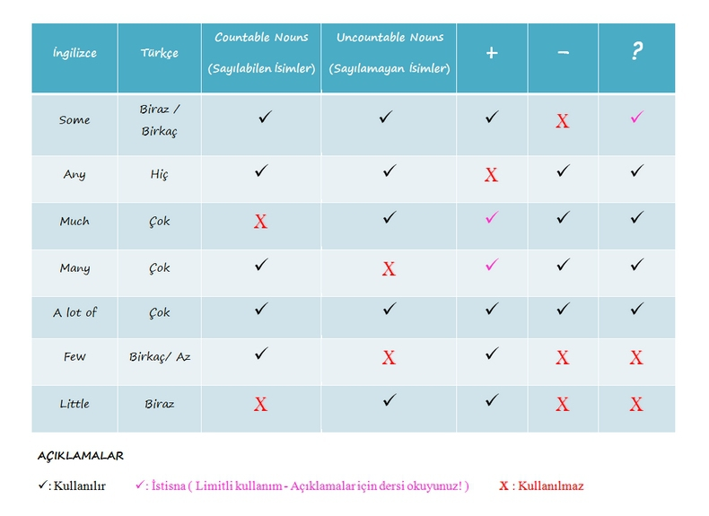 |  |  |  |  | PPT  A whiteboard  A scheme of writing a postcard.
Ending the lesson  6 min. | Students express their attitude to the lesson and give self-assessment using the method: “Six thinking hats”:  - Green: How can you use today's learning in different subjects?  - Red: How do you feel about your work today?  - White: What have you leant today?  - Black: What were the weaknesses of your work?  - Blue: How much progress have you made in this lesson? (Now I can, I still need to work on, I've improved in, Today I learnt... )  Yellow: What did you like about today's lesson?  Slide (Homework)  Slide "Six thinking hats"
Differentiation –  how do you plan to give more support? How do you plan to challenge the more  able learners? |  |  | Assessment –  how are you planning to check learners’learning? |  |  |  | Critical thinking
Differentiation can be achieved through the selection of activities, identification of learning outcomes for a certain student, provision of individual support to learners, selection of learning materials and resources based on the individual abilities of learners. |  |  | Assessment criteria:  Identify the main idea in extended talks with little support.  Descriptor:  A learner:  - selects an appropriate answer.  - completes the task. |  |  |  | Students think critically, exploring, developing, evaluating and making choices about their own and others’ ideas

Lesson 19 Questions |  |  |  | School:
Date: |  |  |  | Teacher’s name:
Class: |  |  |  | Number present: | Number absent:
Lessontitle |  |  |  | Questions
Learning objectives(s) that this lesson is contributing to |  | UE3 use a growing variety of adjectives and regular and irregular comparative and superlative adjectives on a limited range of familiar general and curricular topics  UE9 use simple present and simple past regular and irregular forms to describe routines, habits and states on a limited range of familiar general and curricular topics  C1 use speaking and listening skills to solve problems creatively and cooperatively in groups  C5 use feedback to set personal learning objectives
Lesson objectives |  | All students will be able to:  Revise taught material  Most students will be able to:  Demonstrate learned vocabulary about helping and heroes with sure  Some students will be able to:  - Use taught vocabulary and grammar with accuracy
Value links |  | Cooperation, respect each other's opinion, functional literacy.
Crosscurricular links |  | Social Science, Psychology, Geography,Information Technology.
Previous learning |  | Talking about trips.
Useof ICT |  | Smart board for showing a presentation, getting additional information,playing the audio files.
Intercultural awareness |  | Discuss experiences in different countries.
Health and Safety |  | Breaks and physical activities used. Everyday classroom precautions will ensure that safety measures are provided to prevent the exposure of electrical power cords.
Planned timings | Planned activities |  |  |  |  | Resources
Beginning of the lesson  7 min. | The lesson greeting.  Teacher organizes a warm-up activity for a start of the lesson. Learners look at the names of different places hung on the classroom walls. They choose the place they like and go to that place. In small groups they try to give arguments and explain why the place they have chosen is the best.  Learners are informed about the lesson objectives.  Warm up.Free talk about the best places in their city or town. The teacher asks Sts. in pairs make a list of places they are going to show to the tourists. |  |  |  |  | Pictures  PPT  Writing  Worksheet  Slide (useful phrases).
Main  Activities  15 min.  12 min | Main part  Questions  - Who (asks about a person)—noun  - What (asks about a thing, sometimes a quality)—noun/adj  - When (asks about a time)—adv  - Where (asks about a place)—adv  - Why (asks about a reason)—adv  - How (asks about a method or quality)—adv  Examples:  - Who cooks the most in your family?  - (My mom cooks the most in my family.)  - What’s going on?  - Nothing’s going on.  - When are you walking over to the party?  - I’m walking over to the party in an hour.  - Where on the map does this train go?  - This train goes to Wilmington on the map. |  |  |  |  | PPT  A whiteboard  A scheme of writing a postcard.
Ending the lesson  6 min. | Students express their attitude to the lesson and give self-assessment using the method: “Six thinking hats”:  - Green: How can you use today's learning in different subjects?  - Red: How do you feel about your work today?  - White: What have you leant today?  - Black: What were the weaknesses of your work?  - Blue: How much progress have you made in this lesson? (Now I can, I still need to work on, I've improved in, Today I learnt... )  Yellow: What did you like about today's lesson?  Slide (Homework)  Slide "Six thinking hats"
Differentiation –  how do you plan to give more support? How do you plan to challenge the more  able learners? |  |  | Assessment –  how are you planning to check learners’learning? |  |  |  | Critical thinking
Differentiation can be achieved through the selection of activities, identification of learning outcomes for a certain student, provision of individual support to learners, selection of learning materials and resources based on the individual abilities of learners. |  |  | Assessment criteria:  Identify the main idea in extended talks with little support.  Descriptor:  A learner:  - selects an appropriate answer.  - completes the task. |  |  |  | Students think critically, exploring, developing, evaluating and making choices about their own and others’ ideas

Lesson 20 Present Indefinite Tense |  |  |  | School:
Date: |  |  |  | Teacher’s name:
Class: |  |  |  | Number present: | Number absent:
Lesson title |  |  |  | Present Indefinite Tense
Learning objectives(s) that this lesson is contributing to |  | UE3 use a growing variety of adjectives and regular and irregular comparative and superlative adjectives on a limited range of familiar general and curricular topics  UE9 use simple present and simple past regular and irregular forms to describe routines, habits and states on a limited range of familiar general and curricular topics  C1 use speaking and listening skills to solve problems creatively and cooperatively in groups  C5 use feedback to set personal learning objectives
Lesson objectives |  | All students will be able to:  Revise taught material  Most students will be able to:  Demonstrate learned vocabulary about helping and heroes with sure  Some students will be able to:  - Use taught vocabulary and grammar with accuracy
Value links |  | Cooperation, respect each other's opinion, functional literacy.
Crosscurricular links |  | Social Science, Psychology, Geography,Information Technology.
Previous learning |  | Talking about trips.
Useof ICT |  | Smart board for showing a presentation, getting additional information,playing the audio files.
Intercultural awareness |  | Discuss experiences in different countries.
Health and Safety |  | Breaks and physical activities used. Everyday classroom precautions will ensure that safety measures are provided to prevent the exposure of electrical power cords.
Planned timings | Planned activities |  |  |  |  | Resources
Beginning of the lesson  7 min. | The lesson greeting.  Teacher organizes a warm-up activity for a start of the lesson. Learners look at the names of different places hung on the classroom walls. They choose the place they like and go to that place. In small groups they try to give arguments and explain why the place they have chosen is the best.  Learners are informed about the lesson objectives.  Warm up.Free talk about the best places in their city or town. The teacher asks Sts. in pairs make a list of places they are going to show to the tourists. |  |  |  |  | Pictures  PPT  Writing  Worksheet  Slide (useful phrases).
Main  Activities  15 min.  12 min | Main part  Present Indefinite Tense  Бұндай сөйлемдерде баяндауыш – 1 формадағы мағыналы етістік (Infinitive, белгіленуі – V1, жақ бойынша өзгереді). Баяндауыш формуласы: V1 Жиі қайталанып отыратын қарапайым іс-әрекетті жеткізу үшін қолданылады.always (әрқашан), often (жиі), usually (әдетте), sometimes (кейде), never (еш уақытта), every (әр) т.б. үстеулермен қолданылады.  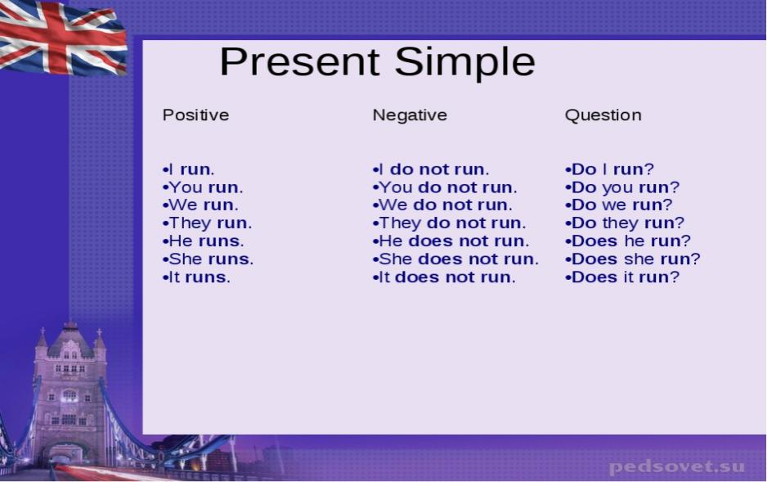  Task . Using these expressions write what you usually do. |  |  |  |  | PPT  A whiteboard  A scheme of writing a postcard.
Ending the lesson  6 min. | Students express their attitude to the lesson and give self-assessment using the method: “Six thinking hats”:  - Green: How can you use today's learning in different subjects?  - Red: How do you feel about your work today?  - White: What have you leant today?  - Black: What were the weaknesses of your work?  - Blue: How much progress have you made in this lesson? (Now I can, I still need to work on, I've improved in, Today I learnt... )  Yellow: What did you like about today's lesson?  Slide (Homework)  Slide "Six thinking hats"
Differentiation –  how do you plan to give more support? How do you plan to challenge the more  able learners? |  |  | Assessment –  how are you planning to check learners’learning? |  |  |  | Critical thinking
Differentiation can be achieved through the selection of activities, identification of learning outcomes for a certain student, provision of individual support to learners, selection of learning materials and resources based on the individual abilities of learners. |  |  | Assessment criteria:  Identify the main idea in extended talks with little support.  Descriptor:  A learner:  - selects an appropriate answer.  - completes the task. |  |  |  | Students think critically, exploring, developing, evaluating and making choices about their own and others’ ideas

Lesson 21 Past Indefinite Tense |  |  |  | School:
Lessontitle |  |  |  | Past Indefinite Tense
Learning objectives(s) that this lesson is contributing to |  | UE3 use a growing variety of adjectives and regular and irregular comparative and superlative adjectives on a limited range of familiar general and curricular topics  UE9 use simple present and simple past regular and irregular forms to describe routines, habits and states on a limited range of familiar general and curricular topics  C1 use speaking and listening skills to solve problems creatively and cooperatively in groups  C5 use feedback to set personal learning objectives
Lesson objectives |  | All students will be able to:  Revise taught material  Most students will be able to:  Demonstrate learned vocabulary about helping and heroes with sure  Some students will be able to:  - Use taught vocabulary and grammar with accuracy
Value links |  | Cooperation, respect each other's opinion, functional literacy.
Crosscurricular links |  | Social Science, Psychology, Geography,Information Technology.
Previous learning |  | Talking about trips.
Useof ICT |  | Smart board for showing a presentation, getting additional information,playing the audio files.
Intercultural awareness |  | Discuss experiences in different countries.
Health and Safety |  | Breaks and physical activities used. Everyday classroom precautions will ensure that safety measures are provided to prevent the exposure of electrical power cords.
Planned timings | Planned activities |  |  |  | Resources
Beginning of the lesson  7 min. | The lesson greeting.  Teacher organizes a warm-up activity for a start of the lesson. Learners look at the names of different places hung on the classroom walls. They choose the place they like and go to that place. In small groups they try to give arguments and explain why the place they have chosen is the best.  Learners are informed about the lesson objectives.  Warm up.Free talk about the best places in their city or town. The teacher asks Sts. in pairs make a list of places they are going to show to the tourists. |  |  |  | Pictures  PPT  Writing  Worksheet  Slide (useful phrases).
Main  Activities  15 min.  12 min | Main part  Past Indefinite Tense  Бұндай сөйлемдерде баяндауыш – 2 формадағы мағыналы етістік (Past Indefinite, белгіленуі – V2, жақ бойынша өзгермейді).  Өткен шақта болып кеткен іс-әрекетті білдіру үшін қолданылады.  during (бойы), an hour ago (бір сағат бұрын), yesterday (кеше), last night (өткен түнде), two month ago (екі ай бұрын), last year (өткен жылы) және т.б (яғни іс-әрекеттің болған уақыты беріледі).  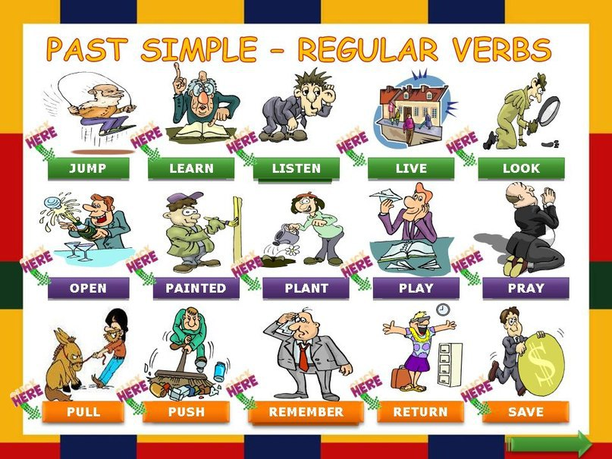  I worked in Moscow last year. – Мен өткен жылы Мәскеуде жұмыс істедім.  The ship moved slowly. – Кеме ақырын қозғалды.  He opened the box yesterday. – Ол қорапты кеше ашты.  Task. Write the verbs in the Past Tense  ask  walk  live  like  play  visit  go  read |  |  |  | PPT  A whiteboard  A scheme of writing a postcard.
Ending the lesson  6 min. | Students express their attitude to the lesson and give self-assessment using the method: “Six thinking hats”:  - Green: How can you use today's learning in different subjects?  - Red: How do you feel about your work today?  - White: What have you leant today?  - Black: What were the weaknesses of your work?  - Blue: How much progress have you made in this lesson? (Now I can, I still need to work on, I've improved in, Today I learnt... )  Yellow: What did you like about today's lesson?  Slide (Homework)  Slide "Six thinking hats"
Differentiation –  how do you plan to give more support? How do you plan to challenge the more  able learners? |  |  | Assessment –  how are you planning to check learners’learning? |  |  | Critical thinking
Differentiation can be achieved through the selection of activities, identification of learning outcomes for a certain student, provision of individual support to learners, selection of learning materials and resources based on the individual abilities of learners. |  |  | Assessment criteria:  Identify the main idea in extended talks with little support.  Descriptor:  A learner:  - selects an appropriate answer.  - completes the task. |  |  | Students think critically, exploring, developing, evaluating and making choices about their own and others’ ideas

Lesson 22 Future Indefinite Tense |  |  |  | School:
Date: |  |  |  | Teacher’s name:
Class: |  |  |  | Number present: | Number absent:
Lessontitle |  |  |  | Future Indefinite Tense
Learning objectives(s) that this lesson is contributing to |  | UE3 use a growing variety of adjectives and regular and irregular comparative and superlative adjectives on a limited range of familiar general and curricular topics  UE9 use simple present and simple past regular and irregular forms to describe routines, habits and states on a limited range of familiar general and curricular topics  C1 use speaking and listening skills to solve problems creatively and cooperatively in groups  C5 use feedback to set personal learning objectives
Lesson objectives |  | All students will be able to:  Revise taught material  Most students will be able to:  Demonstrate learned vocabulary about helping and heroes with sure  Some students will be able to:  - Use taught vocabulary and grammar with accuracy
Value links |  | Cooperation, respect each other's opinion, functional literacy.
Crosscurricular links |  | Social Science, Psychology, Geography,Information Technology.
Previous learning |  | Talking about trips.
Useof ICT |  | Smart board for showing a presentation, getting additional information,playing the audio files.
Intercultural awareness |  | Discuss experiences in different countries.
Health and Safety |  | Breaks and physical activities used. Everyday classroom precautions will ensure that safety measures are provided to prevent the exposure of electrical power cords.
Planned timings | Planned activities |  |  |  |  | Resources
Beginning of the lesson  7 min. | The lesson greeting.  Teacher organizes a warm-up activity for a start of the lesson. Learners look at the names of different places hung on the classroom walls. They choose the place they like and go to that place. In small groups they try to give arguments and explain why the place they have chosen is the best.  Learners are informed about the lesson objectives.  Warm up.Free talk about the best places in their city or town. The teacher asks Sts. in pairs make a list of places they are going to show to the tourists. |  |  |  |  | Pictures  PPT  Writing  Worksheet  Slide (useful phrases).
Main  Activities  15 min.  12 min | Main part  Future Indefinite Tense  Бұндай сөйлемдердегі баяндауыш: shall/will көмекші етістігі  Мағыналы етістік 1 (Infinitive – V1).  Бұл шақ формасында жаққа байланысты shall немесе will қолданылады.  shall көмекші етістігі бірінші жақта, will – екінші, үшінші жақтарда қолданылады.  Қазіргі ағылшын тілінде will бірінші жақта да қолданылады.  Баяндауыш формуласы: shall/will + V1  Болашақта болатын іс-әрекеттерді білдіру үшін қолданылады.  Future Indefinite шағындағы етістік уақыттың нақты көрсеткішімен (күн, сағат), сонымен қатар tomorrow ертең, the day after tomorrow бүрсігүні, next week (month, year) келесі аптада (келесі айда, жылда), in an hour бір сағаттан кейін, in a day (a week, a month, a year) бір күннен кейін (бір аптадан, айдан, жылдан кейін) деген сияқты сөздермен қолданылады.  I shall help you. – Мен саған көмектесемін.  They will go to France next spring. – Олар келесі көктемде Францияға барады.  He will be home tonight. – Ол кешке үйде болады.  Task Write in l’ll, we'll, he'll, she'll, they'll, it’ll.  Task. Complete the sentences  I'd like to see animals. I think _______ go to the zoo today.  Wendy likes dinosaurs. I think _______ go to the Natural History Museum.  We like dancing. I think _______ go to the disco.  My parents want to buy presents. I think_______ go to the gift shop. '  Jim likes walking. I think_______ go to the park.  Put on your scarf and hat. I think _______ be cold today.  I want to watch a cartoon. I think _______ go to the cinema tomorrow.  Mike is ill. I don't think _______ go for a walk with him. |  |  |  |  | PPT  A whiteboard  A scheme of writing a postcard.
Ending the lesson  6 min. | Students express their attitude to the lesson and give self-assessment using the method:  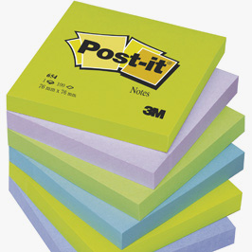
Differentiation –  how do you plan to give more support? How do you plan to challenge the more  able learners? |  |  | Assessment –  how are you planning to check learners’learning? |  |  |  | Critical thinking
Differentiation can be achieved through the selection of activities, identification of learning outcomes for a certain student, provision of individual support to learners, selection of learning materials and resources based on the individual abilities of learners. |  |  | Assessment criteria:  Identify the main idea in extended talks with little support.  Descriptor:  A learner:  - selects an appropriate answer.  - completes the task. |  |  |  | Students think critically, exploring, developing, evaluating and making choices about their own and others’ ideas

Lesson 23 Present Continuous Tense |  |  |  | School:
Date: |  |  |  | Teacher’s name:
Class: |  |  |  | Number present: | Number absent:
Lessontitle |  |  |  | Present Continuous Tense
Learning objectives(s) that this lesson is contributing to |  | UE3 use a growing variety of adjectives and regular and irregular comparative and superlative adjectives on a limited range of familiar general and curricular topics  UE9 use simple present and simple past regular and irregular forms to describe routines, habits and states on a limited range of familiar general and curricular topics  C1 use speaking and listening skills to solve problems creatively and cooperatively in groups  C5 use feedback to set personal learning objectives
Lesson objectives |  | All students will be able to:  Revise taught material  Most students will be able to:  Demonstrate learned vocabulary about helping and heroes with sure  Some students will be able to:  - Use taught vocabulary and grammar with accuracy
Value links |  | Cooperation, respect each other's opinion, functional literacy.
Crosscurricular links |  | Social Science, Psychology, Geography,Information Technology.
Previous learning |  | Talking about trips.
Useof ICT |  | Smart board for showing a presentation, getting additional information,playing the audio files.
Intercultural awareness |  | Discuss experiences in different countries.
Health and Safety |  | Breaks and physical activities used. Everyday classroom precautions will ensure that safety measures are provided to prevent the exposure of electrical power cords.
Planned timings | Planned activities |  |  |  |  | Resources
Beginning of the lesson  7 min. | The lesson greeting.  Teacher organizes a warm-up activity for a start of the lesson. Learners look at the names of different places hung on the classroom walls. They choose the place they like and go to that place. In small groups they try to give arguments and explain why the place they have chosen is the best.  Learners are informed about the lesson objectives.  Warm up.Free talk about the best places in their city or town. The teacher asks Sts. in pairs make a list of places they are going to show to the tourists. |  |  |  |  | Pictures  PPT  Writing  Worksheet  Slide (useful phrases).
Main  Activities  15 min.  12 min | Main part  Present Continuous Tense  Осы шақтағы (Present Indefinite) be көмекші етістігімен мағыналы етістіктің осы шақтағы есімшесі (Present Participle – V4(PI)) көмегімен жасалады.  Баяндауыштың бірінші етістігі болып табылатын be көмекші етістігі бастауышпен жақ бойынша байланысады.  Дәл қазіргі уақытта болып жатқан жалғаспалы іс-әрекетті білдіру үшін қолданылады. Бұл іс-әрекеттің бұрында басталып, қазіргі уақытқа дейін жалғасып жатқанын көрсетеді.  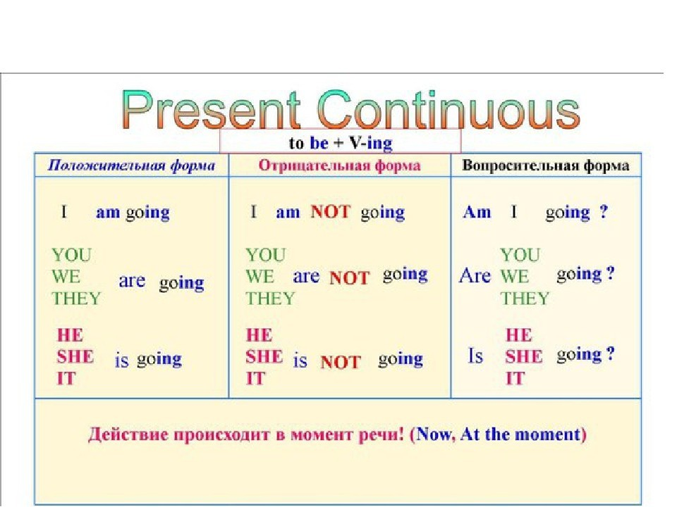  Write sentences in the Present Continuous Tense  1 I/play/tennis/with/my/friend/now.  2 We/walk/on/the/ beach/now.  3 They/have/a/great/time/at/the/camp/at/the/ moment.  4 Angela/paint/a/beautiful/picture/now.  5 Tina/ and/Pam/stay/in/a/five-star/hotel.  6 It/rain/outdoors/at/the/ moment.  7 Bobby/prepare/for/the/test/in/his/room.  8 The/ dog/bark/at/some/strangers.  9 The/water/in/the/kettle/boil.  10 Somebody/knock/at/the/door. |  |  |  |  | PPT  A whiteboard  A scheme of writing a postcard.
Ending the lesson  6 min. | Students express their attitude to the lesson and give self-assessment using the method: “Six thinking hats”:  - Green: How can you use today's learning in different subjects?  - Red: How do you feel about your work today?  - White: What have you leant today?  - Black: What were the weaknesses of your work?  - Blue: How much progress have you made in this lesson? (Now I can, I still need to work on, I've improved in, Today I learnt... )  Yellow: What did you like about today's lesson?  Slide (Homework)  Slide "Six thinking hats"
Differentiation –  how do you plan to give more support? How do you plan to challenge the more  able learners? |  |  | Assessment –  how are you planning to check learners’learning? |  |  |  | Critical thinking
Differentiation can be achieved through the selection of activities, identification of learning outcomes for a certain student, provision of individual support to learners, selection of learning materials and resources based on the individual abilities of learners. |  |  | Assessment criteria:  Identify the main idea in extended talks with little support.  Descriptor:  A learner:  - selects an appropriate answer.  - completes the task. |  |  |  | Students think critically, exploring, developing, evaluating and making choices about their own and others’ ideas

Lesson 24 Past Continuous Tense |  |  |  | School:
Date: |  |  |  | Teacher’s name:
Class: |  |  |  | Number present: | Number absent:
Lessontitle |  |  |  | Past Continuous Tense
Learning objectives(s) that this lesson is contributing to |  | UE3 use a growing variety of adjectives and regular and irregular comparative and superlative adjectives on a limited range of familiar general and curricular topics  UE9 use simple present and simple past regular and irregular forms to describe routines, habits and states on a limited range of familiar general and curricular topics  C1 use speaking and listening skills to solve problems creatively and cooperatively in groups  C5 use feedback to set personal learning objectives
Lesson objectives |  | All students will be able to:  Revise taught material  Most students will be able to:  Demonstrate learned vocabulary about helping and heroes with sure  Some students will be able to:  - Use taught vocabulary and grammar with accuracy
Value links |  | Cooperation, respect each other's opinion, functional literacy.
Crosscurricular links |  | Social Science, Psychology, Geography,Information Technology.
Previous learning |  | Talking about trips.
Useof ICT |  | Smart board for showing a presentation, getting additional information,playing the audio files.
Intercultural awareness |  | Discuss experiences in different countries.
Health and Safety |  | Breaks and physical activities used. Everyday classroom precautions will ensure that safety measures are provided to prevent the exposure of electrical power cords.
Planned timings | Planned activities |  |  |  |  | Resources
Beginning of the lesson  7 min. | The lesson greeting.  Teacher organizes a warm-up activity for a start of the lesson. Learners look at the names of different places hung on the classroom walls. They choose the place they like and go to that place. In small groups they try to give arguments and explain why the place they have chosen is the best.  Learners are informed about the lesson objectives.  Warm up.Free talk about the best places in their city or town. The teacher asks Sts. in pairs make a list of places they are going to show to the tourists. |  |  |  |  | Pictures  PPT  Writing  Worksheet  Slide (useful phrases).
Main  Activities  15 min.  12 min | Main part  Past Continuous Tense  Past Continuous шағы be көмекші етістігінің өткен шақ (Past Indefinite) формасы – was, were және мағыналы етістіктің 4 формасы – V4(PI) арқылы жасалады.Баяндауыштың бірінші етістігіболып табылатын be (was, were) көмекші етістігі бастауышпен жақ бойынша байланысады.Өткен шақтағы белгілі бір уақытта басталып, сол туралы айтқан кезде әліде жалғасып жатқан оқиғаны білдіреді.  I was working in my garden on Friday morning. – Жұма күні таңертеңмен бақта жұмыс істеп жаттым.  Бұл жағдайда Past Continuous Tense бағыныңқы құрмалас сөйлемде өткен шақтың бір түрімен қолданылады.  When I came in he was speaking to my friend. – Мен келген кезде ол менің досыммен сөйлесіп жатты.  Write in the Past Continuous Tense.  1.She (to write) a letter at 6 p.m last evening. 2.Her father (to go) to the art gallery when he (to meet) her mother. 3.At 8.20 yesterday morning my mother (to drive) me to the university. 4.They (to sit) at the café at that time. 5.She (to study) in the library when they suddenly called. |  |  |  |  | PPT  A whiteboard  A scheme of writing a postcard.
Ending the lesson  6 min. | Students express their attitude to the lesson and give self-assessment using the method: “Six thinking hats”:  - Green: How can you use today's learning in different subjects?  - Red: How do you feel about your work today?  - White: What have you leant today?  - Black: What were the weaknesses of your work?  - Blue: How much progress have you made in this lesson? (Now I can, I still need to work on, I've improved in, Today I learnt... )  Yellow: What did you like about today's lesson?  Slide (Homework)  Slide "Six thinking hats"
Differentiation –  how do you plan to give more support? How do you plan to challenge the more  able learners? |  |  | Assessment –  how are you planning to check learners’learning? |  |  |  | Critical thinking
Differentiation can be achieved through the selection of activities, identification of learning outcomes for a certain student, provision of individual support to learners, selection of learning materials and resources based on the individual abilities of learners. |  |  | Assessment criteria:  Identify the main idea in extended talks with little support.  Descriptor:  A learner:  - selects an appropriate answer.  - completes the task. |  |  |  | Students think critically, exploring, developing, evaluating and making choices about their own and others’ ideas

Lesson 25 Future Continuous Tense |  |  |  | School:
Lessontitle |  |  |  | Future Continuous Tense
Learning objectives(s) that this lesson is contributing to |  | UE3 use a growing variety of adjectives and regular and irregular comparative and superlative adjectives on a limited range of familiar general and curricular topics  UE9 use simple present and simple past regular and irregular forms to describe routines, habits and states on a limited range of familiar general and curricular topics  C1 use speaking and listening skills to solve problems creatively and cooperatively in groups  C5 use feedback to set personal learning objectives
Lesson objectives |  | All students will be able to:  Revise taught material  Most students will be able to:  Demonstrate learned vocabulary about helping and heroes with sure  Some students will be able to:  - Use taught vocabulary and grammar with accuracy
Value links |  | Cooperation, respect each other's opinion, functional literacy.
Crosscurricular links |  | Social Science, Psychology, Geography,Information Technology.
Previous learning |  | Talking about trips.
Useof ICT |  | Smart board for showing a presentation, getting additional information,playing the audio files.
Intercultural awareness |  | Discuss experiences in different countries.
Health and Safety |  | Breaks and physical activities used. Everyday classroom precautions will ensure that safety measures are provided to prevent the exposure of electrical power cords.
Planned timings | Planned activities |  |  |  | Resources
Beginning of the lesson  7 min. | The lesson greeting.  Teacher organizes a warm-up activity for a start of the lesson. Learners look at the names of different places hung on the classroom walls. They choose the place they like and go to that place. In small groups they try to give arguments and explain why the place they have chosen is the best.  Learners are informed about the lesson objectives.  Warm up.Free talk about the best places in their city or town. The teacher asks Sts. in pairs make a list of places they are going to show to the tourists. |  |  |  | Pictures  PPT  Writing  Worksheet  Slide (useful phrases).
Main  Activities  15 min.  12 min | Main part  Future Continuous Tense  Future Continuous шағы be көмекші етістігінің келер шақ (Future Indefinite) формасы – shall/will+ be, және мағыналы етістіктің 4 формасы – V4(PI) арқылы жасалады.Бұл шақ формасындағы сөйлемдерде жаққа байланысты shall немесе will қолданылады. shall көмекші етістігі бірінші жақта, will – екінші, үшінші жақтарда қолданылады. Қазіргі ағылшын тілінде will бірінші жақта да қолданылады.  Болашақта белгілі бір уақытта болатын оқиғаны баяндау үшін қолданылады.  I will be answering his letter in the evening. – Мен кешке оның хатына жауап беріп жататын боламын.  I will be working when you return. – Сіз қайта оралғанда мен жұмыс істеп жататын боламын.  Task. Future Continuous . Make sentences  1 Sue/to do/homework/at 5 o’clock/tomorrow.  2 We/to sunbathe/from 9 to 12 o’clock/tomorrow morning.  3 Nick and Jack/to drive/to Berlin/at this time/next Monday.  4 You/to have/a conference/from 3 to 5 o’clock/tomorrow.  5 My cousin/ to practise/in the gym/at 7 o’clock/tomorrow evening.  6 Nelly and Diana/to rest/in Hawaii/at this time/next week.  7 We/to dance/at the party/all the evening/tomorrow.  8 Kate/to visit/ her grandparents/all day/next Saturday.  9 They/to prepare/ to the wedding party/all next week.  10 I/to travel/around Canada/for two weeks/next month. |  |  |  | PPT  A whiteboard  A scheme of writing a postcard.
Ending the lesson  6 min. | Students express their attitude to the lesson and give self-assessment using the method: “Six thinking hats”:  - Green: How can you use today's learning in different subjects?  - Red: How do you feel about your work today?  - White: What have you leant today?  - Black: What were the weaknesses of your work?  - Blue: How much progress have you made in this lesson? (Now I can, I still need to work on, I've improved in, Today I learnt... )  Yellow: What did you like about today's lesson?  Slide (Homework)  Slide "Six thinking hats"
Differentiation –  how do you plan to give more support? How do you plan to challenge the more  able learners? |  |  | Assessment –  how are you planning to check learners’learning? |  |  | Critical thinking
Differentiation can be achieved through the selection of activities, identification of learning outcomes for a certain student, provision of individual support to learners, selection of learning materials and resources based on the individual abilities of learners. |  |  | Assessment criteria:  Identify the main idea in extended talks with little support.  Descriptor:  A learner:  - selects an appropriate answer.  - completes the task. |  |  | Students think critically, exploring, developing, evaluating and making choices about their own and others’ ideas

Lesson 26 |  |  |  | School:
Date: |  |  |  | Teacher’s name:
Class: |  |  |  | Number present: | Number absent:
Lessontitle
Learning objectives(s) that this lesson is contributing to |  | UE3 use a growing variety of adjectives and regular and irregular comparative and superlative adjectives on a limited range of familiar general and curricular topics  UE9 use simple present and simple past regular and irregular forms to describe routines, habits and states on a limited range of familiar general and curricular topics  C1 use speaking and listening skills to solve problems creatively and cooperatively in groups  C5 use feedback to set personal learning objectives
Lesson objectives |  | All students will be able to:  Revise taught material  Most students will be able to:  Demonstrate learned vocabulary about helping and heroes with sure  Some students will be able to:  - Use taught vocabulary and grammar with accuracy
Value links |  | Cooperation, respect each other's opinion, functional literacy.
Crosscurricular links |  | Social Science, Psychology, Geography,Information Technology.
Previous learning |  | Talking about trips.
Useof ICT |  | Smart board for showing a presentation, getting additional information,playing the audio files.
Intercultural awareness |  | Discuss experiences in different countries.
Health and Safety |  | Breaks and physical activities used. Everyday classroom precautions will ensure that safety measures are provided to prevent the exposure of electrical power cords.
Planned timings | Planned activities |  |  |  |  | Resources
Beginning of the lesson  7 min. | The lesson greeting.  Teacher organizes a warm-up activity for a start of the lesson. Learners look at the names of different places hung on the classroom walls. They choose the place they like and go to that place. In small groups they try to give arguments and explain why the place they have chosen is the best.  Learners are informed about the lesson objectives.  Warm up.Free talk about the best places in their city or town. The teacher asks Sts. in pairs make a list of places they are going to show to the tourists. |  |  |  |  | Pictures  PPT  Writing  Worksheet  Slide (useful phrases).
Main  Activities  15 min.  12 min | Main part  «Going to»  We use «going to» when we want to show the plan for the future or our purpose. (оқушыларға болашақтағы жоспар мен ниетті білдіргенде «going to» құрылымы қолданылатындығы түсіндіріледі және де бұл жерде дәстүрлі оқытудың пайдасы зор.) We usually use «going to» in three ways:(«going to» құрылымының үш мағынасын түсіндіру)  I’m going to see my friend tomorrow.-Ертең мен досымды көрмекшімін.  Before hand planning aims and intention. (алдын-ала жоспарланған ниеттер, мақсаттар)  I’m going to be a journalist.- Мен журналист болмақпын.  It’s going to rain.- Жаңбыр жауғалы тұр.  Task. Write the sentences. Give answers about yourself.  1. summer / are / this / you / going I Where I ?  2. there / going / How / you I are I?  3. take / going / to / What / you are ?  4. with / are / you / Who / going / ?  5. do / going / to / you / there / What I are I ?  6. you / stay / going / to / are / Where I ? |  |  |  |  | PPT  A whiteboard  A scheme of writing a postcard.
Ending the lesson  6 min. | Students express their attitude to the lesson and give self-assessment using the method: “Six thinking hats”:  - Green: How can you use today's learning in different subjects?  - Red: How do you feel about your work today?  - White: What have you leant today?  - Black: What were the weaknesses of your work?  - Blue: How much progress have you made in this lesson? (Now I can, I still need to work on, I've improved in, Today I learnt... )  Yellow: What did you like about today's lesson?  Slide (Homework)  Slide "Six thinking hats"
Differentiation –  how do you plan to give more support? How do you plan to challenge the more  able learners? |  |  | Assessment –  how are you planning to check learners’learning? |  |  |  | Critical thinking
Differentiation can be achieved through the selection of activities, identification of learning outcomes for a certain student, provision of individual support to learners, selection of learning materials and resources based on the individual abilities of learners. |  |  | Assessment criteria:  Identify the main idea in extended talks with little support.  Descriptor:  A learner:  - selects an appropriate answer.  - completes the task. |  |  |  | Students think critically, exploring, developing, evaluating and making choices about their own and others’ ideas

Lesson 27 Present Perfect Tense |  |  |  | School:
Date: |  |  |  | Teacher’s name:
Class: |  |  |  | Number present: | Number absent:
Lessontitle |  |  |  | Present Perfect Tense
Learning objectives(s) that this lesson is contributing to |  | UE3 use a growing variety of adjectives and regular and irregular comparative and superlative adjectives on a limited range of familiar general and curricular topics  UE9 use simple present and simple past regular and irregular forms to describe routines, habits and states on a limited range of familiar general and curricular topics  C1 use speaking and listening skills to solve problems creatively and cooperatively in groups  C5 use feedback to set personal learning objectives
Lesson objectives |  | All students will be able to:  Revise taught material  Most students will be able to:  Demonstrate learned vocabulary about helping and heroes with sure  Some students will be able to:  - Use taught vocabulary and grammar with accuracy
Value links |  | Cooperation, respect each other's opinion, functional literacy.
Crosscurricular links |  | Social Science, Psychology, Geography,Information Technology.
Previous learning |  | Talking about trips.
Useof ICT |  | Smart board for showing a presentation, getting additional information,playing the audio files.
Intercultural awareness |  | Discuss experiences in different countries.
Health and Safety |  | Breaks and physical activities used. Everyday classroom precautions will ensure that safety measures are provided to prevent the exposure of electrical power cords.
Planned timings | Planned activities |  |  |  |  | Resources
Beginning of the lesson  7 min. | The lesson greeting.  Teacher organizes a warm-up activity for a start of the lesson. Learners look at the names of different places hung on the classroom walls. They choose the place they like and go to that place. In small groups they try to give arguments and explain why the place they have chosen is the best.  Learners are informed about the lesson objectives.  Warm up.Free talk about the best places in their city or town. The teacher asks Sts. in pairs make a list of places they are going to show to the tourists. |  |  |  |  | Pictures  PPT  Writing  Worksheet  Slide (useful phrases).
Main  Activities  15 min.  12 min | Main part  Present Perfect Tense  Осы шақтағы (Present Indefinite) have көмекші етістігімен мағыналы етістіктің өткен шақтағы есімшесі (Past Participle – V3(PII) арқылы жасалады. Болған оқиғаның нәтижесі туралы айтылады. Кейде өткенде басталған оқиға әліде жалғасып жатқанын білдіреді.  I have made a map. – Мен карта жасадым.  I have lived in Almaty all my life. – Мен өмір бойы Алматыда тұрып жатырмын.  Task.Present Perfect.  1 He _____ (finish) training.  2 She _____ (score) twenty points in the match.  3 We _____ (watch) all the Champions League matches this season.  4 That's amazing! She _____ (run) fifteen kilometers this morning!  5 She _____ (buy) some really nice rollerblades!  6 Oh, no! I _____ (lose) my money!  7 My mum _____ (write) shopping list. It's on the kitchen table.  8 Dad, you _____ (eat) my biscuit!  9 I’m tired. I _____ (watch) three X-Files videos.  10 Hurry up! They _____ (start) the film! |  |  |  |  | PPT  A whiteboard  A scheme of writing a postcard.
Ending the lesson  6 min. | Students express their attitude to the lesson and give self-assessment using the method: “Six thinking hats”:  - Green: How can you use today's learning in different subjects?  - Red: How do you feel about your work today?  - White: What have you leant today?  - Black: What were the weaknesses of your work?  - Blue: How much progress have you made in this lesson? (Now I can, I still need to work on, I've improved in, Today I learnt... )  Yellow: What did you like about today's lesson?  Slide (Homework)  Slide "Six thinking hats"
Differentiation –  how do you plan to give more support? How do you plan to challenge the more  able learners? |  |  | Assessment –  how are you planning to check learners’learning? |  |  |  | Critical thinking
Differentiation can be achieved through the selection of activities, identification of learning outcomes for a certain student, provision of individual support to learners, selection of learning materials and resources based on the individual abilities of learners. |  |  | Assessment criteria:  Identify the main idea in extended talks with little support.  Descriptor:  A learner:  - selects an appropriate answer.  - completes the task. |  |  |  | Students think critically, exploring, developing, evaluating and making choices about their own and others’ ideas

Lesson 28 Past Perfect Tense |  |  |  | School:
Date: |  |  |  | Teacher’s name:
Class: |  |  |  | Number present: | Number absent:
Lessontitle |  |  |  | Past Perfect Tense
Learning objectives(s) that this lesson is contributing to |  | UE3 use a growing variety of adjectives and regular and irregular comparative and superlative adjectives on a limited range of familiar general and curricular topics  UE9 use simple present and simple past regular and irregular forms to describe routines, habits and states on a limited range of familiar general and curricular topics  C1 use speaking and listening skills to solve problems creatively and cooperatively in groups  C5 use feedback to set personal learning objectives
Lesson objectives |  | All students will be able to:  Revise taught material  Most students will be able to:  Demonstrate learned vocabulary about helping and heroes with sure  Some students will be able to:  - Use taught vocabulary and grammar with accuracy
Value links |  | Cooperation, respect each other's opinion, functional literacy.
Crosscurricular links |  | Social Science, Psychology, Geography,Information Technology.
Previous learning |  | Talking about trips.
Useof ICT |  | Smart board for showing a presentation, getting additional information,playing the audio files.
Intercultural awareness |  | Discuss experiences in different countries.
Health and Safety |  | Breaks and physical activities used. Everyday classroom precautions will ensure that safety measures are provided to prevent the exposure of electrical power cords.
Planned timings | Planned activities |  |  |  |  | Resources
Beginning of the lesson  7 min. | The lesson greeting.  Teacher organizes a warm-up activity for a start of the lesson. Learners look at the names of different places hung on the classroom walls. They choose the place they like and go to that place. In small groups they try to give arguments and explain why the place they have chosen is the best.  Learners are informed about the lesson objectives.  Warm up.Free talk about the best places in their city or town. The teacher asks Sts. in pairs make a list of places they are going to show to the tourists. |  |  |  |  | Pictures  PPT  Writing  Worksheet  Slide (useful phrases).
Main  Activities  15 min.  12 min | Main part  Past Perfect Tense  Өткен шақтағы (Past Indefinite) have – had көмекші етістігімен мағыналы етістіктің өткен шақтағы есімшесі (Past Participle – V3(PII)) арқылы  жасалады. had етістігіь жақ бойынша өзгермейді.  Өткен шақтағы белгілі бір уақытқа дейін аяқталған оқиғаны білдіреді.  I had learned all the words by six o'clock. – Сағат 6-ға дейін мен барлық сөздерді жаттап алдым.  He had completed his work by five o'clock. – Ол сағат 5-ке дейін өз жұмысын аяқтады. Оmar had learned English before he came to America. – Омар Америкаға келгенше ағылшын тілін үйренді.  I saw that my friends had gone. – Мен достарымның әлдеқашан кетіп қалғанын көрдім.  Task. Write sentences in the Past Perfect Tense.  1 Brian/to return/books to the library/before last Thursday.  2 We/to know/the results of the test/before two o’clock yesterday.  3 I/to come/to the office/before lunch time.  4 You/ to make/the order/before we came into the cafe.  5 Sally/to send/the letters/before her boss returned from the bank.  6 The ferry/to reach/the port/by three o’clock yesterday.  7 The performance/to finish/by eight o’clock in the evening.  8 They/ to build/a new hospital/before the end of April. |  |  |  |  | PPT  A whiteboard  A scheme of writing a postcard.
Ending the lesson  6 min. | Students express their attitude to the lesson and give self-assessment using the method: “Six thinking hats”:  - Green: How can you use today's learning in different subjects?  - Red: How do you feel about your work today?  - White: What have you leant today?  - Black: What were the weaknesses of your work?  - Blue: How much progress have you made in this lesson? (Now I can, I still need to work on, I've improved in, Today I learnt... )  Yellow: What did you like about today's lesson?  Slide (Homework)  Slide "Six thinking hats"
Differentiation –  how do you plan to give more support? How do you plan to challenge the more  able learners? |  |  | Assessment –  how are you planning to check learners’learning? |  |  |  | Critical thinking
Differentiation can be achieved through the selection of activities, identification of learning outcomes for a certain student, provision of individual support to learners, selection of learning materials and resources based on the individual abilities of learners. |  |  | Assessment criteria:  Identify the main idea in extended talks with little support.  Descriptor:  A learner:  - selects an appropriate answer.  - completes the task. |  |  |  | Students think critically, exploring, developing, evaluating and making choices about their own and others’ ideas

Lesson 29 Future Perfect Tense |  |  |  | School:
Date: |  |  |  | Teacher’s name:
Class: |  |  |  | Number present: | Number absent:
Lessontitle |  |  |  | Future Perfect Tense
Learning objectives(s) that this lesson is contributing to |  | UE3 use a growing variety of adjectives and regular and irregular comparative and superlative adjectives on a limited range of familiar general and curricular topics  UE9 use simple present and simple past regular and irregular forms to describe routines, habits and states on a limited range of familiar general and curricular topics  C1 use speaking and listening skills to solve problems creatively and cooperatively in groups  C5 use feedback to set personal learning objectives
Lesson objectives |  | All students will be able to:  Revise taught material  Most students will be able to:  Demonstrate learned vocabulary about helping and heroes with sure  Some students will be able to:  - Use taught vocabulary and grammar with accuracy
Value links |  | Cooperation, respect each other's opinion, functional literacy.
Crosscurricular links |  | Social Science, Psychology, Geography,Information Technology.
Previous learning |  | Talking about trips.
Useof ICT |  | Smart board for showing a presentation, getting additional information,playing the audio files.
Intercultural awareness |  | Discuss experiences in different countries.
Health and Safety |  | Breaks and physical activities used. Everyday classroom precautions will ensure that safety measures are provided to prevent the exposure of electrical power cords.
Planned timings | Planned activities |  |  |  |  | Resources
Beginning of the lesson  7 min. | The lesson greeting.  Teacher organizes a warm-up activity for a start of the lesson. Learners look at the names of different places hung on the classroom walls. They choose the place they like and go to that place. In small groups they try to give arguments and explain why the place they have chosen is the best.  Learners are informed about the lesson objectives.  Warm up.Free talk about the best places in their city or town. The teacher asks Sts. in pairs make a list of places they are going to show to the tourists. |  |  |  |  | Pictures  PPT  Writing  Worksheet  Slide (useful phrases).
Main  Activities  15 min.  12 min | Main part  Future Perfect Tense  Келер шақтағы (Future Indefinite) have – shall/will + have көмекші етістігімен мағыналы етістіктің өткен шақтағы есімшесі (Past Participle – V3(PII)) арқылы жасалады.  Бұл шақ формасындағы сөйлемдерде баяндауыштың бірінші етістігі ретінде shall немесе will жаққа байланысты қолданылады.  shall көмекші етістігі бірінші жақта, will – екінші, үшінші жақтарда қолданылады.  Келешектегі белгілі бір уақытқа дейін орындалып қоятын оқиға туралы айтқанда қолданылады. By this time next month, you will have forgotten all your present troubles. – Келесі айдағы осы уақытқа дейін сіз барлық бүгінгі күнгі әурелеріңізді ұмытатын боласыз.  Task. Write in the Future Perfect.  1. I ________ a Londoner for five and a half years by next September. (be)  2. By Tuesday Jill ________ these novels by O’Henry. (finish)  3 .Next year is Fred and Kate’s 10th wedding anniversary. They _________ happily married for ten years. (be)  4. Molly thinks the film _________ by the time she gets to Fred’s. (to start)  5. They _________ the plans by then. (to finish)  6. Before his holiday Tom _______ all his money. (to spend)  7. The train _________ by the time the couple get to the station. (to leave)  8. I __________ dinner by then. (cook)  9. I _______my chemistry homework before Jillian comes home. (finish)  10. Fernando __________ his operation by August and should be much fitter. |  |  |  |  | PPT  A whiteboard  A scheme of writing a postcard.
Ending the lesson  6 min. | Students express their attitude to the lesson and give self-assessment using the method: “Six thinking hats”:  - Green: How can you use today's learning in different subjects?  - Red: How do you feel about your work today?  - White: What have you leant today?  - Black: What were the weaknesses of your work?  - Blue: How much progress have you made in this lesson? (Now I can, I still need to work on, I've improved in, Today I learnt... )  Yellow: What did you like about today's lesson?  Slide (Homework)  Slide "Six thinking hats"
Differentiation –  how do you plan to give more support? How do you plan to challenge the more  able learners? |  |  | Assessment –  how are you planning to check learners’learning? |  |  |  | Critical thinking
Differentiation can be achieved through the selection of activities, identification of learning outcomes for a certain student, provision of individual support to learners, selection of learning materials and resources based on the individual abilities of learners. |  |  | Assessment criteria:  Identify the main idea in extended talks with little support.  Descriptor:  A learner:  - selects an appropriate answer.  - completes the task. |  |  |  | Students think critically, exploring, developing, evaluating and making choices about their own and others’ ideas

Lesson 30 FUTURE IN THE PAST |  |  |  | School:
Date: |  |  |  | Teacher’s name:
Class: |  |  |  | Number present: | Number absent:
Lessontitle |  |  |  | FUTURE IN THE PAST
Learning objectives(s) that this lesson is contributing to |  | UE3 use a growing variety of adjectives and regular and irregular comparative and superlative adjectives on a limited range of familiar general and curricular topics  UE9 use simple present and simple past regular and irregular forms to describe routines, habits and states on a limited range of familiar general and curricular topics  C1 use speaking and listening skills to solve problems creatively and cooperatively in groups  C5 use feedback to set personal learning objectives
Lesson objectives |  | All students will be able to:  Revise taught material  Most students will be able to:  Demonstrate learned vocabulary about helping and heroes with sure  Some students will be able to:  - Use taught vocabulary and grammar with accuracy
Value links |  | Cooperation, respect each other's opinion, functional literacy.
Crosscurricular links |  | Social Science, Psychology, Geography,Information Technology.
Previous learning |  | Talking about trips.
Useof ICT |  | Smart board for showing a presentation, getting additional information,playing the audio files.
Intercultural awareness |  | Discuss experiences in different countries.
Health and Safety |  | Breaks and physical activities used. Everyday classroom precautions will ensure that safety measures are provided to prevent the exposure of electrical power cords.
Planned timings | Planned activities |  |  |  |  | Resources
Beginning of the lesson  7 min. | The lesson greeting.  Teacher organizes a warm-up activity for a start of the lesson. Learners look at the names of different places hung on the classroom walls. They choose the place they like and go to that place. In small groups they try to give arguments and explain why the place they have chosen is the best.  Learners are informed about the lesson objectives.  Warm up.Free talk about the best places in their city or town. The teacher asks Sts. in pairs make a list of places they are going to show to the tourists. |  |  |  |  | Pictures  PPT  Writing  Worksheet  Slide (useful phrases).
Main  Activities  15 min.  12 min | Main part  FUTURE IN THE PAST  The Future in the Past - ӛткен шақта болу керек іс-әрекетті  келер шақта білдіреді.  Last time I saw you, were going to start a new job.  The Future in the Past жасалу жолы  The Future in the Past кӛмекші етістіктер ӛткен шақтың  формасында қолданылады.  is going to → was / were going to  will → would  In 1968 I arrived in the town where I would spend the next 10  years of my life.  He knew she would return the following week.  “To be going to” обороты  “To be going to” обороты келер шақтағы іс-әрекетті  білдіреді. Future Simple-дан “to be going to” оборотының  айырмашылығы:  1. Алдын-ала жоспарланған іс-қимыл  I‟m going to watch the next programme.  Rachel and Vicky are going to spend two weeks in Hawaii.  2. Нақты іс-әрекетті білдіреді.  My sister is going to have a baby next month.  Do you think it is going to rain?  This bag isn‟t very strong. It‟s going to break.  “Тo be going to” обороты әдетте to go етістігімен қолдынылмайды. Оның орнына Present Continuous қолданылады:  We are going to go out this evening. (= We are going out this evening |  |  |  |  | PPT  A whiteboard  A scheme of writing a postcard.
Ending the lesson  6 min. | Students express their attitude to the lesson and give self-assessment using the method:  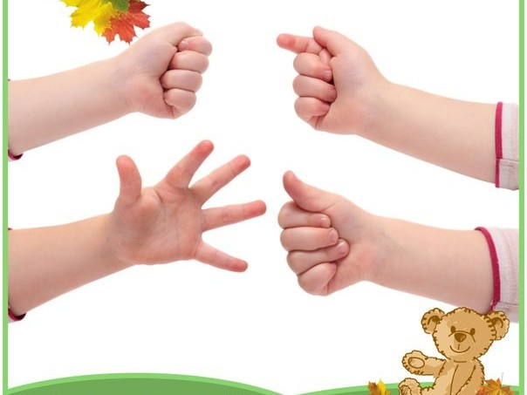
Differentiation –  how do you plan to give more support? How do you plan to challenge the more  able learners? |  |  | Assessment –  how are you planning to check learners’learning? |  |  |  | Critical thinking
Differentiation can be achieved through the selection of activities, identification of learning outcomes for a certain student, provision of individual support to learners, selection of learning materials and resources based on the individual abilities of learners. |  |  | Assessment criteria:  Identify the main idea in extended talks with little support.  Descriptor:  A learner:  - selects an appropriate answer.  - completes the task. |  |  |  | Students think critically, exploring, developing, evaluating and making choices about their own and others’ ideas

Lesson 31 THE GERUND – ГЕРУНДИЙ |  |  |  | School:
Date: |  |  |  | Teacher’s name:
Class: |  |  |  | Number present: | Number absent:
Lessontitle |  |  |  | THE GERUND – ГЕРУНДИЙ
Learning objectives(s) that this lesson is contributing to |  | UE3 use a growing variety of adjectives and regular and irregular comparative and superlative adjectives on a limited range of familiar general and curricular topics  UE9 use simple present and simple past regular and irregular forms to describe routines, habits and states on a limited range of familiar general and curricular topics  C1 use speaking and listening skills to solve problems creatively and cooperatively in groups  C5 use feedback to set personal learning objectives
Lesson objectives |  | All students will be able to:  Revise taught material  Most students will be able to:  Demonstrate learned vocabulary about helping and heroes with sure  Some students will be able to:  - Use taught vocabulary and grammar with accuracy
Value links |  | Cooperation, respect each other's opinion, functional literacy.
Crosscurricular links |  | Social Science, Psychology, Geography,Information Technology.
Previous learning |  | Talking about trips.
Useof ICT |  | Smart board for showing a presentation, getting additional information,playing the audio files.
Intercultural awareness |  | Discuss experiences in different countries.
Health and Safety |  | Breaks and physical activities used. Everyday classroom precautions will ensure that safety measures are provided to prevent the exposure of electrical power cords.
Planned timings | Planned activities |  |  |  |  | Resources
Beginning of the lesson  7 min. | The lesson greeting.  Teacher organizes a warm-up activity for a start of the lesson. Learners look at the names of different places hung on the classroom walls. They choose the place they like and go to that place. In small groups they try to give arguments and explain why the place they have chosen is the best.  Learners are informed about the lesson objectives.  Warm up.Free talk about the best places in their city or town. The teacher asks Sts. in pairs make a list of places they are going to show to the tourists. |  |  |  |  | Pictures  PPT  Writing  Worksheet  Slide (useful phrases).
Main  Activities  15 min.  12 min | Main part  THE GERUND – ГЕРУНДИЙ  Герундий етістік пен зат есімнің ерекшеліктерін байланыс-тыратын етістіктің жіктелмеген формасы. Герундий кез-келген  ағылшын етістігінің инфинитив формасына -ing жалғауы жалғау  арқылы жасалады. Герундийде етістік пен зат есімнің белгілері  болдаы. Оның етістік сияқты шағы, етіс категориялары бар.  Герундийдің сӛйлемдегі қызметі мен қолданылуы  ► Subject - Бастауыш  Playing tennis is fun.  Smoking is bad for you.  ► Part of a compound nominal predicate Етіс болатын  баяндауыш  Her greatest pleasure is travelling.  Me favorite activity is swimming.  ► Object – Толықтауыш  We enjoy playing tennis.  I hate smoking.  ► Attribute – Анықтауыш  I had the pleasure of reading in the newspaper of your success.  There are different ways of obtaining this substance.  ► Adverbial modifier - Пысықтауыш  She walked out of the room smoking.  In writing the test the student made some mistakes.  ► Етістік -ing формасында герундий (gerund) де, есімше  (participle I) де бола алады, бірақ олардың мағыналары әртҥрлі.  A waiting room ( a room for waiting) – бастауыш  A waiting train (a train that is waiting) - есімше  A sleeping pill – герундий  A sleeping child - есімше |  |  |  |  | PPT  A whiteboard  A scheme of writing a postcard.
Ending the lesson  6 min. | Students express their attitude to the lesson and give self-assessment using the method:  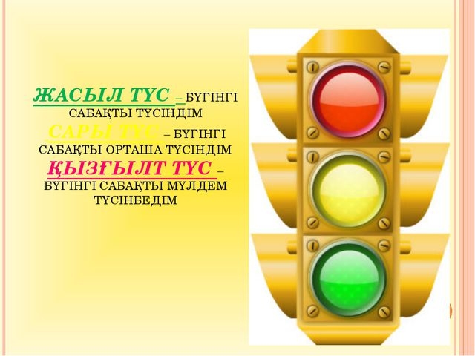
Differentiation –  how do you plan to give more support? How do you plan to challenge the more  able learners? |  |  | Assessment –  how are you planning to check learners’learning? |  |  |  | Critical thinking
Differentiation can be achieved through the selection of activities, identification of learning outcomes for a certain student, provision of individual support to learners, selection of learning materials and resources based on the individual abilities of learners. |  |  | Assessment criteria:  Identify the main idea in extended talks with little support.  Descriptor:  A learner:  - selects an appropriate answer.  - completes the task. |  |  |  | Students think critically, exploring, developing, evaluating and making choices about their own and others’ ideas

Lesson 32 PARTICIPLE - ЕСІМШЕ |  |  |  | School:
Date: |  |  |  | Teacher’s name:
Class: |  |  |  | Number present: | Number absent:
Lessontitle |  |  |  | PARTICIPLE - ЕСІМШЕ
Learning objectives(s) that this lesson is contributing to |  | UE3 use a growing variety of adjectives and regular and irregular comparative and superlative adjectives on a limited range of familiar general and curricular topics  UE9 use simple present and simple past regular and irregular forms to describe routines, habits and states on a limited range of familiar general and curricular topics  C1 use speaking and listening skills to solve problems creatively and cooperatively in groups  C5 use feedback to set personal learning objectives
Lesson objectives |  | All students will be able to:  Revise taught material  Most students will be able to:  Demonstrate learned vocabulary about helping and heroes with sure  Some students will be able to:  - Use taught vocabulary and grammar with accuracy
Value links |  | Cooperation, respect each other's opinion, functional literacy.
Crosscurricular links |  | Social Science, Psychology, Geography,Information Technology.
Previous learning |  | Talking about trips.
Useof ICT |  | Smart board for showing a presentation, getting additional information,playing the audio files.
Intercultural awareness |  | Discuss experiences in different countries.
Health and Safety |  | Breaks and physical activities used. Everyday classroom precautions will ensure that safety measures are provided to prevent the exposure of electrical power cords.
Planned timings | Planned activities |  |  |  |  | Resources
Beginning of the lesson  7 min. | The lesson greeting.  Teacher organizes a warm-up activity for a start of the lesson. Learners look at the names of different places hung on the classroom walls. They choose the place they like and go to that place. In small groups they try to give arguments and explain why the place they have chosen is the best.  Learners are informed about the lesson objectives.  Warm up.Free talk about the best places in their city or town. The teacher asks Sts. in pairs make a list of places they are going to show to the tourists. |  |  |  |  | Pictures  PPT  Writing  Worksheet  Slide (useful phrases).
Main  Activities  15 min.  12 min | Main part  PARTICIPLE - ЕСІМШЕ  (-ING AND –ED FORMS)  Ағылшын тілінде есімше етістіктің жіктелмеген формасы.  Ағылшын есімшесі сӛйлемде анықтауыштың немесе толықтау-ыштың қызметін атқарады.  Есімшенің қолданылуы  ►Present Participle Active (Participle I)  Present Participle Active (Participle I) етістіктің инфинитив формасына (to бӛлшегінсіз) -ing жалғауын жалғау арқылы жасалады.  to cry – crying, to fall – falling, to make – making  1. Present Participle Active – баяндауыш етістікпен қатар жүрген істі білдіреді.  • Who is the fat man sitting in the corner?  • You cannot sit watching television all day.  • He is lying in bed reading a novel.  2. Present Participle зат есімнен кейін анықтауыш функциясын атқарады:  • I love to look at falling leaves  • The screaming children were playing in the kindergarten. |  |  |  |  | PPT  A whiteboard  A scheme of writing a postcard.
Ending the lesson  6 min. | Students express their attitude to the lesson and give self-assessment using the method  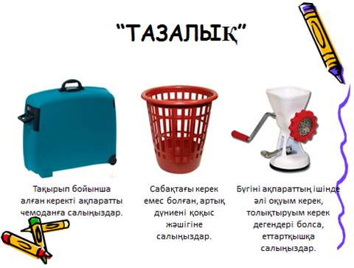
Differentiation –  how do you plan to give more support? How do you plan to challenge the more  able learners? |  |  | Assessment –  how are you planning to check learners’learning? |  |  |  | Critical thinking
Differentiation can be achieved through the selection of activities, identification of learning outcomes for a certain student, provision of individual support to learners, selection of learning materials and resources based on the individual abilities of learners. |  |  | Assessment criteria:  Identify the main idea in extended talks with little support.  Descriptor:  A learner:  - selects an appropriate answer.  - completes the task. |  |  |  | Students think critically, exploring, developing, evaluating and making choices about their own and others’ ideas

Lesson 33 INFINITIVE – ИНФИНИТИВ |  |  |  | School:
Date: |  |  |  | Teacher’s name:
Class: |  |  |  | Number present: | Number absent:
Lessontitle |  |  |  | INFINITIVE – ИНФИНИТИВ
Learning objectives(s) that this lesson is contributing to |  | UE3 use a growing variety of adjectives and regular and irregular comparative and superlative adjectives on a limited range of familiar general and curricular topics  UE9 use simple present and simple past regular and irregular forms to describe routines, habits and states on a limited range of familiar general and curricular topics  C1 use speaking and listening skills to solve problems creatively and cooperatively in groups  C5 use feedback to set personal learning objectives
Lesson objectives |  | All students will be able to:  Revise taught material  Most students will be able to:  Demonstrate learned vocabulary about helping and heroes with sure  Some students will be able to:  - Use taught vocabulary and grammar with accuracy
Value links |  | Cooperation, respect each other's opinion, functional literacy.
Crosscurricular links |  | Social Science, Psychology, Geography,Information Technology.
Previous learning |  | Talking about trips.
Useof ICT |  | Smart board for showing a presentation, getting additional information,playing the audio files.
Intercultural awareness |  | Discuss experiences in different countries.
Health and Safety |  | Breaks and physical activities used. Everyday classroom precautions will ensure that safety measures are provided to prevent the exposure of electrical power cords.
Planned timings | Planned activities |  |  |  |  | Resources
Beginning of the lesson  7 min. | The lesson greeting.  Teacher organizes a warm-up activity for a start of the lesson. Learners look at the names of different places hung on the classroom walls. They choose the place they like and go to that place. In small groups they try to give arguments and explain why the place they have chosen is the best.  Learners are informed about the lesson objectives.  Warm up.Free talk about the best places in their city or town. The teacher asks Sts. in pairs make a list of places they are going to show to the tourists. |  |  |  |  | Pictures  PPT  Writing  Worksheet  Slide (useful phrases).
Main  Activities  15 min.  12 min | Main part  INFINITIVE – ИНФИНИТИВ  Ағылшын тілінде инфинитив жақты, шақты, райды кӛрсет-пей, іс-әрекеттің іске асуын тек қана айтатын етістіктің жіктел-меген формасы. Инфинитив не істеу? не жасау? деген сұрақтарға жауап береді. Әдетте инфинитив “to‟ демеулігімен қолданылады.  ► Инфинитивтің сӛйлемдегі қызметі мен қолданылуы  Subject – баяндауыш функциясын атқарады  • To make mistakes is easy. (Old English)  • It‟s easy to make mistakes. (Modern English)  • To wait for people who are always late makes me angry.  • It makes me angry to wait for people who are always late.  • It was difficult to confess that I had stolen her money.  ► Object – тура толықтауыш функциясын атқарады  • Police warned us not to go there.  • She asked me to wait a little.  • She wants to dance.  • She wants him to help her.  ► Attribute – анықтауыш функциясында: зат есімнен кейін келеді немесе wish, desire, decide, need етістіктерінен жасалған зат есімнен кейін  • I have to wish to change. (=I don‟t wish to change)  • I told her about my decision to leave. I told her that I had made decision to leave.  Is there any need to ask Kamila? Do we need to ask Kamila?  ► Инфинитив анықтауыш функциясын атқарғанда the first, the second, the third, the last, only сөздерінен кейін жиі кездеседі.  • Who was the first person to climb Everest without oxygen?  • She‟s the only scientist to have won three Nobel prizes.  ► Adverbial modifiers of purpose – пысықтауыш функциясында  1) мақсат пысықтауыш  • I sat down to rest.  • I am going to Australia to learn German.  • To switch on, press the red button. |  |  |  |  | PPT  A whiteboard  A scheme of writing a postcard.
Ending the lesson  6 min. | Students express their attitude to the lesson and give self-assessment using the method: “Six thinking hats”:  - Green: How can you use today's learning in different subjects?  - Red: How do you feel about your work today?  - White: What have you leant today?  - Black: What were the weaknesses of your work?  - Blue: How much progress have you made in this lesson? (Now I can, I still need to work on, I've improved in, Today I learnt... )  Yellow: What did you like about today's lesson?  Slide (Homework)  Slide "Six thinking hats"
Differentiation –  how do you plan to give more support? How do you plan to challenge the more  able learners? |  |  | Assessment –  how are you planning to check learners’learning? |  |  |  | Critical thinking
Differentiation can be achieved through the selection of activities, identification of learning outcomes for a certain student, provision of individual support to learners, selection of learning materials and resources based on the individual abilities of learners. |  |  | Assessment criteria:  Identify the main idea in extended talks with little support.  Descriptor:  A learner:  - selects an appropriate answer.  - completes the task. |  |  |  | Students think critically, exploring, developing, evaluating and making choices about their own and others’ ideas

Lesson 34 CONDITIONAL SENTENCES ШАРТТЫ СӨЙЛЕМДЕР |  |  |  | School:
Date: |  |  |  | Teacher’s name:
Class: |  |  |  | Number present: | Number absent:
Lessontitle |  |  |  | CONDITIONAL SENTENCES
Learning objectives(s) that this lesson is contributing to |  | UE3 use a growing variety of adjectives and regular and irregular comparative and superlative adjectives on a limited range of familiar general and curricular topics  UE9 use simple present and simple past regular and irregular forms to describe routines, habits and states on a limited range of familiar general and curricular topics  C1 use speaking and listening skills to solve problems creatively and cooperatively in groups  C5 use feedback to set personal learning objectives
Lesson objectives |  | All students will be able to:  Revise taught material  Most students will be able to:  Demonstrate learned vocabulary about helping and heroes with sure  Some students will be able to:  - Use taught vocabulary and grammar with accuracy
Value links |  | Cooperation, respect each other's opinion, functional literacy.
Crosscurricular links |  | Social Science, Psychology, Geography,Information Technology.
Previous learning |  | Talking about trips.
Useof ICT |  | Smart board for showing a presentation, getting additional information,playing the audio files.
Intercultural awareness |  | Discuss experiences in different countries.
Health and Safety |  | Breaks and physical activities used. Everyday classroom precautions will ensure that safety measures are provided to prevent the exposure of electrical power cords.
Planned timings | Planned activities |  |  |  |  | Resources
Beginning of the lesson  7 min. | The lesson greeting.  Teacher organizes a warm-up activity for a start of the lesson. Learners look at the names of different places hung on the classroom walls. They choose the place they like and go to that place. In small groups they try to give arguments and explain why the place they have chosen is the best.  Learners are informed about the lesson objectives.  Warm up.Free talk about the best places in their city or town. The teacher asks Sts. in pairs make a list of places they are going to show to the tourists. |  |  |  |  | Pictures  PPT  Writing  Worksheet  Slide (useful phrases).
Main  Activities  15 min.  12 min | Main part  CONDITIONAL SENTENCES ШАРТТЫ СӨЙЛЕМДЕР  Zero conditional  Қашанда шындықты білдіретін жағдайды көрсетеді.  Form:  If + present simple / present simple  • If the sun shines the snow melts.  First conditional  Болуы мүмкін шартты және оның келер шақтағы нәтижесін білдіреді. Іс-әрекет осы немесе келер шаққа қатысты.  Қазақ тілінде басыңқы және бағыныңқы сөйлемде келер шақ қолданылады. Ағылшын тілінде бағыныңқы сөйлемде (if clause) present simple қолданылады.  Form  If + present simple / will + simple form  • If I don‟t eat breakfast, I will get hungry.  • If it rains, we will not go to the picnic.  • If we hurry, we‟ll catch the bus.  Басыңқы сөйлемде will көмекші етістігінің орнына модальді етістікті қолдануға болады.  Second conditional  Бұл шарттың орындалуы екі талай және шындыққа келмейтін іс-әрекетті білдіреді.  Form  If + past simple / would + infinitive  • If I won the lottery I would buy an expensive car.  • If I had enough money, I would travel around the world.  • If I were you, I would accept their invitation. Есте сақтаңыз!  Were көмекші етістігі жекеше түрде де, көпше түрде де қолданыла береді.  • If I was / were rich, I would spend all my time travelling.  • If he was / were here, he would help us. (but he is not here…)  Third Conditional (unreal past situations)  Өткен уақытта болмай қалған жағдайларды сипаттау үшін қолданылады. Олар шын фактілерге қарама қайшылықты білдіреді.  Form  If + Past Perfect / would have + Past participle  • If you had told me about the problem., I would have helped you.  (But you didn‟t tell me…)  • They would have passed the exam. If they had studied (But they didn‟t study and failed the exam …)  • If the weather had been nice yesterday, we would have gone to the zoo. (But the weather wasn‟t nice yesterday…)  Mixed Conditional Аралас шартты сөйлем кейде шартты сөйлемнің екі бөлігі де екі шаққа қатысты болуы мүмкін. Мұндай шартты сөйлемді Mixed Conditional (Аралас шартты сөйлем) деп атайды. Оның екі түрі бар:  а) Бірінші түрінде шартты сөйлем өткен шақтағы іс-әрекетті білдіреді, ал оның нәтижесі өткен шаққа қатысты болады.  б) Екінші түрінде шартты сөйлем белгілі бір уақытты білдірмейді, ал оның нәтижесі өткен шаққа қатысты болады.  • If you had taken your medicine yesterday, you would be well now. |  |  |  |  | PPT  A whiteboard  A scheme of writing a postcard.
Ending the lesson  6 min. | 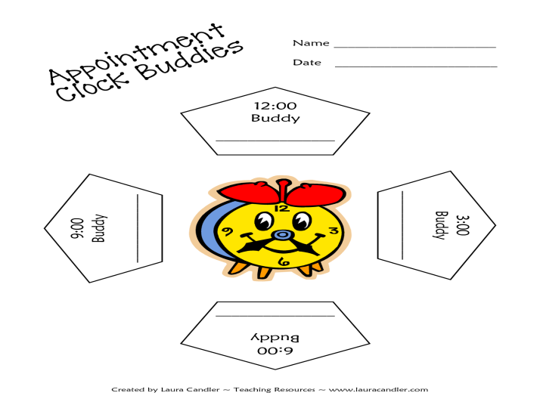  Students express their attitude to the lesson and give self-assessment using the method:
Differentiation –  how do you plan to give more support? How do you plan to challenge the more  able learners? |  |  | Assessment –  how are you planning to check learners’learning? |  |  |  | Critical thinking

Қолданылған әдебиеттер

1. Баданбекқызы З.Р. English grammar in tables. Almaty 1998
2. Бонк Н.А., Котий Г.А. Бонк Н.А., Котий Г.А. Ағылшын тілінің оқулығы. 1 бөлім
3. Васильев В.А. және басқалар. Ағылшын тілінің фонетикасы. Ленинград, 1980.
4. Голицинский Ю.Б. Грамматика. Жаттығулар жинағы.Санкт-Петербург.
5. ШЫҢ КІТАП. Ағылшын тілі. тест жинақтары. Алматы 2009.
6. Ahmetova S.G., Tursunbaeva English-Kazarh dictionary.Almaty 2004.
7. Broukal Milada. TOEFUL Test Assistant Мәскеу, Астрель *Аст 2004
8. Dubrovin I.M. Situational Grammar. / P. II. M., 1974.
9. Grammar Express. For Self-study and Classroom Use.Longman, 2000.
10. English Grammar in Use / Cambridge
11. Oxford Practice Grammar. Oxford University Press 2009
12. Thomson A.J., Martinet A.V. A Practical English Grammar.Oxford University Press.
13. Shershneva T.Y. Digest of Theoretical English Grammar.Almay 2001.

