Lesson plan

LESSON: Module 5 Lesson7  Theme: Germs |  | School: The secondary school of Bukenchi
Date: 02.02.2022 |  | Teacher name: Nashkenova Aigul Khabyzovna
CLASS: 6 |  | Number present: 9 |  | absent: -
Learning objectives(s) that this lesson is contributing to | 6.4.4.1- read independently a limited range of short simple fiction and non-fiction texts;  6.6.13.1- use modal forms including, mustn’t (prohibition), need (necessity), should (for advice) on a range of familiar general and curricular topics;  6.4.6.1- recognize the attitude or opinion of the writer in short texts on a growing range of general and curricular topics;  6.2.7.1- recognise the opinion of the speaker(s) in supported extended talk on a limited range of general and curricular topics6.  6.2.5.1- understand most specific information and detail of supported, extended talk on a range general and curricular topics curricular topics;  6.3.3.1- give an opinion at sentence and discourse level on an increasing range of general and curricular topics;  6.2.5.1- understand most specific information and detail of supported, extended talk on a range general and curricular topics curricular topics;
Lesson objectives | All learners will be able to:
To listen and read for specific information, to predict the content of the text
To understand the use of must / mustn`t
 | Most learners will be able to:
 | To practise using must / mustn’t, to give examples
 | Some learners will be able to:
 | to give presentation on germs
Previous learning | Health services
Plan
Planned timings | Planned activities |  | Student activity |  | Time
Beginning the lesson  6.4.4.1  6.4.6.1  6.2.7.1 | To introduce the topic and predict the content of the text  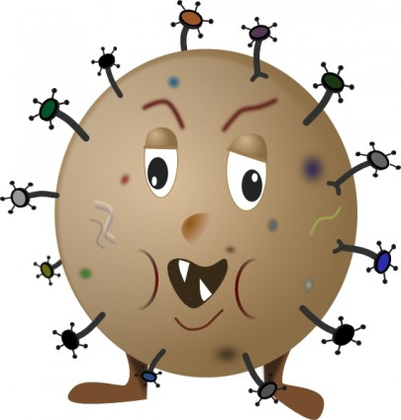  Read the statements (1-4) aloud and ask Ss to decide with their partner which ones they think are true about germs.  Listening  Play the recording.  Direct Ss to the Word List to look up the meanings of the words in the Check these words box. |  | 1.T 2 T 3.T 4F  Ss listen and follow the text in their books and check if their guesses were correct.  Sick,fight,germ,soup,pot,pan,  dishcloth,raw, chopping board |  | 5  4  2
Main activities  6.2.5.1  6.3.3.1  6.2.5.1 | To understand the use of must/mustn’t  Watch the presentation and read the Note box aloud and explain that must/ mustn’t comes before the verb and is used to express necessity or prohibition.  Read out the example and give Ss time to complete the task. Check Ss’ answers.  To practise using must/mustn’t  Explain the task and ask Ss to write the headings into their notebooks.  READING  Allow Ss time to read the text again and complete the task and check Ss’ answers around the class. |  | 2. You must eat a lot of fruit and vegetables  3. You mustn’t go swimming.  4.You must drink a lot of water  5.You mustn’t put lots of salt in the soup.  Dos : You must clean your hands with soap before cooking.  You must clean all kitchen surfaces . Don`ts: You mustn’t leave food out of the fridge for more than 2 hours.  You mustn’t use the same knife to cut raw meat and cooked food. |  | 5  10  4

Ending the lesson  6.1.10.1  6.5.6.1 |  | To give a presentation on germs  Ask Ss to look up information on the Internet using the key word ‘Germs’ in the search bar or in encyclopaedias/other reference books. Ss can use the website suggested at the Express Publishing website.  Assign the task as HW and Ss make their presentations in the next lesson.  Feedback: Teacher asks students what task was difficult to them and which pair worked well. |  | There are 4 types of germs: bacteria, viruses,fungi and protozoa.They can make us sick.Bacteria are one-cell creatures that can cause infections.When viruses get inside peoples bodies they can spread ,makepeople sick.Fungi are plant like organisms made of many cells.Protozoa are one-cell organisms that often spread diseases through water 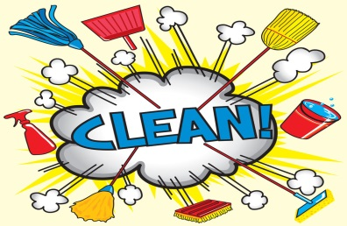 |  | 10  5
 | Additional information
 | Differentiation – how do you plan to give more support? How do you plan to challenge the more able learners? |  | Assessment – how are you planning to check learners’ learning? |  | Cross-curricular links  Health and safety check  ICT links  Values links
 | Challenge more and less able learners to make a dialogue regarding the germs |  | Monitor the learner’s comprehension of the new information |  | Values links: health
 | Reflection  Were the lesson objectives/learning objectives realistic?  Did I stick to timings?  What changes did I make from my plan and why? |  | Answer the most relevant questions from the box on the left about your lesson.

