Calendar Thematic Plan
The Wonderful Wizard of Oz
(The theme of a lesson)

Unit:7 | Reading for pleasure
Teachername: | Kunakova Zhadyra Galimkhanovna

Date:
Grade:6 | Number present: | Number absent:
The theme of the lesson: | The Wonderful Wizard of Oz
Learning objectives(s) that this lesson is contributing to | 6.C4 evaluate and respond constructively to feedback from others  6.C7 develop and sustain a consistent argument when speaking or writing  6.S5 keep interaction going in basic exchanges on a growing range of general and curricular topics  6.R1 understand the main points in a limited range of short simple texts on general and curricular topics
Lessonobjectives | All learners will be able to recognize new vocabulary words and recognize the attitude or opinion of the story  Most learners will be able to use new vocabulary words and list the main events  Some learners will be able to use all new vocabulary words, write a summary of a story and create a story
Lesson plan
Plannedtimings | Teacher'sactions | Students` actions | Assessment | Resources
10minutes | ORGANISATION MOMENT:  Teacher greets students  Teacher: Good morning!  How are you?  Learners answer the question ‘How are you?’  Welcome to our English lesson  Ok, if you are ready let’s start our lesson  Let’s come to the board and make a circle to wish good wishes to each other.  You are clever  You are beautiful  Dividing into groups  Come to the board and count from 1 to 3.  Homework of the previous lesson  Check the names of characters and explain their meaning if they are in positive or in negative meaning | Students respond to greeting and take their places  Students come to the blackboard and say their best wishes to each other  Pupils should count from 1 to 3. Who says one goes to the first group and who says two takes place on the second group and finally who says three goes to the third group by the method of ‘COUNT’  Tell the class about their opinions by the method of ‘BOUNCING BALL’ | Formative assessment  By the method of “Thumb”  ‘excellent’  ‘well done’  ‘good job’  By the method of ‘COMPLIMENTS’  ‘EXCELLENT’  ‘GOOD JOB’  ‘WONDERFUL’  ‘SUPER’ | Books  Copybooks  Interactive white board  Activity book
25 minutes  10 minutes | MAIN PART  Reading  Exercise 1  Group work  There is a text about the writer. Read and translate his biography  Speaking  Individual work  Exercise 2  - Who was Frank Baum?  - When and where was he born?  - For whom did he write his books?  Let’s watch the video  There is a video about Oz. Watch it to understand better the text  Reading  Exercise 3  Group work  There is a text about The Wonderful Wizard Oz  Speaking  Exercise4  Pair work  Put the pictures in order  Writing  Individual work  Exercise 5  1. Dorothy was surprised when she saw Scarecrow  2. Scarecrow couldn’t talk  3. Tin Man has an axe  4. Dorothy’s home is in Emerald city  5. Tin Man has a heart but not a brain  6. Dorothy has no friends  Writing  Group work  Exercise 6  Do the crossword. Find these words from the table  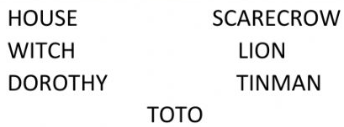  ENDING THE LESSON:  Well what did we do in our lesson?  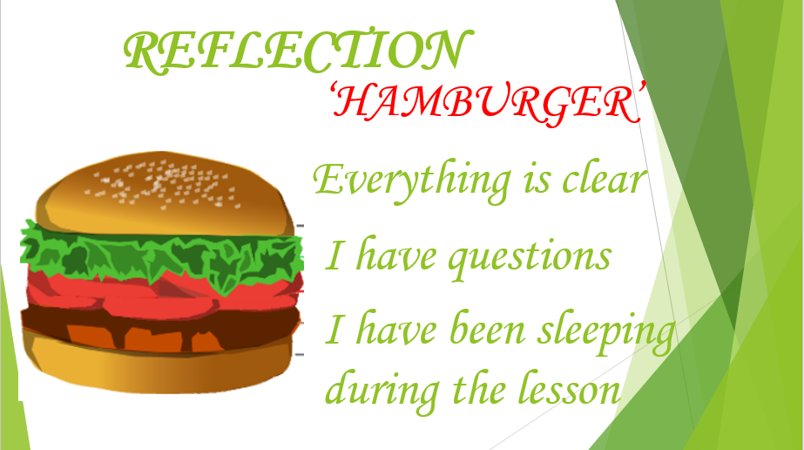  Evaluation of the lesson  Give the home task  Sing a Good bye song | Pupils should read the text about the writer’s biography and understand the main point by the method of ‘THINK TOGETHER’  Pupils read the questions about writer’s biography and answer the by the method of ‘WALKING MICROPHONE’  Pupils pay attention to the screen and watch the video  Read the text and translate into Kazakh to understand the main point by the method of ‘BUS STOP’  It is pair work. Pupils should look at the pictures attentively and put them in the right order by the method of ‘THINK TOGETHER’  It is individual work. Pupils should read the text and write True or False statements by the method of ‘THINK, FIND AND SEEK’  Pupils look up the words from the table and do the crossword by the method of ‘CHAIN’  answer to some questions to know how they understand the lesson  Pupils tell the class if they understand today’s lesson  If they don’t understand they write it to the stickers and leave it to class  Children sing a Good bye song | Formative assessment  By the method of “FIREWORKS”  By the method of ‘COMPLIMENTS’  ‘EXCELLENT’  ‘WONDERFUL’  ‘TRY AGAIN’  By the method of “SHAPES”  A STAR-3 POINTS  A SQUARE-2 POINTS  A TRIANGLE-1 POINT  Formative assessment  BY THE METHOD OF ‘COINS’  10 COINS-3 POINTS  8 COINS-2 POINTS  5 COINS-1 POINT  By the method of “DOLLARS”  10 DOLLARS-3 POINTS  8 DOLLARS-2 POINTS  5 DOLLARS-1 POINT  ‘super’  ‘brilliant’  ‘very well’  Feedback  ‘super’  ‘brilliant’  ‘very well’  ‘super’  ‘brilliant’  ‘very well’ | Smart  phones  Flashcards  https://youtu.be/8D0zt4s13pw  Activity book  Interactive  White boards  Cards  Pupil’s book  Activity book  Cards  Board  Stickers  White board  cards  STICKERS  POSTERS

