Lesson plan

Unit 2 Natural Disasters |  |  | School #13
Date: |  |  | Teacher’s name: Bugayova S.M.
CLASS: 10 |  |  | Number present: |  | Absent:
Lesson title |  | Causes and consequences of natural disasters
Learning objectives that this lesson is contributing to |  | 10.R2 understand specific information and detail in texts on a  growing range of familiar general and curricular topics  10.S7 use appropriate subject-specific vocabulary and syntax to  talk about a growing range of general topics, and some  curricular topics  10.UE17 use if / unless/ if only in second conditional clauses and  wish [that] clauses [present reference]
Lesson objectives |  | All learners will be able to  - understand specific information and detail while reading text  - use subject - specific vocabulary and second conditional clauses for short speaking on the topic  - give 5 right answers after watching the video and explain the answers  Most learners will be able to  - analyze information and identify links between the causes and consequences of natural disasters  - use subject - specific vocabulary and second conditional clauses in discussion  - give 7-8 right answers after watching the video and explain the answers  Some learners will be able to  - use subject - specific vocabulary and second conditional clauses in fluent speech modulating or creating the situations on the topic  - give 10 right answers after watching the video and explain the answers
Assessment criteria |  | - understand specific information and detail while reading  - use subject - specific vocabulary and second conditional clauses for speaking on the topic
Values links |  | - Country’s national security and its engagement in addressing global and regional issues  - Instilling values of safety, correct behavior in nature and helping other people through the content of the topic
Cross-curricular links |  | Geography, Physics, Ecology
Previous learning |  | The learners are familiar to the topic in general as they have learned it in the 7 grade and they have studied grammar structures of Conditionals in the 8 and 9 grades.
Use of ICT |  | Projector, Smartboard for showing the video “5 Natural Disasters that Devastated the U.S. in 2018” and a presentation
Plan
Planned timings | Planned activities |  |  |  |  | Resources
Start  4 min  2 min | Greeting  Organization moment  Warm-up Labelling  Teacher tells learners that they are going to guess the topic of the lesson and discuss about a scene that teacher would like them to draw. Teacher reads out the following text:  “Draw three houses. Each house has four windows and a door. On the roof of one of the houses there are two people and a dog. At the top of the picture draw some clouds. The clouds look grey and it’s raining a lot. In the sky there is a helicopter. Around the houses there is water. The water touches the top windows of the house….”  Teacher asks learners to look at their pictures. What do they think has happened in the scene?  Answers: flood, hurricane, tsunami.  When they have suggested some answers teacher asks them to name the topic of the lesson.  Identifying lesson objectives and learning outcomes by the end of the lesson together with students
Middle  4 min  5 min  15 min  2 min  8 min  2 min | Pre-reading  - Previewing a Text.  Brain storming – collecting words on the topic.  Look and listen to the video “5 Natural Disasters that Devastated the U.S. in 2018” and give 10 words related to it.  Descriptor: A learner give 10 words from the video related the topic  Oral positive feedback  - Extending Vocabulary.  Individual work Match pictures and words  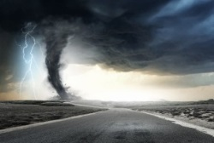  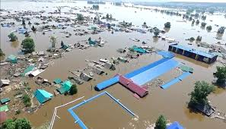  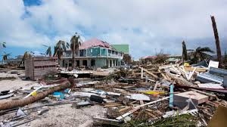  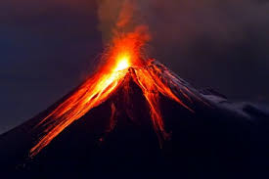  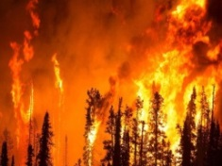  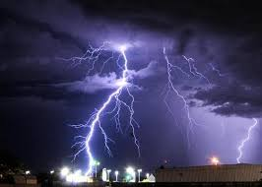  a storm a blizzard a landslide  a tornado an earthquake a heat wave  a tsunami a drought a gale  thunder a hurricane a flood  lightning wildfire volcanic eruption  Descriptor: A learner match 6 pictures with the right words  Feedback in the form of confirmation: “Yes!,  “Good!”, “That is true”. When a mistake is made, elicitation is used  While reading  Text “ Focus on Kazakhstan: Causes and Consequences” p. 22  Group work. Regrouping according to the ability  Group 1 (weak learners)  Strategy “Searching-selecting”  Read the text, choose the names of natural disasters  Descriptor: A learner write all the words, spelling is correct  Assess yourself with Strategy “Rating Scale” (0-3 points)  Criteria for self-assessment  I write all the words, spelling is correct 3  I write all the words, I make 1 mistake in spelling 2  I write all the words, I make 2 mistakes in spelling 1  I write not all the words, I make 2 and more mistakes in spelling 0  Group 2 (intermediate learners)  Strategy “Using Context to Find Meaning”  Read the text and give definitions to the words:  hurricane, flood, earthquake  Descriptor: A learner write definitions to the words correctly  Group 3 (super learners)  Strategy “Sorting Ideas”  Concept mapping  Read the text and fill in a concept map  Natural disaster Causes  1  2  3  4  Descriptor: A learner use subject - specific vocabulary and fill in a concept map  Groups 2 and 3 assess the work of group members  Criteria for assessment “Ticket in” (0-3 points)  S1 S2 S3 S4  Use vocabulary on the topic correctly  Suggest ideas  Participate in discussion  Listen to attentively and ask questions  Focus on the educational task  Total score  Emotional pause  Listen to the song “ My Heart Will Go On” from the film “Titanic”  Post reading  The whole class work  Questioning. Open question  Assessment criteria:  use specific vocabulary and second conditional clauses for speaking on the topic  Give your answer, use the Second Conditional:  - What would it be if it were underwater volcanic eruptions?  - What could it happen if people were careless about campfire?  - What would we fear if our country were on the ocean coast?  - What could people do to prevent drought?  - What would you do if you heard about the flood on the weather forecast?  Peer assessment. Strategy “2 stars and a wish” |  |  |  |  | https://www.youtube.com/watch?v=Lo8A10-ZOEI  PPP Presentation  Handout 1  List of words  Student’s Book English  Grade 10 Sciences  Cambridge University Press  Handout 2  Assessment scale  Handout 3  A concept map  Handout 4  Assessment sheets  Recording
End  3 min | Reflection will be done as a plenary  Strategy “Exploration Table”:  At the end of class, each student answers the following questions presented to them on index cards:  What did we do in class?  Why did we do it?  What did I learn today?  How can I apply it?  What questions do I have about it? |  |  |  |  | Index cards
Additional information
Differentiation  How do you plan to give more support? How do you plan to challenge the more able learners? |  |  |  | Assessment  How are you planning to check learners’ learning? | Health and safety check
Differentiation will be achieved through the selection of activities(less able students will choose the words, more able students will give definitions, the most able students will fill in a concept map), identification of learning outcomes for a certain student (weakest students will be able to use specific vocabulary and grammar structures for short speaking, more able students – for discussion, the most able students – in fluent speech), regrouping according to students’ abilities |  |  |  | To check learners’ learning, to assess what they have learned during the lesson I plan to use strategies and techniques “Rating Scale” for self-assessment, “Ticket in” for group assessment in the while - reading stage. Asking open questions and peer assessment by the strategy “2 stars and a wish” in post reading stage | Health saving technologies:  Emotional pause  Values links:  Country’s national security and its engagement in addressing global and regional issues  Instilling values of safety, correct behavior in nature and helping other people through the content of the topic  Cross-curricular links: Geography, Physics, Ecology  Using ICT

