Short-term lesson plan

Module 6: | Capabilities of the human brain
Teacher: | Zhumakhmetova Elvira Maratovna
School: | Secondary school gymnasium №17
Date: | 27.01.2022
Grade: | 10 A Present: | Absent:
Theme: | Physical structure of the human brain
Learning objectives: | 10.2.3 understand the detail of an argument in unsupported extended talk on a wide range of general and curricular topics, including talk on a limited range of unfamiliar topics;  10.3.7 use appropriate subject-specific vocabulary and syntax to talk about a range of general and curricular topics;  10.4.8 use a wide range of familiar and unfamiliar paper and digital reference resources to check meaning and extend understanding;
Lesson objectives: | All learners will be able to:  Know the key words from the text «One brain or two»  Most learners will be able to:  Understand the main idea of the text «One brain or two»  Some learners will be able to:  Express the points of view about the text «One brain or two»

Lesson progress
Lesson Stages/ Time | Teacher`s actions | Students’ actions | Assessment | Resources
Beginning  0-5 min | Organization moment:  Greetings.  Brief talk.  First of all, look at the screen and look at the picture. Guess, what is the theme of our lesson?  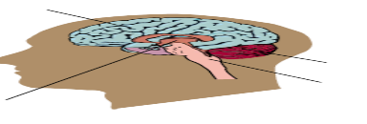  You are right. The theme is Physical structure of the human brain.  We are going to talk about «Physical structure of the human brain». We will do the different tasks.Open your copybooks and write today`s date.  Look at the presentation and listen to the key words. You should write the words in your copybook.  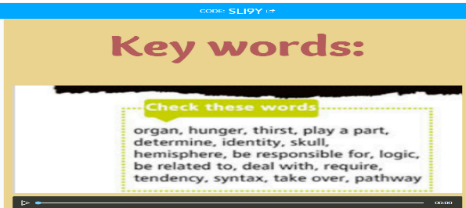 | Students listen to the teacher and write the date.  Students look at the picture and guess the theme of the lesson.  Students pronounce the words. They listen to the words. | Verbal assessment  Evaluation list  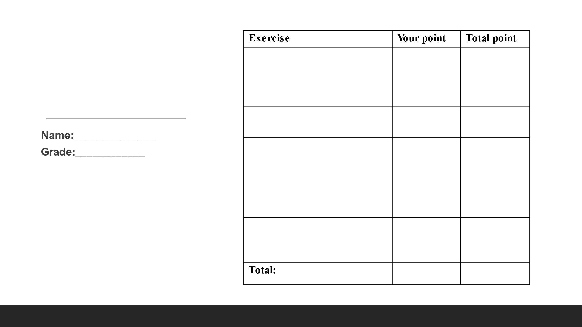 | PPT  Student`s book  Nearpod platform  https://app.nearpod.com/?pin=Z3FPU  Audio  https://www.youtube.com/watch?v=3pCtZEptuyc
5-7 min | Before we will start to do the tasks, you can see evaluation list on the desk. You should write your points for each task. At the end of the lesson, I`m going to collect your evaluation lists. | Students read the evaluation list. | Evaluation list | PPT
Middle  7-12 min | 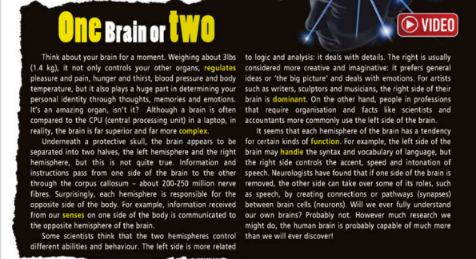  Ex.1 p.70 SB Which hemisphere (left or right) of the brain do you think controls: logic, details, creativity? General ideas? Music skills? Emotions? Lists? Language? Imagination? Listen and read to find out. | Students watch the video and read the text. Then they ask and answer the questions. | Evaluation list | Student`s book  Video  https://www.youtube.com/watch?v=8dcLIVZkZHU  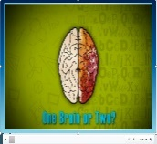
12-17 min | Ex.2 p.70 SB Read the sentences (1-8) and decide if they are True, False or Doesn`t say. | Students work in pairs. They read the sentences and say true, false or doesn`t say. | Evaluation list | PPT  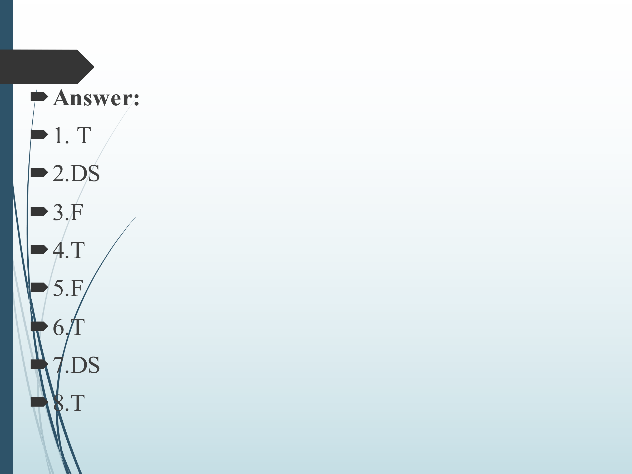
17- 22 min | 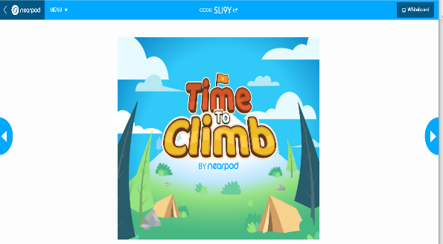  Let`s play a game. You should answer the questions. | Students choose the answers. Student writes the answer on the interactive board. | Well done! | https://app.nearpod.com/command?puid=87942153c6ef534b6b1c880ed6f98b85-1&sid=31329521a3a37964db2306d473e241c9&origin=My%20Library
22-27 min | 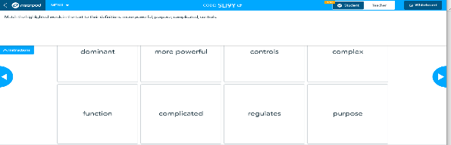  Match the highlighted words in the text to their definitions. | Students read the words and definitions. They match them in nearpod. | Evaluation list | https://app.nearpod.com/command?puid=87942153c6ef534b6b1c880ed6f98b85-1&sid=31329521a3a37964db2306d473e241c9&origin=My%20Library
27-33 min | Ex.7 p.71 SB Listen to two people talking about the human brain. For questions 1-5, choose the correct answer (A, B or C).  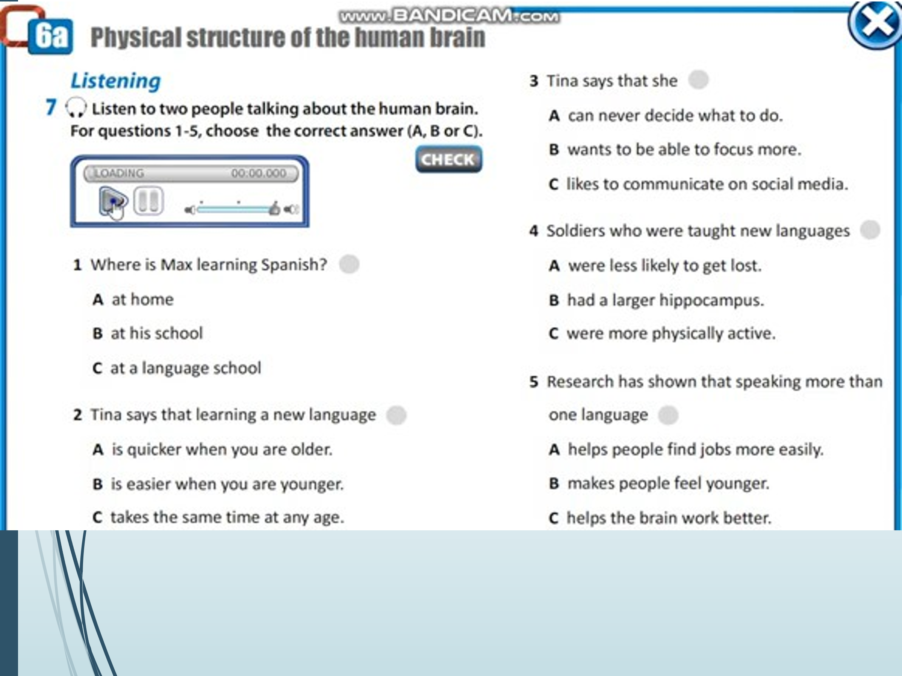 | Students listen to the information. They choose the correct answer. | Evaluation list | PPT  Audio  https://www.youtube.com/watch?v=f8jHG5ZqsD4&t=13s  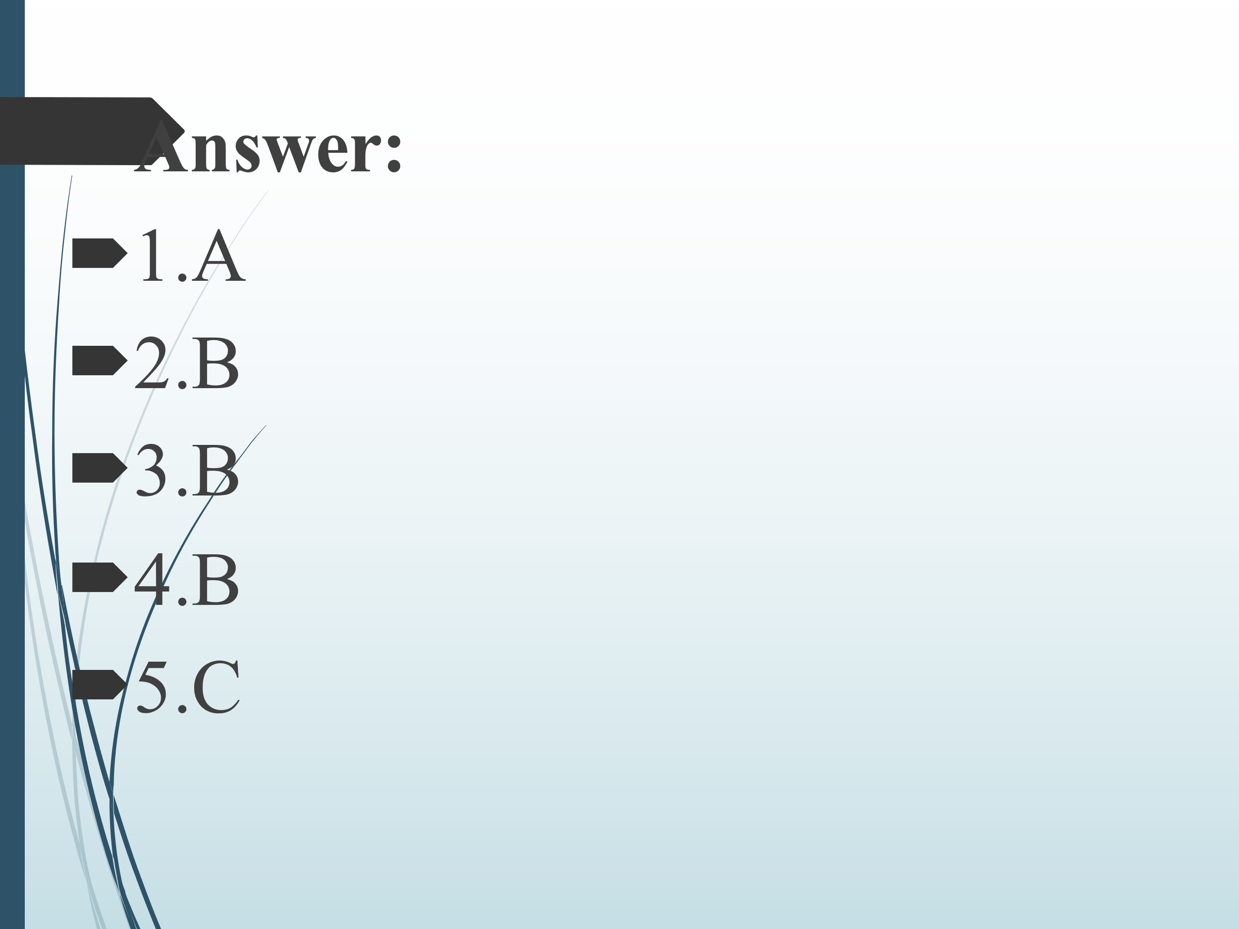
33-40 min | 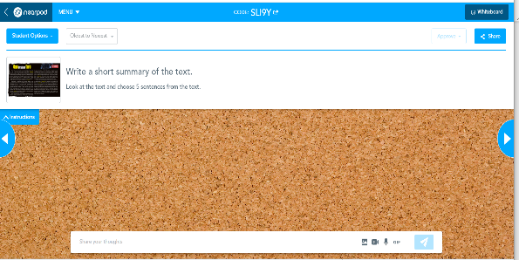  You should write a short summary of the text on whiteboard. You should pay attention on the descriptor. | Students look at the descriptor. They write 5 sentences on the topic. | 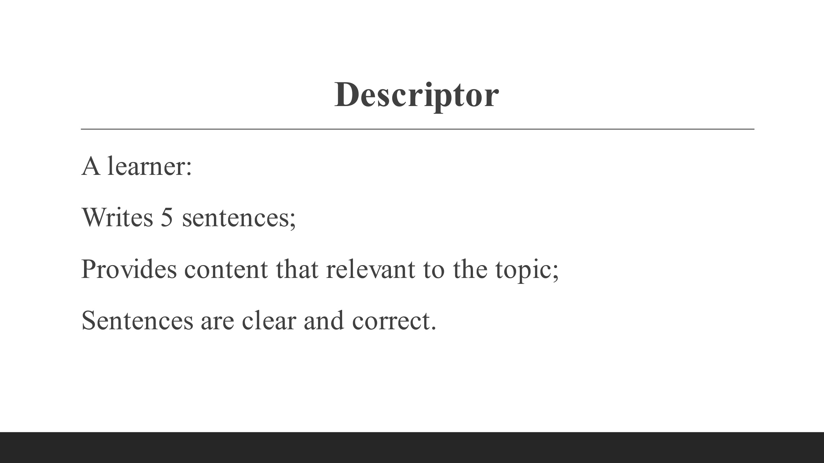  Evaluation list | https://app.nearpod.com/command?puid=87942153c6ef534b6b1c880ed6f98b85-1&sid=31329521a3a37964db2306d473e241c9&origin=My%20Library
End  40-45 min | Reflection:  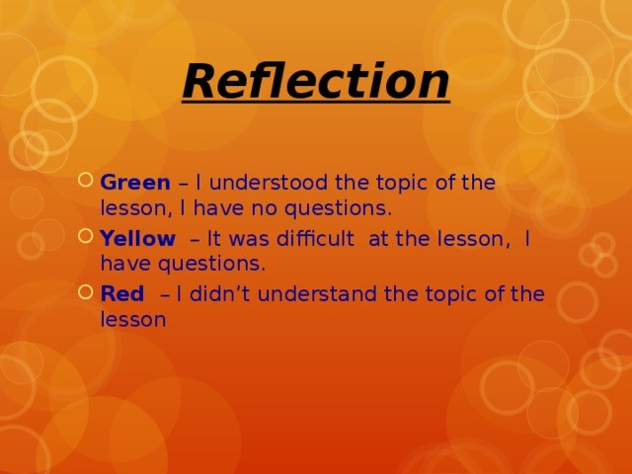  Look at the slide. You should choose the colour.  The lesson is over. Goodbye, students. | Students look at the presentation. Students choose one colour. They express the opinions. | Teacher announces students` formative scores for the lesson.  (1-10) | PPT

