Сабақ жоспары

Бөлім:  Unit  Un |  |  |  | School: Secondary school of Kizilarik
Date: 23.06.2017 year |  |  |  | Teacher name: Zhanysbaev Daulet
CLASS: 5 |  |  |  | Number present: 12 | absent:0
Lesson title |  | Sport for all
Learning objectives(s) that this lesson is contributing to (link to the Subject programme) |  | 5.L2 understand an increasing range of unsupported basic questions which ask for personal information  5.S1 provide basic information about themselves and others at sentence level on an increasing range of general topics
Lesson objectives |  | All learners will be able to:  - ask for personal information  Some learners will be able to:  - provide basic information about themselves  Most learners will be able to:  - describes types of sport
Assessment criteria |  | Identify basic questions with support
Language objective
Values links |  | National unity, peace and harmony in our society
Cross-curricular links |  | Kazakh and Russian language
Previous learning |  | Travel
Plan
Planned timings | Planned activities (replace the notes below  with your planned activities) |  |  |  |  |  | Resources
2 m  3 m | Organization moment  Good morning boys and girls. How are you? Have you got books and pencils?  Task №1. Pre-listening: Introduce new words by changing accent.  Football 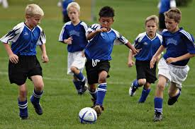  Diving 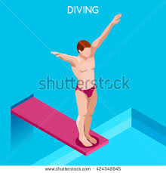  Fencing 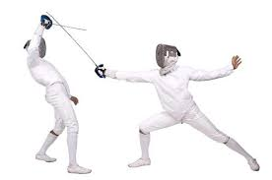  Cricket 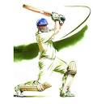  Table tennis 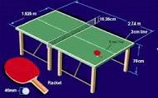 |  |  |  |  |  | Pictures
6 m  5 m  8 m  3 m | Task №2. Strategy: Freeze frame. While-listening: I will show the video. When I stop the video, you should repeat after video.  I like baseball  I like basketball  I like volleyball  I like soccer  What do you like? I like diving  What do you like? I like swimming  What do you like? I like skiing  What do you like? I like skaiting  What do you like? I like tennis  What do you like? I like badminton  What do you like? I like fancing  Task №3. Post-listening: Fill the gaps on the interactive  board.(football, like, diving, What,do, table tennis)  I like …  I … tennis  … like soccer  What do you …? I like …  … do you like? I … fancing  What … you like? … like cricket  What do … like? I like …______  Task №4. Strategy:Role play. You should explain type of sport with action and mimics without words. And others must find what kind of sport is it.  Fair exercise: I will show video and you should dance by watching video. |  |  |  |  |  | https://www.youtube.com/watch?v=  tgUSHk6JaTY  Interactive board  https://www.youtube.com/watch?v=nNq6pXV6Ko0
8 m  10 m | Task №5. Strategy:Talk to talk. Work in pairs. You should speak with your partner “I can play the football and next student I can’t play the cricket. Then change your partner (FA)  Task №6. Strategy: Doodle It. Drawing .  Differentiation by outcomes. Students draw on the sheet of paper kinds of sport. Then describe their pictures. Learners level “C” name the types of sport. Learners level “B” provide basic information about themselves and learners level “A” describes types of sport |  |  |  |  |  | Poster  Sheet of paper, pencils
Differentiation – how do you plan to give more support? How do you plan to challenge the more able learners? |  |  | Assessment – how are you planning to check learners’ learning? |  |  | Health and safety check
Differentiation by outcomes. Students draw on the sheet of paper kinds of sport. Then describe their pictures. Learners level “C” name the types of sport. Learners level “B” provide basic information about themselves and learners level “A” describes types of sport |  |  | (FA) Work in pairs. You should ask and answer the questions “Can you play the cricket? Yes, I can play the cricket/No, I can’t play the cricket. Then change your partner |  |  | I will explain to my learners health saving technologies and using physical exercises.  Rules from the Safety Rules book which can be applied in this lesson.
Reflection  Were the lesson objectives/learning objectives realistic?  Did all the learners achieve the lesson objectives/ learning objectives? If not, why?  Did my planned differentiation work well?  Did I stick to timings?  What changes did I make from my plan and why? |  |  | Use the space below to reflect on your lesson. Answer the most relevant questions from the box on the left about your lesson.
Summary evaluation

What two things went really well (consider both teaching and learning)?

1:

2:

What two things would have improved the lesson (consider both teaching and learning)?

1:

2:

What have I learned from this lesson about the class or individuals that will inform my next lesson?

