Lesson Plan
Unit:5
Teacher’s name:
Date: | 16.01.2024
School:
Grade:8 | Number present: absent:
Theme of the lesson: | The legend of Alpamys Batyr
Learning objectives(s) that this lesson is contributing to: | 8.R4 read a growing range of extended fiction and non-fiction texts on familiar and some unfamiliar general and curricular topics  8.UE12 use comparative degree adverb structures not as quickly as / far less quickly with regular and irregular adverbs. use an increased variety of pre-verbal, post-verbal and end-position adverbs on a range of familiar general and curricular topics
Lesson objectives: | Students  - Identify the meaning of a legend about a Kazakh hero.  - Recall how to use adjectives and adverbs, comparatives and superlatives.  - Understand details in reading extracts
Value link: | Be friendly, be responsible.
Plan:
Part of the lesson/Time | Teacher’s activity | Student’s activity | Assessment | Resources
Beginning of the lesson  Warming-up  3 min. | Organization moment:  1.Greeting with students.  Teacher asks students to take the stars and read the compliments  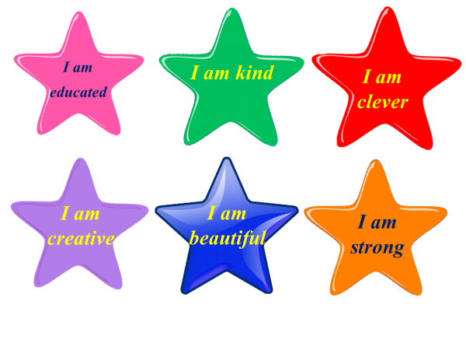 | Greet with teacher.  Students take the stars and read the compliments | At the organization moment T tries to award active Ss. «The praise» method is used to evaluate Ss with phrases like:  “Good job!  Well done!” | Stars
Checking up the home task  3 min | Method: “Spinner” Teacher asks students to answer the questions  1. Who is the author?  2. What is the type of book?  3. What is the setting?  4. What is the book about?  5. Who is the main character?  6. What is the characteristic of main hero? | Students answer the questions correctly | Teacher evaluates Ss with phrases like:  “Good job!  Well done!”
Pre-learning  «Brainstorming» method  5 min. | Teacher shows pictures and asks students to guess what the theme of the lesson is.  After that Teacher introduces the theme and aim of the lesson.  Teacher divides students into two groups with the help of yurt | Students watch the pictures and guess the theme of the lesson  Students divide into two groups | Teacher evaluates Ss with phrases like:  “Good job!  Well done!” | Presentation  pictures
Middle of the lesson  Presentation part  3 min  3 min  Group work  4 min  Pair work  5 min  Individual work  3min  3 min  Individual work  4 min | New words  Teacher presents new words.  noble – асыл, бай  tribe – тайпа  cattle – ірі қара  pray – дұға ету  miracle – ғажайып  feast – мереке  unfairly – әділетсіз  compete – жарысу  fearless – ержүрек  stable – ат тұратын жер  rock – жартас  inscription - жазба  Teacher asks students to read and remember the words | Students read and repeat the new words after teacher and remember them | T tries to award active Ss. «The praise» method is used to evaluate Ss with phrases like:  “Good job!  Well done!” | Presentation
 | Teacher asks students to watch the video about the legend of Alpamys Batyr | Students watch the video about the legend of Alpamys Batyr |  | Video  Pupil’s book
 | Method: “Sword”  Teacher asks students to put the sentences in the correct order | Students put the sentences in the correct order | Descriptor  - identify the meaning of text 1  - put the sentences in the correct order 1 | Swords  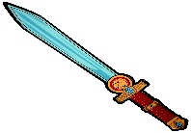  Presentation  Pupils book
 | Method: “Bauyrsak”  Teacher asks students to choose the correct answer | Students choose the correct answer | Descriptor  - understand the text 1  - choose the correct answer 1 | Presentation  Bauyrsak  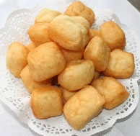
 | Dove: Answer the questions. Teacher asks students to answer the questions | Students answer the questions | Descriptor  - understand the questions 1  - answer the questions correctly 1 | Dove
 | Teacher asks students to watch the video about Grammar: Comparative and Superlative degrees of adjectives | Students watch the video about Grammar: Comparative and Superlative degrees of adjectives |  | Video
 | Sorting game: Yurt  Teacher asks students to divide the adjectives and adverbs correctly | Students divide the adjectives and adverbs correctly | Descriptor  -know how to form the adjective and adverb 1  -divide the adjectives and adverbs correctly 1  Total: 2 points | Yurt
Pair work  4 min | Teacher asks students to choose the correct words to complete the sentences | Students choose the correct words to complete the sentences | Descriptor:  -understand the rule of degrees of adjective and adverb 1  -choose the correct words to complete the sentences 1  Total: 2 points | Presentation  Pupil’s book
End of the lesson.  Reflection  5 min. | The Target is used to show students’ reflection.  Teacher asks students to evaluate themselves with the help of dombyra | Students write their names on stickers and stick on target to show their knowledge according to the lesson  Aim: To know how many students got the theme. | Students evaluate themselves and teacher encourages students with phrases like:  Well done! Brilliant! Good job! I like it! | Target  Stickers  Dombyra  