**Theme of the lesson:** Four walls

|  |  |
| --- | --- |
| Unit:4 |  |
| Teacher’s name: | **Kim V.V** |
| Date: | **07.12** |
| Grade:3 B | Number present: absent: |
| Theme of the lesson: | Four walls |
| Learning objectives(s) that this lesson is contributing to: | 3.UE11 use have got + noun to describe and ask about possessions use how many are there? question form  3.R5 understand the main points of simple sentences on familiar topics by  using contextual clues  3.R4 begin to use with support a simple picture dictionary  3.S3 use a limited range of basic words, phrases and short sentences to  describe objects, activities and classroom routines  3.L1 understand a range of short basic supported classroom instructions |
| Lessonobjectives: | **All learners will be able to:** use have got + noun to describe and use a limited range of basic words, phrases  **Most learners will be able to:** understand the main points of simple sentences and use a limited range of basic words, phrases  **Some learners will be able to:** understand the main points of simple sentences, use have got + noun to describe and use a limited range of basic words, phrases and short sentences to  describe objects, activities |
| Value link: | Be friendly, respect each other. |

**Plan:**

|  |  |  |  |  |
| --- | --- | --- | --- | --- |
| **Part of the lesson/Time** | **Teacher’s activity** | **Student’s activity** | **Assessment** | **Resources** |
| **Beginning of the lesson**  Warming-up  Team work  **3 min.** | **Organization moment:**  1.Greeting.  Ask about the weather.  T divides class into three teams and gives them box with letter.  T asks them to rearrange and find the team’s name.  T divides Ss into: Ground floor team, First floor and Second floor.  **In differentiation** part **«Observation»** method was used to encourage them to answer the questions and find his/her team. | ***“A note****” method helps to start the lesson with telling supporting words to each other.*  **The aim:** To develop Ss writing skills and create friendly atmosphere  **Efficiency:** By telling the wishes they show their appreciations . | At the organization moment T tries to award active Ss. ***«The praise»*** method is used to evaluate Ss with phrases like:  “Good job!  Well done!” | CD player  cards |
| ***Pre-learning***  ***«Brainstorming» method***  Team work  **10 min.** | Revision of previous lessons materials: “**Flashcards”** game.  T shows cards quickly and asks to write the words.  **In differentiation** part **«Visual aids»** method was used to check up student’s vocabulary knowledge.  After that T introduces the aim and theme of the lesson. | Ss look at the cards and write know all the words  Present to the class.  Compare with second team’s answer.  Count words.    **Aim:** Revise the previous lessons material. Find out how much do they remember.  **Efficiency:** Ss refresh their mind before starting new theme. | **Descriptor:**  -know key phrases  - can write words correctly  - know vocabulary of previous lesson.  Total: 1point | Whiteboard  Cards  Pupils Book |
| **Middle of the lesson**  Presentation part.  Team work.  **8 min.** | **«Presentation time»** method**.**  T introduces new words connected with the theme.  T shows picture of the house and rooms asks to predict the theme of the lesson.  Writes on the board key words. | Ss guess the theme of the lesson by making the prediction.  Write down new words.  Drill them. | **Descriptor:**  **-**can predict  -can write words correctly  Total: 1point | Whiteboard  Pupils Book  Flashcards |
| T asks Ss to think and add more words about house and room | Ss add words and read them loud.  Compare with other teams. | T praise active Ss with phrases such as: “Good job!  Well done!” “One more time, please” | Whiteboard  Pupils Book  Poster |
| Team work  **6 min.** | T gives the task **«Look and write»**  T presents pictures  T asks each team match pictures for each room  2023-12-03_22-51-16  ***Aim:*** increase lexical knowledge  **Efficiency:**  To develop Ss critical thinking skills and use new grammar  **Differentiation:** ***«*Verbal support*»*** method is used to help Ss use new words in the sentences. | Look at the picture, discuss with teammates. | **Descriptor:**  -cooperate as a team  -collect information  -complete the table  Total: 1point | Whiteboard  Pupils Book  Poster |
| Work in pairs.  **8 min.** | Work with flashcards  **Look, read and put a tick or cross.**  2023-12-04_00-41-14  **Aim*:*** teach to describe the house  **Differentiation:** ***«*Verbal support*»*** method is used to help Ss use new words in the sentences. | Ss use the T’s instructions. | **Descriptor:**  -can use new grammar  -can use there is/are  - know new words  Total: 1point | Whiteboard  Pupils Book  Poster |
| Individual work  **5 min**  *Writing task* | Match the words with the correct pictures  4b4cea46c9e1bbdfd37fc80c118cae92  ***Aim:*** *develop listening skills.*  **Efficiency:**  Ss listen and use grammar  **Differentiation:** ***«Change the pair»*** game is used to develop their speaking and listening skills. | Ss listen and tick the correct answer.  Evaluate each other. | **Descriptor:**  -understand listening task-1point.  -can use past tense 1point.  -can choose the correct answer -1point. | Whiteboard  Pupils Book  Poster. |
| End of the lesson.  Reflection  Individual work:  **5 min.** | The Ladder method was used as a reflection. T asks Ss to stick their stickers to the Success Ladder. | Ss use their stickers to show their knowledge according to the lesson  ***Aim:*** To know how many Ss got the theme.  **Efficiency:**  Ss can use colors to show how much do they remember***.***  **Differentiation:** ***«Conclusion»*** method is used to finish the lesson. | **Descriptor:**  Speak on the theme “House”,  -can name rooms and objects at home  -can listen and do the task - 2points.  Ss evaluate each other and encourage classmate with phrases like:  Well done! Brilliant! Good job! I like it! | Whiteboard  Pupils Book Poster: Success Ladder. |

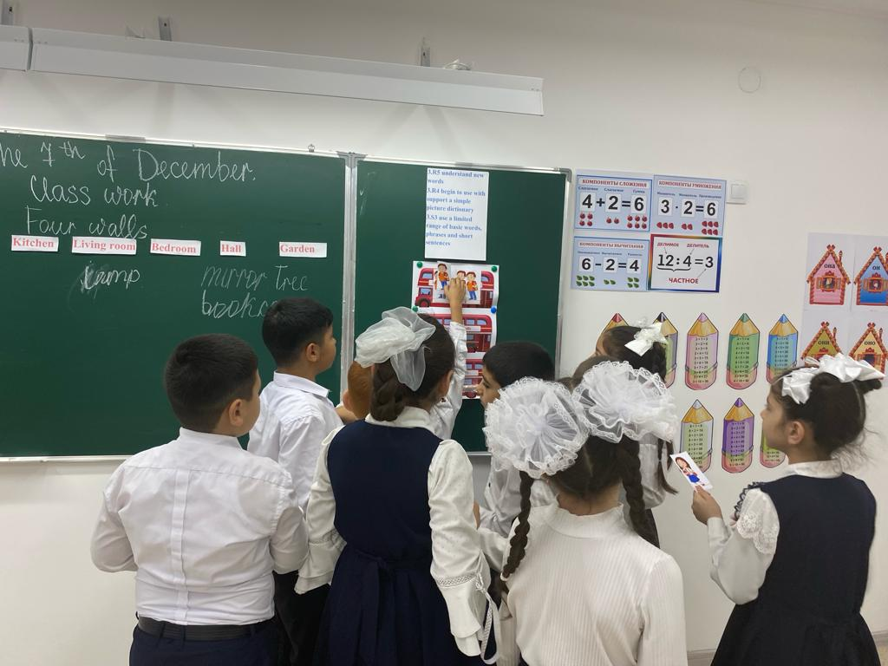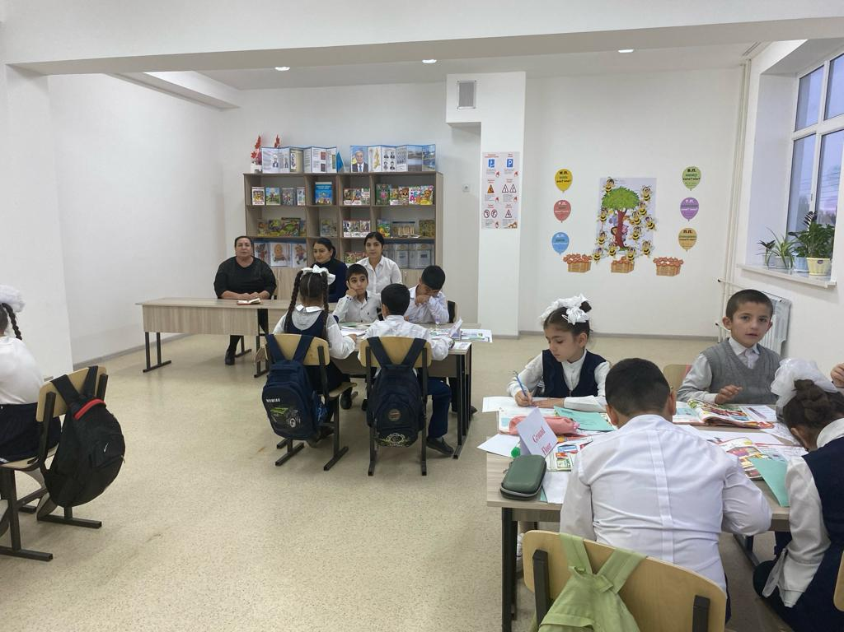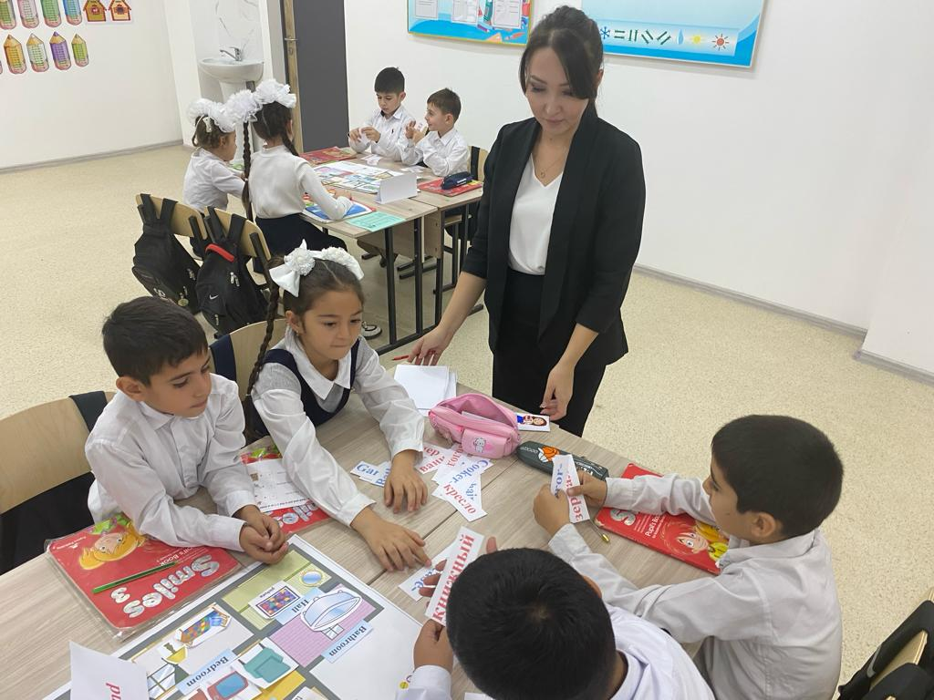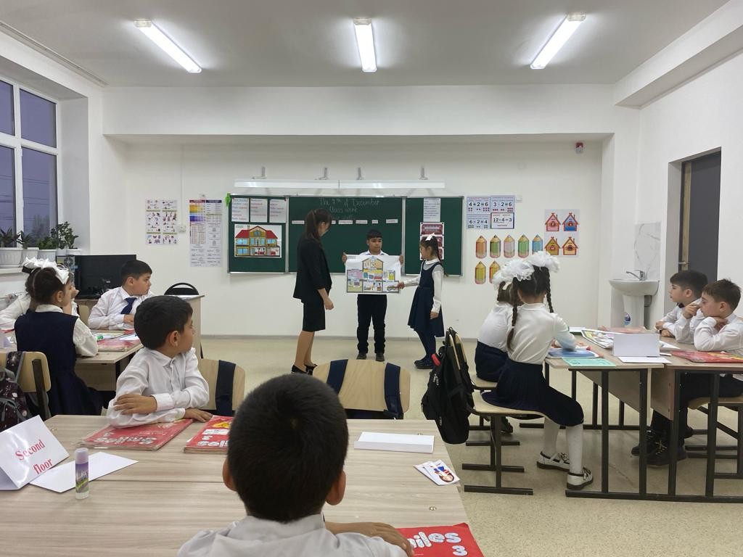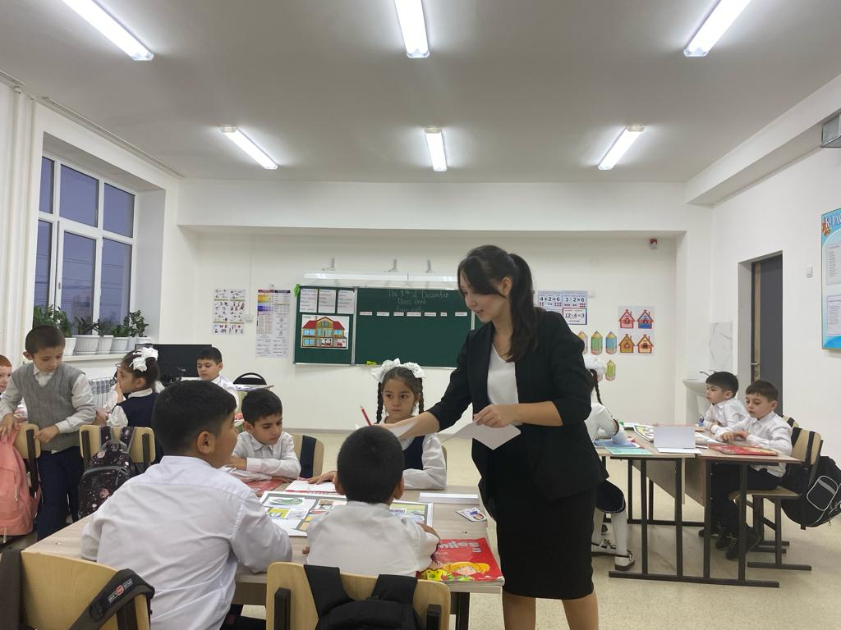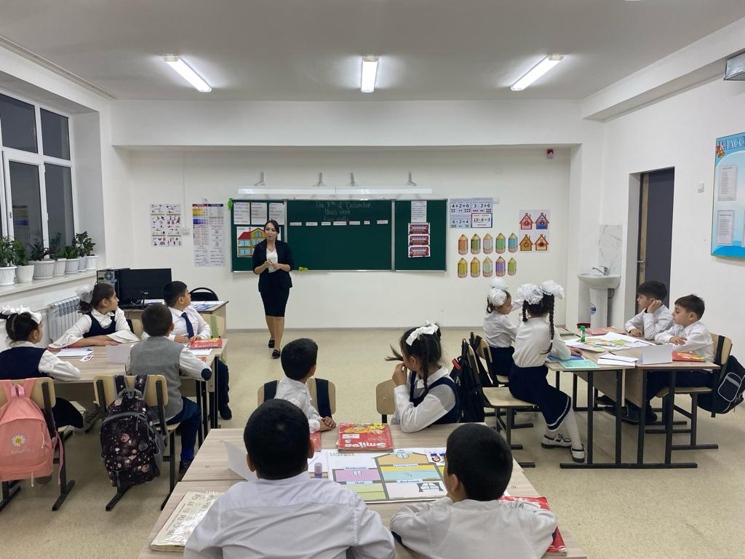

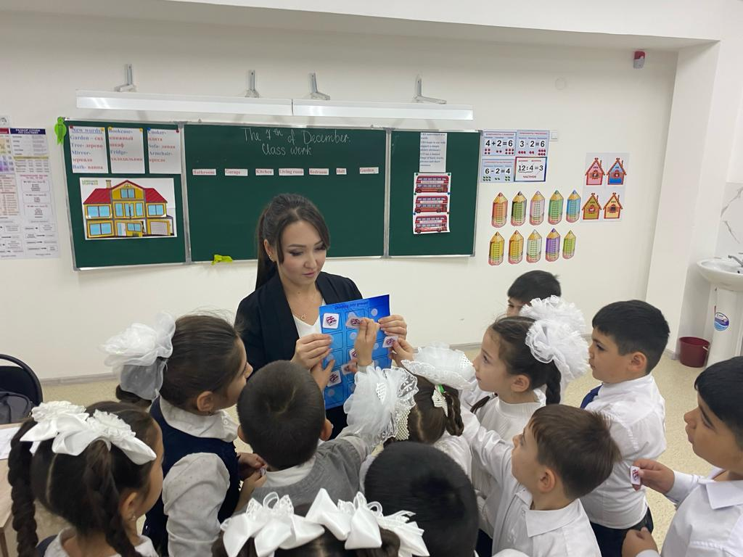

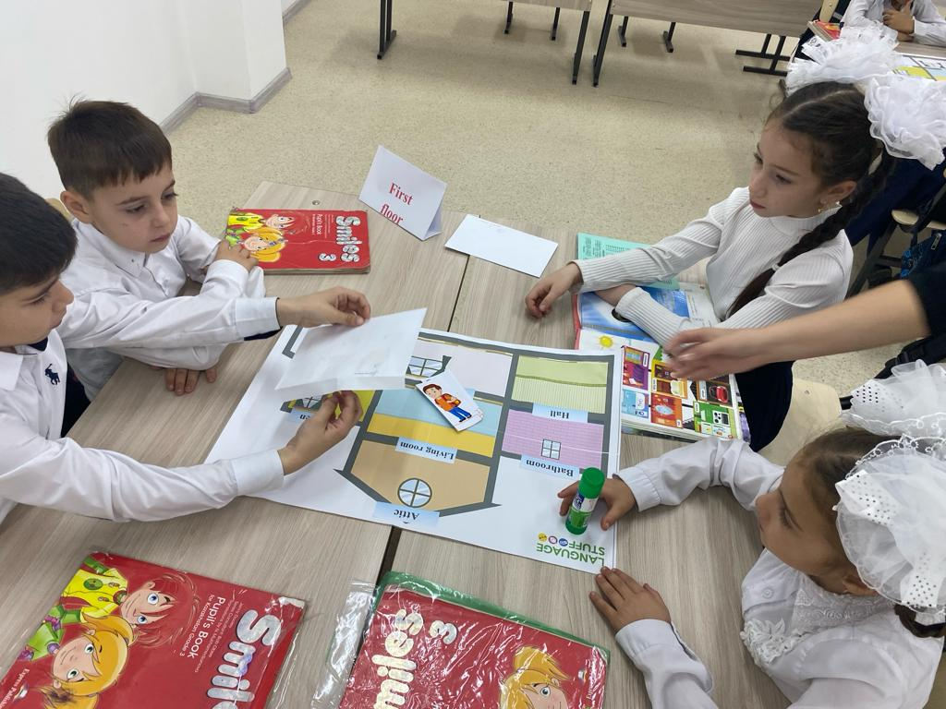

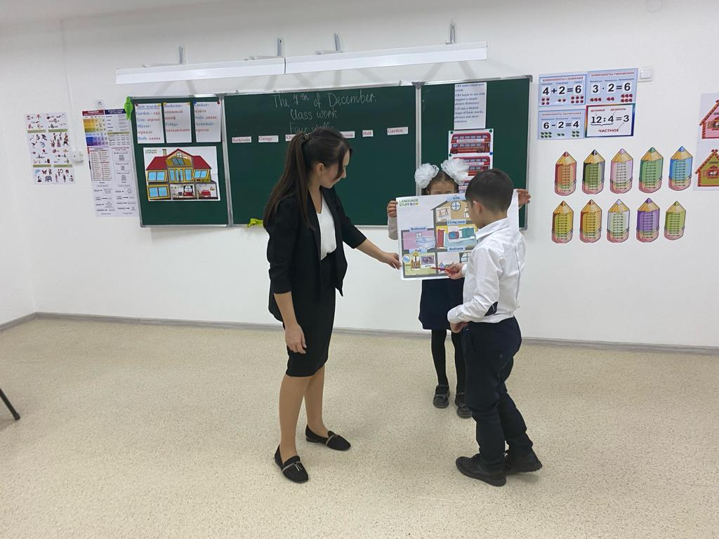

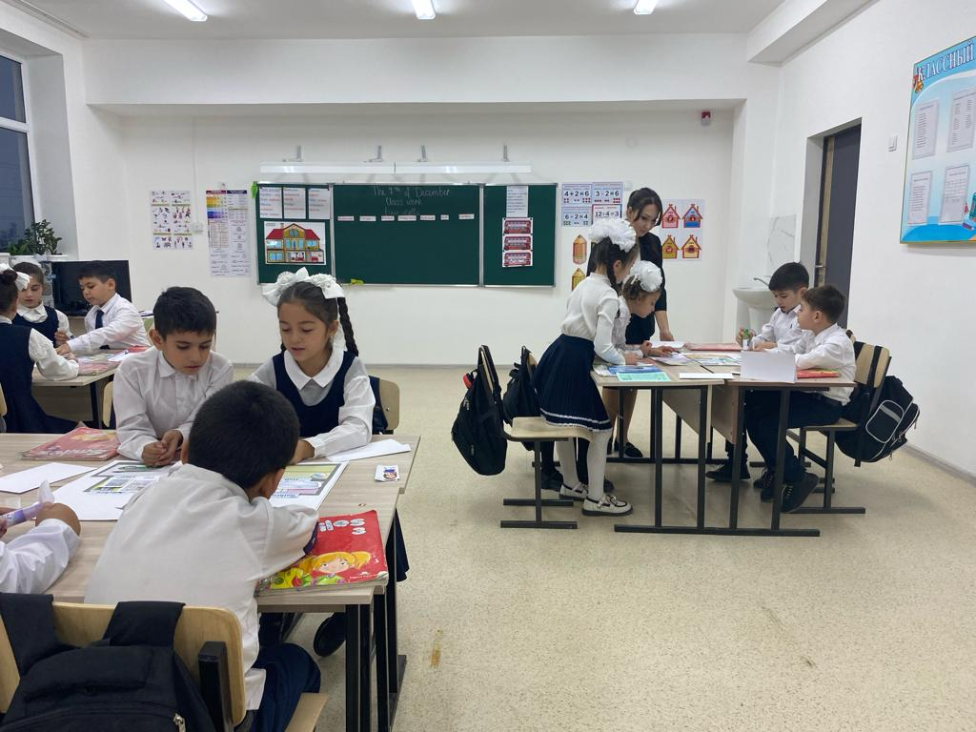

**КОММУНАЛЬНОЕ ГОСУДАРСТВЕННОЕ УЧРЕЖДЕНИЕ «СРЕДНЯЯ ШКОЛА ИМЕНИ АЛЬ-ФАРАБИ» ОТДЕЛА ОБРАЗОВАНИЯ АКИМАТА ШУСКОГО РАЙОНА**

**Открытый урок**

**по английскому языку**

**На тему: «Four walls»**

**Учитель английского языка: Ким В.В**

**Класс: 3 «Б»**

**2023 год**