Қостанай облысы әкімдігі Білім басқармасының «Қостанай ауданы білім бөлімі Тобыл қаласының мектеп – гимназиясы» КММ

КГУ «Школа – гимназия города Тобыл отдела образования Костанайского района» Управления образования акимата Костанайской области

УМК для формирования функциональной грамотности и коммуникативных навыков на уроках английского языка в 6 классе через

систему упражнений и заданий

Автор: учитель английского языка

Педагог-модератор

Малык Е.А.

г.Тобыл, 2025

**Содержание**

Пояснительная записка

1. Теоретическая часть:

1.1 Тематическое планирование………………………………….…..…3

* 1. Планы уроков…………………………………...…………………...6

1. Практическая часть…………………………………………………………65

2.1 Рабочие листы, задания, упражнения для учеников………….…65

3. Методические рекомендации использования пособия

Источники………………………………..………………………..……………103

**ПОЯСНИТЕЛЬНАЯ ЗАПИСКА**

 Программа учебного предмета *английский язык, 6 класс*разработана  в соответствии с компонентом государственного образовательного стандарта и базисным  учебным планом общеобразовательных организаций.

**Актуальность программы**

Актуальность программы состоит в формировании коммуникативной компетенции, способности и готовности осуществлять иноязычное межличностное  и межкультурное общение.

Программа способствует развитию коммуникативных способностей, познавательных способностей; формированию умения осознанного чтения у учащихся.

**Цель программы:** расширить и систематизировать знания учащихся для формирования функциональной грамотности и коммуникативных навыков, полученных в курсе английского языка; знакомство с современными способами изучения языка.

**Задачи программы:**

- расширить и систематизировать знания обучающихся, полученные в курсе английского языка;

- создать условия для развития творческого мышления, умения самостоятельно применять и пополнять свои знания;

- создание условий для формирования функциональной грамотности и коммуникативных навыков;

- интереса к изучению английского языка;

- умение самостоятельно приобретать и применять знания;

- развитие творческих способностей, умение работать в группе, вести дискуссию, отстаивать свою точку зрения.

**Ожидаемые результаты:** программа направлена на формирование функциональной грамотности обучающихся, которая предполагает применение языка в реальных жизненных ситуациях. Обучающие ситуации связаны с жизнью и отражают понятную и знакомую им действительность.

|  |  |  |
| --- | --- | --- |
| **№ п/п** | **Название раздела** | **Количество часов** |
| **1.** | Trip to Kazakhstan | **10** |
| **2.** | Jobs and Professions | **4** |
| **3.** | Animals and Nature | **3** |

**Thematic Plan**

|  |  |  |  |  |  |  |
| --- | --- | --- | --- | --- | --- | --- |
| **№** | **Units/ Changing lessons** | **Theme** | **Learning objectives** | **Hours** | **Date** | **Notes** |
| **17 hours** | | | | | | |
| 1 | **Unit 1:**  **Trip to Kazakhstan (10 hours)** | Trip to Kazakhstan | 6.2.5.1 understand with support most of the specific information and details in a long conversation on general and educational topics;  6.1.3.1 respect different points of view;  6.1.8.1 develop intercultural understanding through reading and discussion;  6.2.5.1 understand with support most of the specific information and details in a long conversation on general and educational topics; | 1 |  |  |
| 2 | Vacation in Kazakhstan | 1 |  |  |
| 3 | Baikonur | 1 |  |  |
| 4 | Kazakh national food | 1 |  |  |
| 5 | Popular sport in Kazakhstan | 1 |  |  |
| 6 | Famous people of Kazakhstan | 1 |  |  |
| 7 | Future job | 1 |  |  |
| 8 | Shopping in Kazakhstan | 1 |  |  |
| 9 | The world of wonders | 1 |  |  |
| 10 | My native city | 1 |  |  |
| 11 | **Jobs and Professions**  **(4 hours)** | Popular job in Kazakhstan | 1 |  |  |
| 12 | Jobs Around us | 1 |  |  |
| 13 | **Daily Routines of Different Professions** | 1 |  |  |
| 14 | Future Jobs | 6.3.7.1 use specific vocabulary and syntax within some general and curricular topics | 1 |  |  |
| 15 | **Animals and Nature (3 hours)** | Animals Around Us | 1 |  |  |
| 16 | **Nature Wonders of my Country** | 1 |  |  |
| 17 | **National Parks and Wildlife Reserves** | 1 |  |  |

**Lesson 1**

|  |  |
| --- | --- |
| Unit: 1 |  |
| Teacher’s name: | **Yekaterina Aleksandrovna** |
| Date: |  |
| Grade:6 | Number present: absent: |
| Theme of the lesson: | **A Trip to Kazakhstan** |
| Learning objectives(s) that this lesson is contributing to: | 6.2.5.1 understand with support most of the specific information and details in a long conversation on general and educational topics; |
| Lessonobjectives: | **You will be able to**   * **Study new definitions** * **Understand the text** * **Do the tasks after reading** |
| Value link: | Be friendly, respect each other. |

**Plan:**

|  |  |  |  |  |
| --- | --- | --- | --- | --- |
| **Part of the lesson/Time** | **Teacher’s activity** | **Student’s activity** | **Assessment** | **Resources** |
| **Beginning of the lesson**  **Warming-up**  **3 min.** | **Organization moment:**  1.Greeting.  Ask about the weather, day, and mood. | **The aim:** To develop Ss speaking skills and create friendly atmosphere  **Efficiency:** By telling the wishes they show their appreciations . | At the organization moment T tries to award active Ss. ***«The praise»*** method is used to evaluate Ss with phrases like:  “Good job!  Well done!” | Whiteboard |
| ***Pre-learning***  ***«Brainstorming» method***  **5 min.** | Look at the picture and guess the theme of our lesson.  **The aim of the lesson:** | Ss guess the theme of the lesson  Home Remedies  Ss read the aim | “Good job!  Well done!” | Computer  Presentation |
| **Middle of the lesson**  **30 min.** | **New vocabulary:**  **Bayterek** (Kazakh: Бәйтерек, **Bäyterek**, "tall poplar [tree]") - is a monument and observation tower in Astana, Kazakhstan.  **Medeu** - (Kazakh: **Медеу**; **Medeu**) or **Medeo** (Russian: **Медео**) is an outdoor speed skating and bandy rink in Almaty city.  **Shymbulak** - (Kazakh: Шымбұлақ), also known as Chimbulak (Russian: Чимбулак) is a ski resort near Almaty, the largest city of Kazakhstan.  **Barkhan** - a crescent-shaped shifting sand dune, convex on the windward side and steeper and concave on the leeward  **Tamgaly Tas** - (каз. Тамғалы-**Тас**, «камни со знаками/писанные камни») in Kazakhstan is famous for its rock carvings of Buddha and Burhans (Bodhisattvas).  **Burabai** – National Nature Park in Kazakhstan, also known as Burabay.  **Besbarmak** - (**Бесбармак**, **Beşbarmak**) Kazakh national dish.  **Dombra** (a long-necked lute and a musical string instrument) player  **Group work**  **Let’s read the text**  Task 1 , true or false  **Pair work**  Astana is the capital of …  A. Kazakhstan B. Spain C. Poland D. Turkey E. Kirgizstan  Medeu is situated in …  A. Astana B. Moscow C. Almaty D. New-York E. Kostanai  Bayterek is situated in …  A. Astana B. Almaty C. Taraz D. Chicago E. Kostanai  The most urbanized country in Central Asia is …  A. Kirgizstan B. Turkey C. Turkmenistan D. Afghanistan E. Kazakhstan  **Individual work**  **-** What do you know about cities of Kazakhstan?  - What city is the most visited by tourists?  - What can you tell about people of Kazakhstan?  - What city of Kazakhstan you had visited?  - Give your advices for tourists who want to visit Kazakhstan. | Ss remember phrases about health  Ss work together; they pronounce new vocabulary  Ss read and pronounce  Ss write the task T/F  They marked True (T) or False (F) based on the reading. It was nonproductive task.  - Kazakhstan is a bilingual country.  - Kazakhstan is located in the center of Europe.  - Kazakhstan is 8th largest country in the world.  - The population of Kazakhstan has reached the number of 17, 958, 000 people.  - Urban population in Kazakhstan makes more than 30 % of the total population.  - The greatest numbers of cities in Kazakhstan are located in the Almaty region.  - In Kazakhstan there are 86 cities.  - In cities of Kazakhstan there are only few wonderful places that attract attention of travelers. | “Good job!  Well done!”  Great!  Good job!  Well done!”  Good job!  Well done!”  **Descriptor:**   * Can understand the text * Choose the right answer | Whiteboard  Lists of the words  Presentation  Texts/pictures  cards  Pictures |
| **End of the lesson.**  **Reflection** | T asks students to analyze the lesson and their result. | ***Aim:*** To know how many Ss got the theme.  **Differentiation:** ***«Conclusion»*** method is used to finish the lesson. | Ss evaluate each other and encourage classmate with phrases like:  Well done! Brilliant! Good job! I like it! | Whiteboard |

**Lesson 2**

|  |  |
| --- | --- |
| Unit: 1 |  |
| Teacher’s name: | **Yekaterina Aleksandrovna** |
| Date: |  |
| Grade:6 | Number present: absent: |
| Theme of the lesson: | **Vacation in Kazakhstan** |
| Learning objectives(s) that this lesson is contributing to: | 6.2.5.1 understand with support most of the specific information and details in a long conversation on general and educational topics; |
| Lessonobjectives: | **You will be able to**   * **Study new definitions** * **Understand the text** * **Do the tasks after reading** |
| Value link: | Be friendly, respect each other. |

**Plan:**

|  |  |  |  |  |
| --- | --- | --- | --- | --- |
| **Part of the lesson/Time** | **Teacher’s activity** | **Student’s activity** | **Assessment** | **Resources** |
| **Beginning of the lesson**  **Warming-up**  **3 min.** | **Organization moment:**  1.Greeting.  Ask about the weather, day, and mood. | **The aim:** To develop Ss speaking skills and create friendly atmosphere  **Efficiency:** By telling the wishes they show their appreciations . | At the organization moment T tries to award active Ss. ***«The praise»*** method is used to evaluate Ss with phrases like:  “Good job!  Well done!” | Whiteboard |
| ***Pre-learning***  ***«Brainstorming» method***  **5 min.** | Guess the theme    **The aim of the lesson:**  **Task1**. What are some of new facts you have learnt about Kazakhstan after reading the text? Work with your partner and complete your carts with rounds | Ss guess the theme of the lesson  Ss remember the text about Kazakhstan ( scheme 1) | “Good job!  Well done!” | Computer  Presentation |
| **Middle of the lesson**  **22 min.** | **Task 2.** There are 10 must do and see’s for every traveler who chooses vacation in Kazakhstan. Match these things to do with picture.  **Group work**  Read the text about Vacation in Kazakhstan  **Pair work** ask and answer the questions after reading the text  **Individual task**  Imagine you ar e a tourist agent and you tell some information about Kazakhstan. What can you tell the tourists? | Ss match  Ss work together;  Ss read the text  Ss work in pairs and make a dialogue  Ss make a monologue about Kazakhstan. | “Good job!  Well done!”  Great!  Good job!  Well done!”  Good job!  Well done!”  **Descriptor:**   * Can understand the text | Whiteboard  Lists of the words  Presentation  Texts/pictures  cards  Pictures |
| **End of the lesson.**  **Reflection** | T asks students to analyze the lesson and their result. | ***Aim:*** To know how many Ss got the theme.  **Differentiation:** ***«Conclusion»*** method is used to finish the lesson. | Ss evaluate each other and encourage classmate with phrases like:  Well done! Brilliant! Good job! I like it! | Whiteboard |

**Lesson 3**

|  |  |
| --- | --- |
| Unit: 1 |  |
| Teacher’s name: | **Yekaterina Aleksandrovna** |
| Date: |  |
| Grade:6 | Number present: absent: |
| Theme of the lesson: | **Baikonur** |
| Learning objectives(s) that this lesson is contributing to: | 6.2.5.1 understand with support most of the specific information and details in a long conversation on general and educational topics; |
| Lessonobjectives: | **You will be able to**   * **Study new definitions** * **Understand the text** * **Do the tasks after reading** |
| Value link: | Be friendly, respect each other. |

**Plan:**

|  |  |  |  |  |
| --- | --- | --- | --- | --- |
| **Part of the lesson/Time** | **Teacher’s activity** | **Student’s activity** | **Assessment** | **Resources** |
| **Beginning of the lesson**  **Warming-up**  **3 min.** | **Organization moment:**  1.Greeting.  Ask about the weather, day, and mood. | **The aim:** To develop Ss speaking skills and create friendly atmosphere  **Efficiency:** By telling the wishes they show their appreciations . | At the organization moment T tries to award active Ss. ***«The praise»*** method is used to evaluate Ss with phrases like:  “Good job!  Well done!” | Whiteboard |
| ***Pre-learning***  ***«Brainstorming» method***  **5 min.** | Guess the theme    **The aim of the lesson:**  **Task 1.** Find the word and make the sentence.  **K** and **O** are exactly in the middle.  **N** is one letter before **U** and after **O**.  **R** is at the end.  **B** is at the beginning.  **A** is between **B** and **I**.  ... is a town in Kyzylorda region of Kazakhstan. | Ss guess the theme of the lesson  Ss remember the text about Kazakhstan ( scheme 1) | “Good job!  Well done!” | Computer  Presentation |
| **Middle of the lesson**  **22 min.** | **Group work**  Read the text about Baikonur  **Pair work** **Task 2.** Name the text. .  - Baikonur  - One city of Kazakhstan  - The space center  - The town of national importance  **Task3,4,5** (worksheets)  Individual work  **Task 5 Answer the question and find the odd keyword.**  Keywords: Mercury, Saturn, Mars, Gravity, Jupiter, Neil Armstrong, Venus, Solar system.  1. Does the sun orbit the Earth?  2. What is the closest planet to the Sun?  3. What is the hottest planet in our solar system?  4. What planet is famous for the beautiful rings that surround it?  5. Can humans breathe normally in space as they can on Earth?  6. Is the sun a star or a planet?  7. What planet is known as the red planet?  8. Is the planet Neptune bigger than Earth?  **Group work**  **Make a Spaceship.**  Divide into two groups. Design and build your own spaceship, space station or satellite. What features will you add to make your creation safe as it travels in space? You can draw it or make it from paper. When you've finished, show off your finished creation to others in the class. | Ss read the text  Ss work together;  Ss read the text  Ss work in pairs and do tasks  Ss make a monologue about Kazakhstan.  Ss read and pronounce  . | “Good job!  Well done!”  Great!  Good job!  Well done!”  Good job!  Well done!”  **Descriptor:**   * Can understand the text * Can find the odd word * Answer the questions   **Descriptor**   * Work in groups * Make own spaceship * Use new information * Present to the class | Whiteboard  Lists of the words  Presentation  Texts/pictures  cards  Pictures |
| **End of the lesson.**  **Reflection** | T asks students to analyze the lesson and their result. | ***Aim:*** To know how many Ss got the theme.  **Differentiation:** ***«Conclusion»*** method is used to finish the lesson. | Ss evaluate each other and encourage classmate with phrases like:  Well done! Brilliant! Good job! I like it! | Whiteboard |

**Lesson 4**

|  |  |
| --- | --- |
| Unit: 1 |  |
| Teacher’s name: | **Yekaterina Aleksandrovna** |
| Date: |  |
| Grade:6 | Number present: absent: |
| Theme of the lesson: | **Kazakh national food** |
| Learning objectives(s) that this lesson is contributing to: | 6.2.5.1 understand with support most of the specific information and details in a long conversation on general and educational topics; |
| Lessonobjectives: | **You will be able to**   * **Study new definitions** * **Understand the text** * **Do the tasks after reading** |
| Value link: | Be friendly, respect each other. |

**Plan:**

|  |  |  |  |  |
| --- | --- | --- | --- | --- |
| **Part of the lesson/Time** | **Teacher’s activity** | **Student’s activity** | **Assessment** | **Resources** |
| **Beginning of the lesson**  **Warming-up**  **3 min.** | **Organization moment:**  1.Greeting.  Ask about the weather, day, and mood. | **The aim:** To develop Ss speaking skills and create friendly atmosphere  **Efficiency:** By telling the wishes they show their appreciations . | At the organization moment T tries to award active Ss. ***«The praise»*** method is used to evaluate Ss with phrases like:  “Good job!  Well done!” | Whiteboard |
| ***Pre-learning***  ***«Brainstorming» method***  **5 min.** | Guess the theme  **The aim of the lesson:**  . | Ss guess the theme of the lesson  Ss remember the text about Kazakhstan ( scheme 1) | “Good job!  Well done!” | Computer  Presentation |
| **Middle of the lesson**  **22 min.** | **Group work**  Read the text about Traditional food.  **Pair work** **Task 2.**  Match the picture and the name of food.  **Task 3**  Choose the right variant.  1.Traditional Kazakh food “Besbarmak” is the  a. Horse dish  b. Pig dish  2.Style of Kazakh eating is eating  a. On carpet on the floor b. On the table  3.Traditional Kazakh way of eating is when you  a. Use hands  b. use spoons and forks  4.Speaker … traditional Kazakh food.  a. Likes b. doesn’t like  **Individual work.** Match the words and their definition. Table 1.  Task 4. Correct the statements.  1.Baursaks are served to the kumis and shurpa.  2.The dastarhan is filled with fruits and seafood.  1.The most popular Uygur dish is “besbarmak”.  2.Traditional first course dish in the Kazakh cuisine is tea.  3.Traditionally Kazakh cuisine was based on seafood. | Ss read the text  Ss work together;  Ss work in pairs and do tasks  Ss watch video material and choose the right answer  .  Ss work individually. | “Good job!  Well done!”  Great!  Good job!  Well done!”  Good job!  Well done!”  **Descriptor:**   * Can understand the text * Can find the odd word * Answer the questions   **Descriptor**   * Work individual * Use new knowledge after reading | Whiteboard  Lists of the words  Presentation  Texts/pictures  cards  Pictures |
| **End of the lesson.**  **Reflection** | T asks students to analyze the lesson and their result. | ***Aim:*** To know how many Ss got the theme.  **Differentiation:** ***«Conclusion»*** method is used to finish the lesson. | Ss evaluate each other and encourage classmate with phrases like:  Well done! Brilliant! Good job! I like it! | Whiteboard |

**Lesson 5**

|  |  |
| --- | --- |
| Unit: 1 |  |
| Teacher’s name: | **Yekaterina Aleksandrovna** |
| Date: |  |
| Grade:6 | Number present: absent: |
| Theme of the lesson: | **Popular sport in Kazakhstan** |
| Learning objectives(s) that this lesson is contributing to: | 6.2.5.1 understand with support most of the specific information and details in a long conversation on general and educational topics; |
| Lessonobjectives: | **You will be able to**   * **Study new definitions** * **Understand the text** * **Do the tasks after reading** |
| Value link: | Be friendly, respect each other. |

**Plan:**

|  |  |  |  |  |
| --- | --- | --- | --- | --- |
| **Part of the lesson/Time** | **Teacher’s activity** | **Student’s activity** | **Assessment** | **Resources** |
| **Beginning of the lesson**  **Warming-up**  **3 min.** | **Organization moment:**  1.Greeting.  Ask about the weather, day, and mood. | **The aim:** To develop Ss speaking skills and create friendly atmosphere  **Efficiency:** By telling the wishes they show their appreciations . | At the organization moment T tries to award active Ss. ***«The praise»*** method is used to evaluate Ss with phrases like:  “Good job!  Well done!” | Whiteboard |
| ***Pre-learning***  ***«Brainstorming» method***  **5 min.** | Guess the theme  **The aim of the lesson:**  . | Ss guess the theme of the lesson  Ss remember the text about Kazakhstan ( scheme 1) | “Good job!  Well done!” | Computer  Presentation |
| **Middle of the lesson**  **22 min.** | **Group work**  Read the text  **Pair work**  Answer the questions  1. Do you like sport?  2. What kinds of sports do you know?  3. How do you think: sport is exciting or dangerous?  4. Do you prefer going in for sports or watching it on TV?  5. What kinds of sports are popular in Kazakhstan?  6. What national Kazakh sports do you know? | Ss read the text  Ss work together;  Ss work in pairs and do tasks  Ss watch video material and choose the right answer  . | “Good job!  Well done!”  Great!  Good job!  Well done!”  Good job!  Well done!”  **Descriptor:**   * Can understand the text * Can find the odd word * Answer the questions   **Descriptor**   * Work individual * Use new knowledge after reading | Whiteboard  Lists of the words  Presentation  Texts/pictures  cards  Pictures |
| **End of the lesson.**  **Reflection** | T asks students to analyze the lesson and their result. | ***Aim:*** To know how many Ss got the theme.  **Differentiation:** ***«Conclusion»*** method is used to finish the lesson. | Ss evaluate each other and encourage classmate with phrases like:  Well done! Brilliant! Good job! I like it! | Whiteboard |

**Lesson 6**

|  |  |
| --- | --- |
| Unit: 1 |  |
| Teacher’s name: | **Yekaterina Aleksandrovna** |
| Date: |  |
| Grade:6 | Number present: absent: |
| Theme of the lesson: | **Famous people of Kazakhstan** |
| Learning objectives(s) that this lesson is contributing to: | 6.2.5.1 understand with support most of the specific information and details in a long conversation on general and educational topics; |
| Lessonobjectives: | **You will be able to**   * **Study new definitions** * **Understand the text** * **Do the tasks after reading** |
| Value link: | Be friendly, respect each other. |

**Plan:**

|  |  |  |  |  |
| --- | --- | --- | --- | --- |
| **Part of the lesson/Time** | **Teacher’s activity** | **Student’s activity** | **Assessment** | **Resources** |
| **Beginning of the lesson**  **Warming-up**  **3 min.** | **Organization moment:**  1.Greeting.  Ask about the weather, day, and mood. | **The aim:** To develop Ss speaking skills and create friendly atmosphere  **Efficiency:** By telling the wishes they show their appreciations . | At the organization moment T tries to award active Ss. ***«The praise»*** method is used to evaluate Ss with phrases like:  “Good job!  Well done!” | Whiteboard |
| ***Pre-learning***  ***«Brainstorming» method***  **5 min.** | Guess the theme  **The aim of the lesson:**  . | Ss guess the theme of the lesson  Ss remember the text about Kazakhstan ( scheme 1) | “Good job!  Well done!” | Computer  Presentation |
| **Middle of the lesson**  **22 min.** | **Group work**  Read the text  **Pair work**  **Task 1. Answer the questions.**  1. What is the name of a famous violin player?  2. What is the name of the first goal-tender in the history of NHL who scored the power play goal?  3. What is the name of scientist who currently lives and works in U.S.  4. Who was born in Ust-Kamenogorsk?  5. Who are 36?  6. Who are 50?  7. Who are currently lives in Great Britain and India?  8. Who is the first Kazakh Minister in Europe?  9. Who is the best goaltender of the World Championship 2008?  10. Who has two children? | Ss read the text  Ss work together;  Ss work in pairs and do tasks  Ss watch video material and choose the right answer  . | “Good job!  Well done!”  Great!  Good job!  Well done!”  Good job!  Well done!”  **Descriptor:**   * Can understand the text * Can find the odd word * Answer the questions   **Descriptor**   * Work individual * Use new knowledge after reading | Whiteboard  Lists of the words  Presentation  Texts/pictures  cards  Pictures |
| **End of the lesson.**  **Reflection** | T asks students to analyze the lesson and their result. | ***Aim:*** To know how many Ss got the theme.  **Differentiation:** ***«Conclusion»*** method is used to finish the lesson. | Ss evaluate each other and encourage classmate with phrases like:  Well done! Brilliant! Good job! I like it! | Whiteboard |

**Lesson 7**

|  |  |
| --- | --- |
| Unit: 1 |  |
| Teacher’s name: | **Yekaterina Aleksandrovna** |
| Date: |  |
| Grade:6 | Number present: absent: |
| Theme of the lesson: | **Future job** |
| Learning objectives(s) that this lesson is contributing to: | 6.1.3.1 respect different points of view;  6.1.8.1 develop intercultural understanding through reading and discussion; |
| Lessonobjectives: | **You will be able to**   * **Study new vocabulary** * **Understand the text** * **Do the tasks after reading** |
| Value link: | Be friendly, respect each other. |

**Plan:**

|  |  |  |  |  |
| --- | --- | --- | --- | --- |
| **Part of the lesson/Time** | **Teacher’s activity** | **Student’s activity** | **Assessment** | **Resources** |
| **Beginning of the lesson**  **Warming-up**  **3 min.** | **Organization moment:**  1.Greeting.  Ask about the weather, day, and mood. | **The aim:** To develop Ss speaking skills and create friendly atmosphere  **Efficiency:** By telling the wishes they show their appreciations . | At the organization moment T tries to award active Ss. ***«The praise»*** method is used to evaluate Ss with phrases like:  “Good job!  Well done!” | Whiteboard |
| ***Pre-learning***  ***«Brainstorming» method***  **5 min.** | Guess the theme  **The aim of the lesson:**  .  Let’s think about your future.   * I’ll be a pilot in Air Company of Kazakhstan. * I’ll be a doctor in Almaty hospita * I’ll be a teacher in Nazarbaev School. * I’ll be a manager in Astana shop. | Ss guess the theme of the lesson  Ss think about future and speak | “Good job!  Well done!”  Good job!  Well done!”  Good job!  Well done!” | Computer  Presentation |
| **Middle of the lesson**  **22 min.** | **Group work**  **Task 2.** Complete the table.  **Pair work**  **Task 3.** Read the dialogue and make the  same.  New material  **Task 4.**  Compare with the meaning. | Ss read the text  Ss work together;  Ss work in pairs and do tasks  Ss read material and translate | “Good job!  Well done!”  Great!  Good job!  Well done!”  **Descriptor:**   * Can understand the words of wisdom * Can find the meaning | Whiteboard  Lists of the words  Presentation  Texts/pictures  cards  Pictures |
| **End of the lesson.**  **Reflection** | T asks students to analyze the lesson and their result. | ***Aim:*** To know how many Ss got the theme.  **Differentiation:** ***«Conclusion»*** method is used to finish the lesson. | Ss evaluate each other and encourage classmate with phrases like:  Well done! Brilliant! Good job! I like it! | Whiteboard |

**Lesson 8**

|  |  |
| --- | --- |
| Unit: 1 |  |
| Teacher’s name: | **Yekaterina Aleksandrovna** |
| Date: |  |
| Grade:6 | Number present: absent: |
| Theme of the lesson: | **Shopping in Kazakhstan** |
| Learning objectives(s) that this lesson is contributing to: | 6.1.3.1 respect different points of view;  6.1.8.1 develop intercultural understanding through reading and discussion; |
| Lessonobjectives: | **You will be able to**   * **Study new vocabulary** * **Understand the text** * **Do the tasks after reading** |
| Value link: | Be friendly, respect each other. |

**Plan:**

|  |  |  |  |  |
| --- | --- | --- | --- | --- |
| **Part of the lesson/Time** | **Teacher’s activity** | **Student’s activity** | **Assessment** | **Resources** |
| **Beginning of the lesson**  **Warming-up**  **3 min.** | **Organization moment:**  1.Greeting.  Ask about the weather, day, and mood. | **The aim:** To develop Ss speaking skills and create friendly atmosphere  **Efficiency:** By telling the wishes they show their appreciations . | At the organization moment T tries to award active Ss. ***«The praise»*** method is used to evaluate Ss with phrases like:  “Good job!  Well done!” | Whiteboard |
| ***Pre-learning***  ***«Brainstorming» method***  **5 min.** | Guess the theme  **The aim of the lesson:**  .  **Task 1**. Answer the questions about yourself. | Ss guess the theme of the lesson  Ss think about questions and answe | “Good job!  Well done!”  Good job!  Well done!”  Good job!  Well done!” | Computer  Presentation |
| **Middle of the lesson**  **22 min.** | New words   * Range * Megamall * Teeming * Bargain * Vender * Butcher * Hand-stuffing * Spicy * Colorful piles of fruits * Sampling * Bowling alley * Deli * A welcoming vibe * Flashy * Dozens * Florist, * Chemist * Painkillers * Withdraw cash * Grocer * Stock up.   **Group work**  **Task 2.** Compare name picture  **Pair work**  **Task 3.** Read the dialogue and make the  same.  **Task 4. Answer.**  Where can you buy these things?  - Mobile phone  - Traditional food  - Cheese at midnight  - Fashionable clothes  - Everything what you want  **Task 5. Match (pair work)**  **Group work**  **Task 6**  Read and act the dialogue. | Ss read and pronounce  Ss work together;  Ss read the text  Ss work in pairs and do tasks  Ss read material and translate  .  Ss act and show their dialogue | “Good job!  Well done!”  Great!  Good job!  Well done!”  **Descriptor:**   * Can understand the new vocabulary * Can match * Can act the dialogue | Whiteboard  Lists of the words  Presentation  Texts/pictures  cards  Pictures |
| **End of the lesson.**  **Reflection** | T asks students to analyze the lesson and their result. | ***Aim:*** To know how many Ss got the theme.  **Differentiation:** ***«Conclusion»*** method is used to finish the lesson. | Ss evaluate each other and encourage classmate with phrases like:  Well done! Brilliant! Good job! I like it! | Whiteboard |

**Lesson 9**

|  |  |
| --- | --- |
| Unit: 1 |  |
| Teacher’s name: | **Yekaterina Aleksandrovna** |
| Date: |  |
| Grade:6 | Number present: absent: |
| Theme of the lesson: | **The world of wonders** |
| Learning objectives(s) that this lesson is contributing to: | 6.1.3.1 respect different points of view;  6.1.8.1 develop intercultural understanding through reading and discussion; |
| Lessonobjectives: | **You will be able to**   * **Study new vocabulary** * **Understand the text** * **Do the tasks after reading** |
| Value link: | Be friendly, respect each other. |

**Plan:**

|  |  |  |  |  |
| --- | --- | --- | --- | --- |
| **Part of the lesson/Time** | **Teacher’s activity** | **Student’s activity** | **Assessment** | **Resources** |
| **Beginning of the lesson**  **Warming-up**  **3 min.** | **Organization moment:**  1.Greeting.  Ask about the weather, day, and mood. | **The aim:** To develop Ss speaking skills and create friendly atmosphere  **Efficiency:** By telling the wishes they show their appreciations . | At the organization moment T tries to award active Ss. ***«The praise»*** method is used to evaluate Ss with phrases like:  “Good job!  Well done!” | Whiteboard |
| ***Pre-learning***  ***«Brainstorming» method***  **5 min.** | Guess the theme    **The aim of the lesson:**  .  **Task 1**. Find the words.  DLOWR – world  DSWNOER –  Ybaruab – | Ss guess the theme of the lesson  Ss think and find | “Good job!  Well done!”  Good job!  Well done!”  Good job!  Well done!” | Computer |
| **Middle of the lesson**  **30 min.** | **Group work**  **Task 2.**  Read the text  **Pair work**  **Task 3.**  **task**. Answer the questions   1. Where is Burabay situated? 2. What can you see in Burabay? 3. What legend do you know about Burabay? 4. According to legend what happened with Oirat princess?   **Group work**  **Task4**  Play the situation.  1.Tourist guides and other  2.Tourists Tourists must ask different questions and tourist guides should answer  . | Ss read the text  Ss work together;  Ss read the text  Ss work in pairs and do tasks  Ss read material and translate  Ss act and show their dialogue | “Good job!  Well done!”  Great!  Good job!  Well done!”  **Descriptor:**   * Can understand the new vocabulary * Can match * Can act the dialogue | Whiteboard  Lists of the words  Presentation  Texts/pictures  cards  Pictures |
| **End of the lesson.**  **Reflection** | T asks students to analyze the lesson and their result. | ***Aim:*** To know how many Ss got the theme.  **Differentiation:** ***«Conclusion»*** method is used to finish the lesson. | Ss evaluate each other and encourage classmate with phrases like:  Well done! Brilliant! Good job! I like it! | Whiteboard |

**Lesson 10**

|  |  |
| --- | --- |
| Unit: 1 |  |
| Teacher’s name: | **Yekaterina Aleksandrovna** |
| Date: |  |
| Grade:6 | Number present: absent: |
| Theme of the lesson: | **The world of wonders** |
| Learning objectives(s) that this lesson is contributing to: | 6.1.3.1 respect different points of view;  6.1.8.1 develop intercultural understanding through reading and discussion; |
| Lessonobjectives: | **You will be able to**   * **Study new vocabulary** * **Understand the text** * **Do the tasks after reading** |
| Value link: | Be friendly, respect each other. |

**Plan:**

|  |  |  |  |  |
| --- | --- | --- | --- | --- |
| **Part of the lesson/Time** | **Teacher’s activity** | **Student’s activity** | **Assessment** | **Resources** |
| **Beginning of the lesson**  **Warming-up**  **3 min.** | **Organization moment:**  1.Greeting.  Ask about the weather, day, and mood. | **The aim:** To develop Ss speaking skills and create friendly atmosphere  **Efficiency:** By telling the wishes they show their appreciations . | At the organization moment T tries to award active Ss. ***«The praise»*** method is used to evaluate Ss with phrases like:  “Good job!  Well done!” | Whiteboard |
| ***Pre-learning***  ***«Brainstorming» method***  **5 min.** | Guess the theme  We are going to speak about …Look at the board and try to translate.  **The aim of the lesson:** | Ss guess the theme of the lesson  Ss think and find | “Good job!  Well done!”  Good job!  Well done!”  Good job!  Well done!” | Computer |
| **Middle of the lesson**  **30 min.** | **Group work**  **Task 1**. Read the text  **Task 1.**  Answer the questions:   1. What is the origin of the name "Karaganda"? 2. What industry was the city built around? 3. What is the climate like in Karaganda?   **Task 2.**  Find and write down three important facts about Karaganda’s history.  **Individual work**  **Task 3.**  Retell the text  **Task 4.**  Tell some information about your native city. Use the text as an example. | Ss read the text  Ss work together;  Ss read the text  Ss work in pairs and do tasks  Ss read material and translate  Ss act and show their dialogue | “Good job!  Well done!”  Great!  Good job!  Well done!”  **Descriptor:**   * Can understand the text * Can answer the questions * Can retell | Whiteboard  Lists of the words  Presentation  Texts/pictures  cards  Pictures |
| **End of the lesson.**  **Reflection** | T asks students to analyze the lesson and their result. | ***Aim:*** To know how many Ss got the theme.  **Differentiation:** ***«Conclusion»*** method is used to finish the lesson. | Ss evaluate each other and encourage classmate with phrases like:  Well done! Brilliant! Good job! I like it! | Whiteboard |

**Lesson 11**

|  |  |
| --- | --- |
| Unit: 1 |  |
| Teacher’s name: | **Yekaterina Aleksandrovna** |
| Date: |  |
| Grade:6 | Number present: absent: |
| Theme of the lesson: | **Popular job in Kazakhstan** |
| Learning objectives(s) that this lesson is contributing to: | 6.1.3.1 respect different points of view;  6.1.8.1 develop intercultural understanding through reading and discussion; |
| Lessonobjectives: | **You will be able to**   * **Study new vocabulary** * **Understand the text** * **Do the tasks after reading** |
| Value link: | Be friendly, respect each other. |

**Plan:**

|  |  |  |  |  |
| --- | --- | --- | --- | --- |
| **Part of the lesson/Time** | **Teacher’s activity** | **Student’s activity** | **Assessment** | **Resources** |
| **Beginning of the lesson**  **Warming-up**  **3 min.** | **Organization moment:**  1.Greeting.  Ask about the weather, day, and mood. | **The aim:** To develop Ss speaking skills and create friendly atmosphere  **Efficiency:** By telling the wishes they show their appreciations . | At the organization moment T tries to award active Ss. ***«The praise»*** method is used to evaluate Ss with phrases like:  “Good job!  Well done!” | Whiteboard |
| ***Pre-learning***  ***«Brainstorming» method***  **5 min.** | Guess the theme  We are going to speak about  **The aim of the lesson:** | Ss guess the theme of the lesson  Ss think and find | “Good job!  Well done!”  Good job!  Well done!”  Good job!  Well done!” | Computer |
| **Middle of the lesson**  **30 min.** | **Group work**  **Task 1**. Read the text  **Task 1.**  Underline the names of the jobs  Answer the questions:   1. Why is the IT sector growing in Kazakhstan? 2. What profession helps to prepare future generations? 3. Why do some people choose to become entrepreneurs? 4. Why oil and gas engineers are important for Kazakhstan?   **Pair work**  **Task 2.**  Make a presentation Which profession from the text do you think is the best? Why?  **Individual work**  **Task 3.** Write a short paragraph (10 sentences) about your favorite job and why it is important. | Ss read the text  Ss work together;  Ss read the text  Ss work in pairs and do tasks  Ss read material and translate  Ss act and show their dialogue | “Good job!  Well done!”  Great!  Good job!  Well done!”  **Descriptor:**   * Can understand the text * Can answer the questions * Can retell | Whiteboard  Lists of the words  Presentation  Texts/pictures  cards  Pictures |
| **End of the lesson.**  **2 min**  **Reflection** | T asks students to analyze the lesson and their result. | ***Aim:*** To know how many Ss got the theme.  **Differentiation:** ***«Conclusion»*** method is used to finish the lesson. | Ss evaluate each other and encourage classmate with phrases like:  Well done! Brilliant! Good job! I like it! | Whiteboard |

**Lesson 12**

|  |  |
| --- | --- |
| Unit: 1 |  |
| Teacher’s name: | **Yekaterina Aleksandrovna** |
| Date: |  |
| Grade:6 | Number present: absent: |
| Theme of the lesson: | **Popular job in Kazakhstan** |
| Learning objectives(s) that this lesson is contributing to: | 6.1.3.1 respect different points of view;  6.1.8.1 develop intercultural understanding through reading and discussion; |
| Lessonobjectives: | **You will be able to**   * **Study new vocabulary** * **Understand the text** * **Do the tasks after reading** |
| Value link: | Be friendly, respect each other. |

**Plan:**

|  |  |  |  |  |
| --- | --- | --- | --- | --- |
| **Part of the lesson/Time** | **Teacher’s activity** | **Student’s activity** | **Assessment** | **Resources** |
| **Beginning of the lesson**  **Warming-up**  **3 min.** | **Organization moment:**  1.Greeting.  Ask about the weather, day, and mood. | **The aim:** To develop Ss speaking skills and create friendly atmosphere  **Efficiency:** By telling the wishes they show their appreciations . | At the organization moment T tries to award active Ss. ***«The praise»*** method is used to evaluate Ss with phrases like:  “Good job!  Well done!” | Whiteboard |
| ***Pre-learning***  ***«Brainstorming» method***  **5 min.** | Guess the theme  We are going to speak about  **The aim of the lesson:** | Ss guess the theme of the lesson  Ss think and find | “Good job!  Well done!”  Good job!  Well done!”  Good job!  Well done!” | Computer |
| **Middle of the lesson**  **30 min.** | **Group work**  **Task 1**. Read the text  **Task 2.**  1.List three well-paid jobs in Kazakhstan and explain 2.Why they are important?  3.Why do some people choose to become entrepreneurs?  4.Find and write down three jobs that require a university education.  5.Describe how different professions help society.  **Pair work**  **Task 3.**  Compare two professions from the text. How are they similar and different?  **Individual work**  **Task 4.**  Tell to the class What job would you like to have in the future? Why? | Ss read the text  Ss work together;  Ss read the text  Ss work in pairs and do tasks  Ss read material and translate  Ss act and show their dialogue | “Good job!  Well done!”  Great!  Good job!  Well done!”  **Descriptor:**   * Can understand the text * Can answer the questions * Can tell about their dream | Whiteboard  Lists of the words  Presentation  Texts/pictures  cards  Pictures |
| **End of the lesson.**  **2 min**  **Reflection** | T asks students to analyze the lesson and their result. | ***Aim:*** To know how many Ss got the theme.  **Differentiation:** ***«Conclusion»*** method is used to finish the lesson. | Ss evaluate each other and encourage classmate with phrases like:  Well done! Brilliant! Good job! I like it! | Whiteboard |

**Lesson 13**

|  |  |
| --- | --- |
| Unit: 1 |  |
| Teacher’s name: | **Yekaterina Aleksandrovna** |
| Date: |  |
| Grade:6 | Number present: absent: |
| Theme of the lesson: | **Popular job in Kazakhstan** |
| Learning objectives(s) that this lesson is contributing to: | 6.1.3.1 respect different points of view;  6.1.8.1 develop intercultural understanding through reading and discussion; |
| Lessonobjectives: | **You will be able to**   * **Study new vocabulary** * **Understand the text** * **Do the tasks after reading** |
| Value link: | Be friendly, respect each other. |

**Plan:**

|  |  |  |  |  |
| --- | --- | --- | --- | --- |
| **Part of the lesson/Time** | **Teacher’s activity** | **Student’s activity** | **Assessment** | **Resources** |
| **Beginning of the lesson**  **Warming-up**  **3 min.** | **Organization moment:**  1.Greeting.  Ask about the weather, day, and mood. | **The aim:** To develop Ss speaking skills and create friendly atmosphere  **Efficiency:** By telling the wishes they show their appreciations . | At the organization moment T tries to award active Ss. ***«The praise»*** method is used to evaluate Ss with phrases like:  “Good job!  Well done!” | Whiteboard |
| ***Pre-learning***  ***«Brainstorming» method***  **5 min.** | Guess the theme  We are going to speak about  **The aim of the lesson:** | Ss guess the theme of the lesson  Ss think and find | “Good job!  Well done!”  Good job!  Well done!”  Good job!  Well done!” | Computer |
| **Middle of the lesson**  **30 min.** | **Group work**  **Task 1**. Read the text  **Task 2.**  1.List three well-paid jobs in Kazakhstan and explain 2.Why they are important?  3.Why do some people choose to become entrepreneurs?  4.Find and write down three jobs that require a university education.  5.Describe how different professions help society.  **Pair work**  **Task 3.**  Compare two professions from the text. How are they similar and different?  **Individual work**  **Task 4.**  Tell to the class What job would you like to have in the future? Why? | Ss read the text  Ss work together;  Ss read the text  Ss work in pairs and do tasks  Ss read material and translate  Ss act and show their dialogue | “Good job!  Well done!”  Great!  Good job!  Well done!”  **Descriptor:**   * Can understand the text * Can answer the questions * Can tell about their dream | Whiteboard  Lists of the words  Presentation  Texts/pictures  cards  Pictures |
| **End of the lesson.**  **2 min**  **Reflection** | T asks students to analyze the lesson and their result. | ***Aim:*** To know how many Ss got the theme.  **Differentiation:** ***«Conclusion»*** method is used to finish the lesson. | Ss evaluate each other and encourage classmate with phrases like:  Well done! Brilliant! Good job! I like it! | Whiteboard |

**Lesson 14**

|  |  |
| --- | --- |
| Unit: 1 |  |
| Teacher’s name: | **Yekaterina Aleksandrovna** |
| Date: |  |
| Grade:6 | Number present: absent: |
| Theme of the lesson: | **Future Jobs in Kazakhstan** |
| Learning objectives(s) that this lesson is contributing to: | 6.1.3.1 respect different points of view;  6.1.8.1 develop intercultural understanding through reading and discussion; |
| Lessonobjectives: | **You will be able to**   * **Study new vocabulary** * **Understand the text** * **Do the tasks after reading** |
| Value link: | Be friendly, respect each other. |

**Plan:**

|  |  |  |  |  |
| --- | --- | --- | --- | --- |
| **Part of the lesson/Time** | **Teacher’s activity** | **Student’s activity** | **Assessment** | **Resources** |
| **Beginning of the lesson**  **Warming-up**  **3 min.** | **Organization moment:**  1.Greeting.  Ask about the weather, day, and mood. | **The aim:** To develop Ss speaking skills and create friendly atmosphere  **Efficiency:** By telling the wishes they show their appreciations . | At the organization moment T tries to award active Ss. ***«The praise»*** method is used to evaluate Ss with phrases like:  “Good job!  Well done!” | Whiteboard |
| ***Pre-learning***  ***«Brainstorming» method***  **5 min.** | Guess the theme  We are going to speak about  **The aim of the lesson:** | Ss guess the theme of the lesson  Ss think and find | “Good job!  Well done!”  Good job!  Well done!”  Good job!  Well done!” | Computer |
| **Middle of the lesson**  **30 min.** | **Group work**  **Task 1**. Read the text  **Task 2.**  Test.  1. Which field is growing the fastest in Kazakhstan?  a) Agriculture  b) Information Technology (IT)  c) Tourism  2. What kind of energy will be important in the future?  a) Coal and oil  b) Gas and nuclear energy  c) Solar and wind energy  3. Who will use artificial intelligence in their work?  a) Teachers  b) AI-assisted diagnostics experts  c) Farmers  **Pair work**  **Task 3.**  Match the profession to its description.  **Individual work**  **Task 4.**  Fill in the blanks with the correct words from the text.   1. In the future, many companies will need _________ to protect businesses from cyberattacks. 2. Kazakhstan is investing in _________ and wind energy to reduce pollution. 3. _________ specialists will help businesses sell products online.   **Task 4:** Write T/F   1. Kazakhstan is not interested in renewable energy. 2. New medical technologies will help improve healthcare. 3. Business innovation will create new job opportunities. | Ss read the text  Ss work together;  Ss read the text  Ss work in pairs and do tasks  Ss read material and translate  Ss act and show their dialogue | “Good job!  Well done!”  Great!  Good job!  Well done!”  **Descriptor:**   * Can understand the text * Can answer the questions * Can tell about their dream | Whiteboard  Lists of the words  Presentation  Texts/pictures  cards  Pictures |
| **End of the lesson.**  **2 min**  **Reflection** | T asks students to analyze the lesson and their result. | ***Aim:*** To know how many Ss got the theme.  **Differentiation:** ***«Conclusion»*** method is used to finish the lesson. | Ss evaluate each other and encourage classmate with phrases like:  Well done! Brilliant! Good job! I like it! | Whiteboard |

**Lesson 15**

|  |  |
| --- | --- |
| Unit: 1 |  |
| Teacher’s name: | **Yekaterina Aleksandrovna** |
| Date: |  |
| Grade:6 | Number present: absent: |
| Theme of the lesson: | **Animals Around Us in Kazakhstan** |
| Learning objectives(s) that this lesson is contributing to: | 6.1.3.1 respect different points of view;  6.1.8.1 develop intercultural understanding through reading and discussion; |
| Lessonobjectives: | **You will be able to**   * **Study new vocabulary** * **Understand the text** * **Do the tasks after reading** |
| Value link: | Be friendly, respect each other. |

**Plan:**

|  |  |  |  |  |
| --- | --- | --- | --- | --- |
| **Part of the lesson/Time** | **Teacher’s activity** | **Student’s activity** | **Assessment** | **Resources** |
| **Beginning of the lesson**  **Warming-up**  **3 min.** | **Organization moment:**  1.Greeting.  Ask about the weather, day, and mood. | **The aim:** To develop Ss speaking skills and create friendly atmosphere  **Efficiency:** By telling the wishes they show their appreciations . | At the organization moment T tries to award active Ss. ***«The praise»*** method is used to evaluate Ss with phrases like:  “Good job!  Well done!” | Whiteboard |
| ***Pre-learning***  ***«Brainstorming» method***  **5 min.** | Guess the theme  We are going to speak about  **The aim of the lesson:** | Ss guess the theme of the lesson  Ss think and find | “Good job!  Well done!”  Good job!  Well done!”  Good job!  Well done!” | Computer |
| **Middle of the lesson**  **30 min.** | **Group work**  **Task 1**. Read the text  **Task 2.** Match the animal and habitat.  **Pair work**  **Task 3.** Choose the answer.  1.Which animal is known for its unusual nose? a) Golden eagle b) Snow leopard c) Saiga antelope  2.Where does the Tian Shan brown bear live? a) In the desert b) In the mountains c) In the sea  3.What do people in Kazakhstan train for hunting? a) Wolves b) Golden eagles c) Sand lizards  **Individual work**  **Task 4.**  How can you describe your favorite animal in your country? Draw and present | Ss read the text  Ss work together;  Ss read the text  Ss work in pairs and do tasks  Ss read material and translate  Ss act and show their dialogue | “Good job!  Well done!”  Great!  Good job!  Well done!”  **Descriptor:**   * Can understand the text * Can answer the questions * Can tell about their dream | Whiteboard  Lists of the words  Presentation  Texts/pictures  cards  Pictures |
| **End of the lesson.**  **2 min**  **Reflection** | T asks students to analyze the lesson and their result. | ***Aim:*** To know how many Ss got the theme.  **Differentiation:** ***«Conclusion»*** method is used to finish the lesson. | Ss evaluate each other and encourage classmate with phrases like:  Well done! Brilliant! Good job! I like it! | Whiteboard |

**Lesson 16**

|  |  |
| --- | --- |
| Unit: 1 |  |
| Teacher’s name: | **Yekaterina Aleksandrovna** |
| Date: |  |
| Grade:6 | Number present: absent: |
| Theme of the lesson: |  |
| Learning objectives(s) that this lesson is contributing to: | 6.3.7.1 use specific vocabulary and syntax within some general and curricular topics |
| Lessonobjectives: | **You will be able to**   * **Study new vocabulary** * **Understand the text** * **Do the tasks after reading** |
| Value link: | Be friendly, respect each other. |

**Plan:**

|  |  |  |  |  |
| --- | --- | --- | --- | --- |
| **Part of the lesson/Time** | **Teacher’s activity** | **Student’s activity** | **Assessment** | **Resources** |
| **Beginning of the lesson**  **Warming-up**  **3 min.** | **Organization moment:**  1.Greeting.  Ask about the weather, day, and mood. | **The aim:** To develop Ss speaking skills and create friendly atmosphere  **Efficiency:** By telling the wishes they show their appreciations . | At the organization moment T tries to award active Ss. ***«The praise»*** method is used to evaluate Ss with phrases like:  “Good job!  Well done!” | Whiteboard |
| ***Pre-learning***  ***«Brainstorming» method***  **5 min.** | Guess the theme  We are going to speak about  **The aim of the lesson:** | Ss guess the theme of the lesson  Ss think and find | “Good job!  Well done!”  Good job!  Well done!”  Good job!  Well done!” | Computer |
| **Middle of the lesson**  **30 min.** | **Group work**  **Task 1**. Read the text  **Task 2.**  Match the natural wonder with its description.  **Pair work**  **Task 3.**  Fill in the blanks with words from the text.  1.________ is called the "Little Brother of the Grand Canyon."  2.________ was created after an earthquake and has trees underwater.  3.________ produces a sound that is similar to music.  **Task 4**  Answer the questions in full sentences.  1.Which of Kazakhstan’s natural wonders would you like to visit the most? Why?  2.How do national parks help protect nature?  3.What can people do to take care of these beautiful places?  **Individual work**  **Task 5.**  Write a short paragraph (10 sentences) about a natural wonder in Kazakhstan that is not mentioned in the text. Describe its location, why it is special, and why people should visit it. | Ss read the text  Ss work together;  Ss read the text  Ss work in pairs and do tasks  Ss read material and translate  Ss act and show their dialogue | “Good job!  Well done!”  Great!  Good job!  Well done!”  **Descriptor:**   * Can understand the text * Can answer the questions * Can tell about nature * Can write 10 sentences | Whiteboard  Lists of the words  Presentation  Texts/pictures  cards  Pictures |
| **End of the lesson.**  **2 min**  **Reflection** | T asks students to analyze the lesson and their result. | ***Aim:*** To know how many Ss got the theme.  **Differentiation:** ***«Conclusion»*** method is used to finish the lesson. | Ss evaluate each other and encourage classmate with phrases like:  Well done! Brilliant! Good job! I like it! | Whiteboard |

**Lesson 17**

|  |  |
| --- | --- |
| Unit: 1 |  |
| Teacher’s name: | **Yekaterina Aleksandrovna** |
| Date: |  |
| Grade:6 | Number present: absent: |
| Theme of the lesson: | **National Parks and Wildlife Reserves** |
| Learning objectives(s) that this lesson is contributing to: | 6.3.7.1 use specific vocabulary and syntax within some general and curricular topics |
| Lessonobjectives: | **You will be able to**   * **Study new vocabulary** * **Understand the text** * **Do the tasks after reading** |
| Value link: | Be friendly, respect each other. |

**Plan:**

|  |  |  |  |  |
| --- | --- | --- | --- | --- |
| **Part of the lesson/Time** | **Teacher’s activity** | **Student’s activity** | **Assessment** | **Resources** |
| **Beginning of the lesson**  **Warming-up**  **3 min.** | **Organization moment:**  1.Greeting.  Ask about the weather, day, and mood. | **The aim:** To develop Ss speaking skills and create friendly atmosphere  **Efficiency:** By telling the wishes they show their appreciations . | At the organization moment T tries to award active Ss. ***«The praise»*** method is used to evaluate Ss with phrases like:  “Good job!  Well done!” | Whiteboard |
| ***Pre-learning***  ***«Brainstorming» method***  **5 min.** | Guess the theme  We are going to speak about  **The aim of the lesson:** | Ss guess the theme of the lesson  Ss think and find | “Good job!  Well done!”  Good job!  Well done!”  Good job!  Well done!” | Computer |
| **Middle of the lesson**  **30 min.** | **Group work**  **Task 1**. Read the text  **Task 2.**  Matching  **Pair work**  **Task 3.**  Choose the correct answer.  1.What makes a sound in Altyn-Emel National Park? a) The wind in the trees b) The Singing Dune c) A waterfall  2.What animal lives in Katon-Karagay National Park? a) Crocodile b) Snow leopard c) Camel  3.Which nature reserve is famous for flamingos? a) Korgalzhyn Nature Reserve b) Aksu-Zhabagly Nature Reserve c) Altyn-Emel National Park  **Task 4.**  True or False?  1.Altyn-Emel National Park is famous for its forests. (___)  2.Katon-Karagay National Park is the largest in Kazakhstan. (___)  3.Wildlife reserves help protect rare animals.  **Individual work**  Write a short paragraph (10 sentences) about another national park or wildlife reserve in Kazakhstan that is not mentioned in the text. Explain why it is important and what can be found there. | Ss read the text  Ss work together;  Ss read the text  Ss work in pairs and do tasks  Ss read material and translate  Ss act and show their dialogue | “Good job!  Well done!”  Great!  Good job!  Well done!”  **Descriptor:**   * Can understand the text * Can answer the questions * Can tell about National Parks * Can write 10 sentences | Whiteboard  Lists of the words  Presentation  Texts/pictures  cards  Pictures |
| **End of the lesson.**  **2 min**  **Reflection** | T asks students to analyze the lesson and their result. | ***Aim:*** To know how many Ss got the theme.  **Differentiation:** ***«Conclusion»*** method is used to finish the lesson. | Ss evaluate each other and encourage classmate with phrases like:  Well done! Brilliant! Good job! I like it! | Whiteboard |

**Lesson 1**

**Text 1**

Kazakhstan is a bilingual country. Kazakhstan is a unique region in the world, because of its history, geographical position and size. Being the world’s 9th largest country and located in the center of Eurasia, it is also the largest landlocked country in the world [1].

The population of Kazakhstan has reached the number of 17,948,000 people. The Republic of Kazakhstan is a typical multiethnic country, where, besides Kazakhs, represented other ethnic groups, which preserve their linguistic, historical and cultural values. Among them are: Russians (23.7 %), Uzbeks (2.9%), Ukrainians (2.1%), Uyghurs (1.4%), Tatars (1.3%), German (1.1%), others (4.4%). Kazakhstan is also the most urbanized country in Central Asia. Urban population makes more than 60% of the total population. The most populous city of Kazakhstan is its "southern capital" - Almaty, where currently live about 1.5 million inhabitants. Among other cities with large population are listed: Astana (828,000) and Shymkent (680, 000). In total, there are 86 cities in Kazakhstan and the greatest numbers of them are located in the Karaganda region (11 cities) [2].

In each of 86 cities of the country there are many monumental and wonderful places that attract attention of travelers. Each of 14 regions has a unique beautiful nature [3].

**Task 1.Tick True (T) or False (F)**

- Kazakhstan is a bilingual country.

- Kazakhstan is located in the center of Europe.

- Kazakhstan is 8th largest country in the world.

- The population of Kazakhstan has reached the number of 17, 958, 000 people.

- Urban population in Kazakhstan makes more than 30 % of the total population.

- The greatest numbers of cities in Kazakhstan are located in the Almaty region.

- In Kazakhstan there are 86 cities.

- In cities of Kazakhstan there are only few wonderful places that attract attention of travelers.

**Task 2.**

Astana is the capital of …

A. Kazakhstan B. Spain C. Poland D. Turkey E. Kirgizstan

Medeu is situated in …

A. Astana B. Moscow C. Almaty D. New-York E. Kostanai

Bayterek is situated in …

A. Astana B. Almaty C. Taraz D. Chicago E. Kostanai

The most urbanized country in Central Asia is …

A. Kirgizstan B. Turkey C. Turkmenistan D. Afghanistan E. Kazakhstan

**Task 3**

**-** What do you know about cities of Kazakhstan?

- What city is the most visited by tourists?

- What can you tell about people of Kazakhstan?

- What city of Kazakhstan you had visited?

- Give your advices for tourists who want to visit Kazakhstan.

**Lesson 2**

**Text 2.**

Kazakhstan is a beautiful and diverse country in Central Asia. It is the ninth-largest country in the world and offers a mix of modern cities, breathtaking landscapes, and rich cultural heritage.

**Top Places to Visit**

1. **Astana)** – The capital city is famous for its futuristic architecture, including the Bayterek Tower and the Khan Shatyr shopping mall**.**
2. **Almaty** – The largest city and the cultural center of Kazakhstan. Here, you can visit Medeu ice rink, Shymbulak ski resort, and the beautiful Big Almaty Lake.
3. **Charyn Canyon** – A stunning natural wonder, often compared to the Grand Canyon in the USA.
4. **Lake Kaindy** – A mysterious lake with sunken trees, perfect for nature lovers.
5. **Baikonur Cosmodrome** – The world’s first and largest space launch facility, where Yuri Gagarin started his space journey.

**Traditional Food to Try**

1. **Beshbarmak** – The national dish made of boiled meat and noodles.
2. **Baursaks** – Fried dough balls, often served with tea.
3. **Kazy** – A special horse meat sausage.

**Interesting Facts**

* Kazakhstan is home to the world’s largest steppe.
* The country has five UNESCO World Heritage Sites.
* Apples originally come from Kazakhstan, and the city of Almaty’s name means "Father of Apples."

Kazakhstan is a great destination for adventure, history, and culture. Whether you love mountains, deserts, or modern cities, this country has something for everyone!

**Task1.** What are some of new facts you have learnt about Kazakhstan after reading the text? Work with your partner and complete your carts with rounds

There are different ethnic groups in Kazakhstan:

Kazakhstan is …

Cities with large population are:

***Scheme 1 “Carts with rounds”***

**Task 2.** There are 10 must do and see’s for every traveler who chooses vacation in Kazakhstan. Match these things to do with picture.

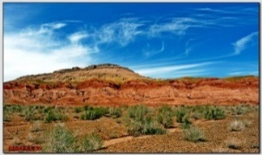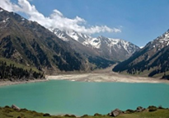1. Enjoy the melodies of Kurmangazy.

A

B

2. Enjoy the view of Astana from "Bayterek".

J

3. Touch the mystery of Mausoleum

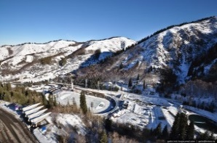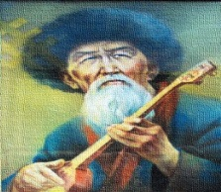4. Hear the singing of barkhan.

D

C

5. Climb to Medeu and Shymbulak.

6. Indulge into the power of the Tamgaly Tas.

7. Feel yourself a cosmonaut.

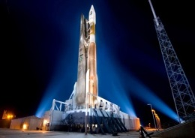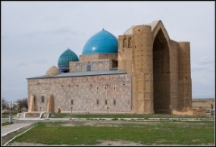8. Breathe the air of pinewood in the park “Burabai”.

F

E

9. Take a trip to a Big Almaty Hike.

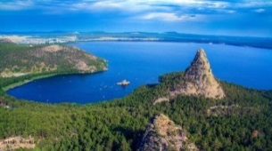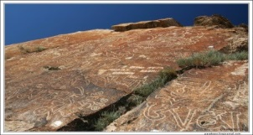10. Try besbarmak.

G

H

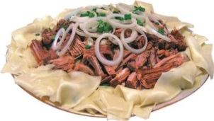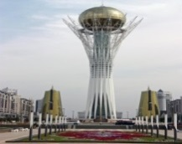

J

I

***Picture 1 “Vacation in Kazakhstan”***

**Task 3.** Imagine you are a tourist agent and you tell some information about Kazakhstan. What can you tell about Kazakhstan?

**Lesson 3.**

**Task 1.** Find the word and make the sentence.

**K** and **O** are exactly in the middle.

**N** is one letter before **U** and after **O**.

**R** is at the end.

**B** is at the beginning.

**A** is between **B** and **I**.

... is a town in Kyzylorda region of Kazakhstan.

**Text 3.**

Baikonur - Baikonur (kazakh. Байкоңыр) - town in Kyzylorda region of Kazakhstan. Baikonur is a town of national importance. Before December 1995 it was called Leninsk. December 20, 1995 the town was renamed from Lenninsk to Baikonur.

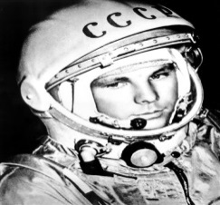Together with the complex Baikonur it is in Russia's **lease** till 2050 [4].

Baikonur is situated between two towns Kazalinsk and Dzhusaly.

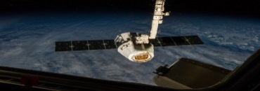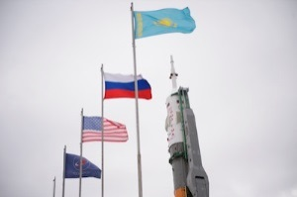The name Baikonur actually belonged to **a small mining town** 322 km (200 miles) away from **the space center**. Now many travel companies organize guided tours to the city of Baikonur. With sufficient amount of finances and having met all the physical criteria, people can also become a space tourist. Baikonur has been the site of some of the earliest achievements in space: 4 October 1957- Sputnik, the first man-made satellite to orbit the Earth, was launched from Baikonur. 12 April 1961 - Yuri Gagarin lifted off from Baikonur to become the first man in space. 16 June 1963 - the first flight of woman Valentina Tereshkova in space. 20 November 1998-Zarya, the first piece of the International Space Station (ISS), designed and built by Khrunichev launched on Proton. 12 July 2000- Zvezda, the main component of the Russian section of the ISS is launched on Proton [5].

**Task 2.** Name the text. .

- Baikonur

- One city of Kazakhstan

- The space center

- The town of national importance

**Task 3. Answer the questions.**

1. In what year the first man made satellite to the orbit Earth?
2. Who was the first man in space?
3. Who was the first woman in space?
4. In what year Yuri Gagarin lifted off from Baikonur?
5. In what year Valentina Tereshkova flight in space?
6. What is the name of the first piece of the International Space Station?

**Task 4. Complete the sentences.**

1. Baikonur town in … region.
2. Before December 1995 Baikonur was called ... .
3. Baikonur is situated between two towns … and … .
4. The name Baikonur actually belonged to a small … … .
5. Many travel companies organize … … to the city of Baikonur.

**Task 5. Answer the question and find the odd keyword.**

Keywords: Mercury, Saturn, Mars, Gravity, Jupiter, Neil Armstrong, Venus, Solar system.

1. Does the sun orbit the Earth?

2. What is the closest planet to the Sun?

3. What is the hottest planet in our solar system?

4. What planet is famous for the beautiful rings that surround it?

5. Can humans breathe normally in space as they can on Earth?

6. Is the sun a star or a planet?

7. What planet is known as the red planet?

8. Is the planet Neptune bigger than Earth?

**Task 6. Make a Spaceship.**

Divide into two groups. Design and build your own spaceship, space station or satellite. What features will you add to make your creation safe as it travels in space? You can draw it or make it from paper. When you've finished, show off your finished creation to others in the class.

**Lesson 4**

**Text 4.**

**Traditional Kazakh Food**

Kazakh cuisine is rich in flavors and traditions. It reflects the nomadic lifestyle of the Kazakh people, who lived in the vast steppes and relied on meat, dairy products, and bread as their main food sources. Here are some of the most famous traditional dishes:

1. **Beshbarmak – The National Dish .**Beshbarmak means "five fingers" because Kazakh people traditionally eat it with their hands. It is made of boiled meat (usually lamb or beef) served over homemade flat noodles and topped with onion sauce. It is often eaten with a strong meat broth called **sorpa**.
2. **Kazy – Horse Meat Sausage** Kazy is a special sausage made from horse meat and fat. It has a rich, unique taste and is usually served on special occasions, such as weddings and celebrations.
3. **Baursak – Kazakh Fried Bread.** Baursak are small pieces of dough deep-fried until golden brown. They are crispy on the outside and soft on the inside. People eat them with tea, honey, or jam.
4. **Kumis – Fermented Mare’s Milk.** Kumis is a traditional Kazakh drink made from fermented mare’s milk. It has a slightly sour and fizzy taste and is believed to be very healthy.
5. **Shubat – Camel’s Milk.** Shubat is similar to kumis but made from camel’s milk. It is thicker and has a stronger taste. It is often drunk in the summer because it is very refreshing.

**Facts About Kazakh Cuisine** Horse meat is considered a delicacy in Kazakhstan. Traditional Kazakh meals are usually served on a low table called **dastarkhan**. Kazakh people love drinking tea, especially with milk or cream. And of course - Kazakh cuisine is a wonderful mix of history, culture, and delicious flavors. If you ever visit Kazakhstan, be sure to try these traditional dishes!

**Task 1.** Match each picture with the name of food and drinks.

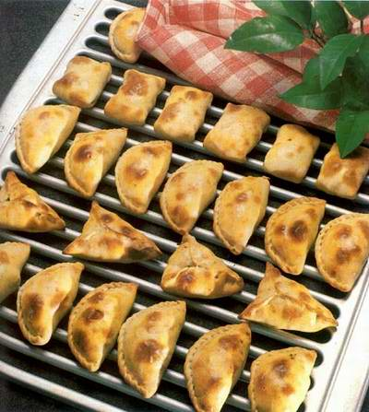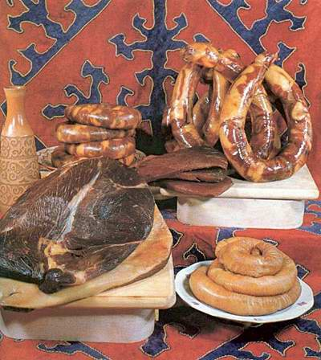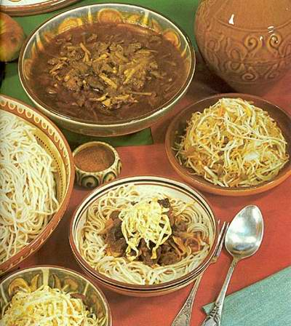

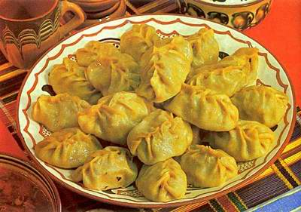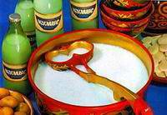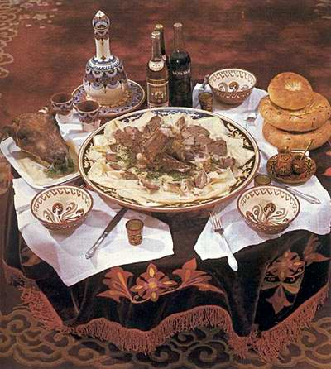

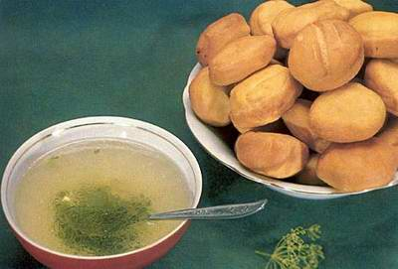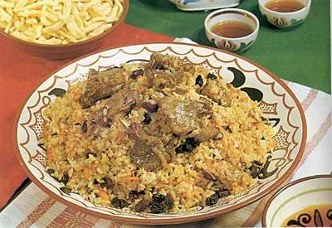

***Picture 2 “Kazakh nation food and drinks”***

1. Besbarmak - H
2. Kazi, Karta, Shuzhuk
3. Kuirdak
4. Baursaki
5. Sorpa and Baursaki
6. Lagman
7. Palau
8. Manti
9. Samsa
10. Chak-chak
11. Kumiss

**Task 2.** Match the words and their definition.

|  |  |
| --- | --- |
| Kumys | First dish in the Kazakh cuisine. |
| Shubat | Tablecloth |
| Ayran | Fried puffy bread/bun |
| Baursaks | Pressed sour cream |
| Kurt | Dish which translated as “five fingers”. |
| Dastarhan | Cow milk |
| Besbarmak | Horse milk |
| Shurpa | Camel milk |

***Table 1 “Definitions of Kazakh nation food and drinks”***

**Lesson 5**

Task 1. Choose the right

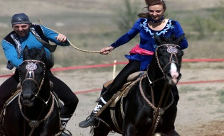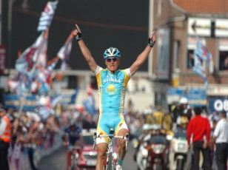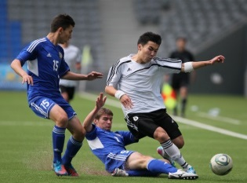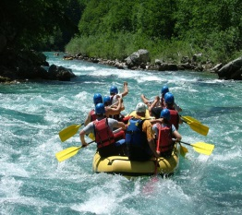

1

2

[Введите цитату из документа или краткое описание интересного события. Надпись можно поместить в любое место документа. Для изменения форматирования надписи, содержащей броские цитаты, используйте вкладку "Средства рисования".]

[Введите цитату из документа или краткое описание интересного события. Надпись можно поместить в любое место документа. Для изменения форматирования надписи, содержащей броские цитаты, используйте вкладку "Средства рисования".]

4

3

1

**Picture 1:** a. happy b. sad

**Picture 2:** a. exciting b. angry

**Picture 3:** a. brave b. upset

**Picture 4:** a. excited b. quite

**Task 2. Answer the questions**

1. Do you like sport?
2. What kinds of sports do you know?
3. How do you think: sport is exciting or dangerous?
4. Do you prefer going in for sports or watching it on TV?
5. What kinds of sports are popular in Kazakhstan?
6. What national Kazakh sports do you know?

**Task 2. Match the definition and the name of the sport**

|  |
| --- |
| Wind-surfing Trampoiling Parachuting Mountaineering  Alaman baiga Kumis alu |

***Table 3 “Definitions of the names of the sport”***

1. It is the sport of riding a small sort of boat with a sail.
2. It's the sport in which acrobats and gymnasts jump up and down to perform exercises on a sheet of material tightly stretched to a metal frame.
3. It’s jumping from an airplane with a parachute.
4. It is the sport of climbing mountains.
5. This is long distance horse riding to demonstrate the stamina of both the horse and the horseman.
6. In this game, horsemen pick up golden coins from the ground at full speed. The one who collects the most, wins.

**Task 3. Answer the questions.**

1. What's common about the following sports? (Motor-racing, climbing, scuba-diving, gliding, mountaineering, windsurfing)
2. Which of the groups do you think is the riskiest? Write as many activities as you can in each group.
3. What’s common about the following sports ? (Kumis alu, Audaryspak, Alaman baiga, Tenge alu, Ot oiyny)

**Task 4. Let’s find how much do you like sport?**

1. It’s a raining, cold Sunday evening. Do you:
2. Go out and play a game?
3. Watch sport on TV?
4. Read a book?
5. The World Cup Final is on TV. Do you:
6. Watch the match?
7. Listen match on the radio?
8. Go to your bedroom and play on your computer?
9. The Olympics are taking place on the other side of the world. Do you:
10. Stay up all night to watch everything?
11. Read the results in the newspaper?
12. Yawn when friends talk about it?
13. Your friends want to play Kumis Alu on Sunday; Do you:
14. Agree immediately and practice every day?
15. Go, but say you’re not very good?
16. Say you’re not interested and suggest going to the cinema?
17. The sports teacher is talking to the class about organizing a sport day. Do you:
18. Volunteer for every event?
19. Choose one event you’d like to be in?
20. Hide behind a big student?
21. Your sports teacher chooses you to run in the 2000 meters race. Do you:
22. Practice running for a week before the race?
23. Just do your best and not worry about winning?
24. Phone the school on the day and say you are ill?

***Table 5 “Results”***

|  |  |  |
| --- | --- | --- |
|  | **Points** | **Results** |
| **a** | 5 points | 6 points or less: You hate sport |
| **b** | 3 points | 7-18 points: You quite like sport |
| **c** | 0 points | More than 18 points: You are a sport fanatic |

**Task 5**

Read the text. Decide which answer given below A, B, C, or D best fits each space.

Text.

Someone once said that there are three kinds of people who are (1)… in sport: people who (2)… part, people who watch, and people who watch (3)… television. It’s very easy to make fun of stay-at-home sports (4)… , but on the other hand, television does enable us to enjoy all kinds of (5)… events. We can watch a racing car (6)… another, see a cyclist (7)… the fishing line or enjoy the goals of our favorite football (8)… . The first time I watched tennis (9)… was on television, and I found it (10)… interesting. It’s not always easy to (11)… long distances to football (12)… , and television is a good so union. Of course, you can (13)… used to sitting indoors all time, and this is dangerous. We should all try to (14)…f it, and have other interests and (15)…

1. A) playing B) really C) interested D) succeed
2. A) take B) have C) make D) get
3. A) on B) with C) by D) from
4. A) people B) centers C) programmers D) fans
5. A) the B) future C) sports D) athlete
6. A) cross B) overtake C) or D) from
7. A) overtake B) and C) cross D) professional
8. A) group B) class C) band D) team
9. A) match B) game C) film D) fans
10. A) valuable B) imaginatively C) inexpectedly D) real
11. A) trip B) tour C) pass D) travel
12. A) areas B) grounds C) lands D) spots
13. A) make B) get C) keep D) do
14. A) keep B) make C) do D) kept
15. A) customs B) habits C) pastimes D) leisure

**Lesson 6**

**Text 6**

**Kazakhstan – born famous people**

Internet magazine “Vlast” made a rating of Top 10 Kazakhstan-born famous people who achieved success and acknowledgment outside Kazakhstan. "They work in different areas, some of them no longer hold Kazakhstan citizenship, but they are always closely linked to Kazakhstan," the magazine writes.

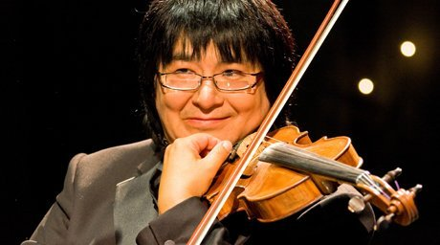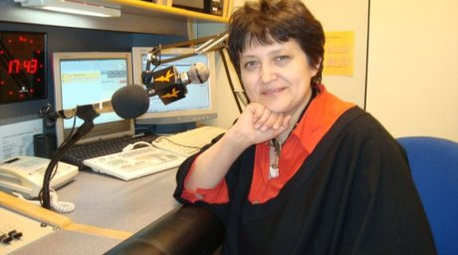1. **Marat Bissengaliyev**, a famous violin player. He is 50. Born in Almaty, he currently lives most of the time in Great Britain and India. He is the citizen of Kazakhstan, even though he has been living in Great Britain for over 20 years. He is an Honored Artist of Kazakhstan, a professor of Birmingham Conservatory and one of directors of the Alliance of Asia-Pacific Region Orchestras (AAPRO).

2. **Dzhamilya Stekhlikova**, the first Kazakh minister in Europe and the first non-Czech former minister of Czech Republic. Dzhamilya Stekhlikova, 50, is a grand-daughter of Education Minister of Kazakh Republic Abdykhamit Sembayev. Born in Almaty, she lived in Moscow for a long time and then moved to Czech Republic. She has two children.

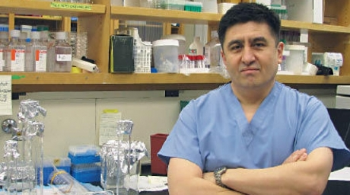3. **Shoukhrat Mitalipov**, a scientist. He currently lives and works in the U.S. He was the first scientist in the world to clone primates. In 2010 the U.S. Clinical Tests Commission gave a license to professor Mitalipov for experiments with human eggs and embryos for the first time in the history. He is a co-author of the research where the first “mixed-embryo monkeys” were born. Mitalipov is ethnic Uighur. He was born in Almaty oblast.

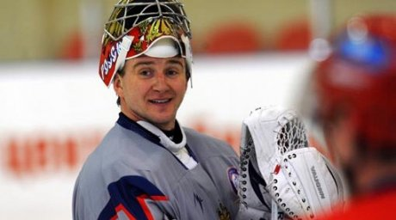4. **Yevgeniy Nabokov**, a professional hockey-player. He is 36. He set NHL record with 11 away wins in a row. He is the first goal-tender in the history of NHL who scored the powerplay goal. He is the second goaltender who managed to keep 40 victories 3 seasons in a row. He is the best goaltender of the World Championship 2008. He was born in Ust-Kamenogorsk and graduated from Ust-Kamenogorsk hockey-school. In 1997 he moved to North America [6].

**Task 1. Answer the questions.**

1. What is the name of a famous violin player?

2. What is the name of the first goal-tender in the history of NHL who scored the power play goal?

3. What is the name of scientist who currently lives and works in U.S.

4. Who was born in Ust-Kamenogorsk?

5. Who are 36?

6. Who are 50?

7. Who are currently lives in Great Britain and India?

8. Who is the first Kazakh Minister in Europe?

9. Who is the best goaltender of the World Championship 2008?

10. Who has two children?

**Lesson 7**

**Task 1. Future plans.**

* I’ll be a pilot in Air Company of Kazakhstan.
* I’ll be a doctor in Almaty hospital.
* I’ll be a teacher in Nazarbaev School.
* I’ll be a manager in Astana shop.

**Task 2. Complete the table.**

Aigul likes her job because she can play with children every day.

Samat likes his job because he really like using his car every day.

Andrew likes his job because he likes animals.

Zarina likes her job because she can sing from morning to night.

Asel likes her job because she can eat cakes every lunch.

Ainur likes her job because she can work with flowers.

***Table 6 “Types of job”***

|  |  |  |  |  |  |
| --- | --- | --- | --- | --- | --- |
| Veterinarian | Singer | Florist | Baker | Taxi driver | Nurse |
|  |  |  |  |  |  |
|  |  |  |  |  |  |

**Task 3. Read the dialogue and make the same one**.

**Situation.** Dana Naurizbaeva, an 18-year-old college girl, wants to move out of her parents’ home, although she goes to a nearby college. She has a job; she is a doctor assistant, so she can support herself. The parents feel it’s a waste of money. Each gives a research for his or her position.

This dialogue might help you get started.

Dana: Mom you know that I’m 18 so I’m old enough to live on my own and I’m able to support myself. I don’t understand why you are so against of my moving out.

Mom: Do you really think that your salary will be enough? The fact is that you’ll have to not only support yourself but also pay rent. Think well because with us it will be much easier.

Dana: I’m not saying that if I live it would be easier. I’ll just have a chance to learn to be more responsible and self-confident.

Dad: Oh dear, you’re just 18. You’re hurrying up to become an adult. Take time! You’ll have much time to enjoy your adult life and even get tired of it.

Dana: No dad, you don’t understand that I’m not a child already! Also, you know that I have a job and I like it! I’m a doctor assistant and I like my job very much!

Mom: I think that living apart seems to be a waste of money…

Dana: I’ll find a way out for sure. I’m very happy that I have this job and I think that it’s very good lesson in my life.

Parents: Dana, we think you should change your position!

**Task 4.** Compare with the meaning.

|  |  |
| --- | --- |
| **Stupid head disturbs the legs** | Means vanity to go to party is useless. |
| **While a bald man combs his hair, the party is ended** | You should not eat the bread that someone else has baked. |
| **The dog asks dog, that dog asks the tail** | She knows who she is; she knows her place in society. |
| **To live with wolves, to talk as a wolf** | If you are hesitant to do something you are ineffective. |
| **Meet with clothes but pass by mind** | When you meet a person you didn’t see his clothes but you see whether his spirit is beautiful or not. |
| **A cat in gloves cannot catch a mouse** | Means if you are to succeed in the society of wolves, you have to be like them. |
| **A girl has got 40 souls or lives** | Too much bureaucracy. |
| **Don’t open your mouth at somebody’s cake** | Worrying too much is a waste. |

***Table 7 “Words of wisdom”***

Example: Stupid head disturbs the legs – Worrying too much is a waste.

**Vocabulary**

**Stupid head disturbs the legs** (Kazakh proverb means worrying too much is a waste)

**While a bald man combs his hair, the party is ended.** (Kazakh-Russian – means vanity to go to party is useless)

**The dog asks dog, that dog asks the tail** (Kazakh – means too much bureaucracy which puts off the one who questions something to the next level of authority, passing the buck)

**“To live with wolves, to talk as a wolf.”** Means if you are to succeed in the society of wolves, you have to be like them – [negative connotation, if you are with aggressive people, you must also become aggressive and pushy]

**“Meet with clothes but pass by mind.”** When you meet a person you didn’t see his clothes but you see whether his spirit is beautiful or not.

**“A cat in gloves cannot catch a mouse.”** It means that you are ineffective if you are hesitant to do something]

**“A girl has got 40 souls or lives.”** Kazakh proverb [my thoughts on this which puts the women’s lib mantra to shame.  Kazakh women know who they are and their place in society, it is highly exalt.

**“Don’t open your mouth at somebody’s cake.”** Means that you should not eat the bread that someone else has baked, don’t use someone else’s effort and claim as your own.

**“Fall Down in the Fire for your Motherland, You won’t be burned; Get into the water and you will not drown.”** Means:  Do the best for the sake of your country.

**Lesson 8.**

**Task 1. Answer the questions about yourself.**

1. What do people usually do in the shop?

2. Do you like do shopping?

3. What are your feelings about shopping? Is it a pleasure or a torture?

4. Do you have different feelings about shopping for clothes, shoes, electronic gadgets and food?

5. Do you ever shop on the internet? What is your opinion of this way of shopping?

6. What do you know about shopping in Almaty city? Have you ever been in Almaty city?

**Text 8**

Shopping in Almaty city

Almaty’s shopping options **range** from traditional to modern to just plain interesting.

Whether you want a three-story glass enclosed **megamall** with a rock climbing wall or **a teeming** local bazaar where you can **bargain** with the **venders**, you will be able to find it in Kazakhstan’s business capital.

Starting with the more traditional options, you can head to the Green Bazaar. This is a huge outdoor and indoor traditional Kazakh bazaar which specializes in the foods of the region. You can watch **butchers** chop up chunks of horse meat and experienced workers **hand-stuffing spicy** Kazakh sausages. **Colorful piles of fruits**, vegetables and mixed dishes line the aisle and **sampling** is encouraged.

Among the city’s most modern malls is Mega Center where you’ll find more than 100 top designer boutiques such as Zara, Calvin Klein and Yves Rocher. Mega also includes a skating rink, rock climbing wall and **bowling alley**.

And for an interesting slice of local flavor, head to Barakholka and Adem. Barakholka is a **teeming** crowded marketplace where you can find just about anything you could want. It can appear a bit chaotic but is certainly an experience. Nearby is Adem, which is a similar atmosphere only less crowded and with much appreciated air conditioning. And if you’re hungry, Almaty offers an excellent 24 hour food market with a large selection of imported items, a quality **deli** and lots of wine. From modern to traditional you can find it in the shops of Almaty [7].

**Task 2 Compare name and picture.**

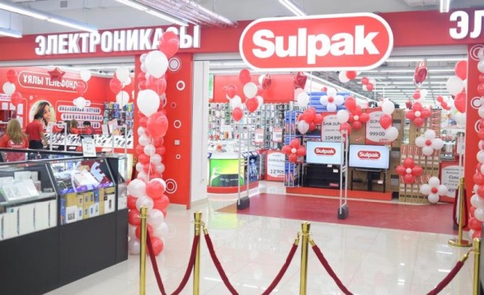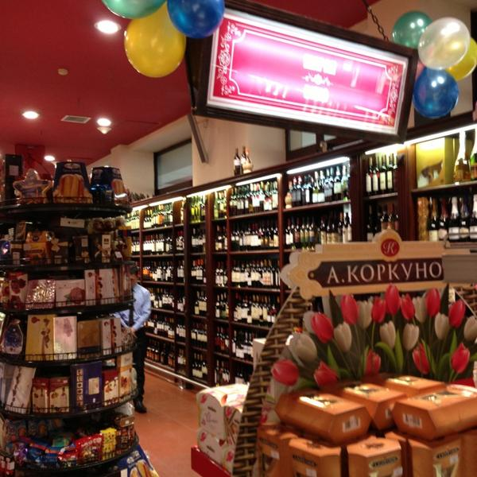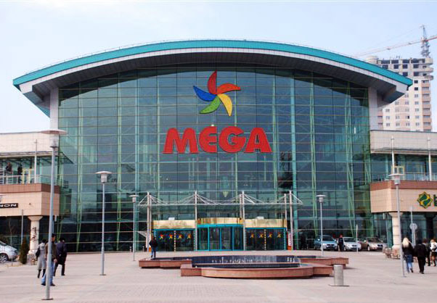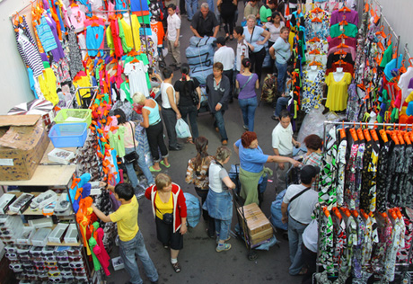

1. **Mega Center**Hours: Daily 10 am-10 pmAddress: 247A Rozybakiyev Street
2. **Barakholka and Adem**Hours: Daily 10am - 6pm.Closed MondaysAddress: Take a ‘Barakholka’ bus headed down Rozybakiyev Street from Raimbek Street
3. **Zangar, also known as Tsum** Hours: Daily 10am - 9pmAddress: 62 Abylay Khan Street
4. **Stolichny** Hours: Daily 24 hoursAddress: 121 Abylay Khan Avenue

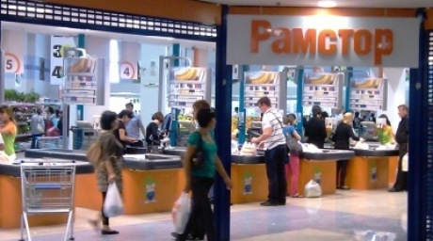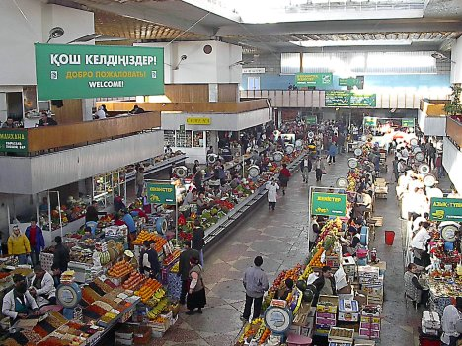

1. **Ramstore** Hours: Daily 9am - 11pmAddress: 226 Furmanov Street
2. **Zelyony Bazar, also known as Green Bazaar** Hours: Daily 10 am-6 pm. Closed Sundays.Address: Intersection of Zhibek Zholy Street and Zenkov Street – one street down from the St. Ascension Cathedral (also known as Zenkov Cathedral)

***Picture 6 “Shops with descriptions”***

1. Is one of the best places in Almaty to find traditional Kazakh food. You can watch butchers chopping up chunks of horse meat and experienced workers hand-stuffing spicy Kazakh sausages. Fruits, salads, cheeses, meats and traditional mixed dishes line the aisles of the large indoor section. And the best part is that sampling is encouraged. So feel free to taste before you buy. The large bazaar includes indoor and outdoor sections and features clothing, shoes, appliances and other everyday items in addition to its food offerings. The vendors are friendly and the whole market has **a welcoming vibe**. It’s a great place to spend some time getting a real cultural taste of Kazakhstan.
2. If you’re hungry at 4 am, this is where you go. It’s a 24-hour supermarket that is way more than a late night convenience store. It offers an ample selection of imported food and beverages, a well-stocked deli and lots of wines. It’s also right in the center of Almaty. So if you can’t sleep or just want some good cheese at midnight, head to…
3. It’s not **flashy**, but you’ll find what you need. Whether you’re searching for souvenirs, mobile phones or a new toaster. It’s **dozens** of boutiques and small shops spread over three levels will have it. The first floor is the place for electronics, the second floor offers clothing, and footwear. And cosmetics are found on the third level. It also features numerous souvenir shops where you can find traditional Kazakh swords, horse whips, felt hats and other kitsch for your friends back home. Immediately beside the mall is a pedestrian-only section of Zhibek Zholy Street featuring small venders selling their wares and local artists selling their works. It is one of Almaty’s oldest and best known malls.
4. Kazakhstan’s growing energy wealth is beginning to reach the pockets of Almaty’s middle and upper classes. And this Center is where they go to spend it. You’ll find the latest fashions at this Center’s more than 100 boutiques including Zara, Calvin Klein Jeans, Yves Rocher and Benetton. The center also offers a rock climbing wall, bowling alley, movie theater and skating rink.
5. It is best known around Almaty as a high quality supermarket chain with one of the city’s best selections of imported items. But this Trade Center is way more than a food shop. The Ramstore Center at the corner of Furmanov and Zholdasbekov Streets is a combination mega food store, entertainment complex and upscale mall. In addition to its quality supermarket, the center offers restaurants, cafes, a movie theater, skating rink and 56 stylish boutiques.
6. If you like a little local flavor with your shopping this is the place to go. It is a huge, teeming and crowded flea market. It may seem a bit chaotic at first but you can find bargains on literally everything you could want – from household appliances, to shoes, to souvenirs. Just remember to keep a hand on your wallet as the jostling crowds are prime feeding grounds for pickpockets. Sunday mornings are the most crowded. Just before arriving you’ll notice three buildings on your right. These buildings make up another market, which is the better known and more modern. You’ll find pretty much the same selection of stuff here, but it is smaller, less crowded, offers better security, and – best of all – it is air conditioned.

**Task 4. Answer.**

Where can you buy these things?

- Mobile phone

- Traditional food

- Cheese at midnight

- Fashionable clothes

- Everything what you want

**Task 5. Match**

Example: Shoe shop – buy trainers.

|  |  |  |
| --- | --- | --- |
| Supermarket | Buy trainers | |
| Building society | Withdraw cash | |
| Department store | Stock up on food | |
| Florist | Buy a coat | |
| Deli | Buy a television | |
| Chemist | Buy some flowers | |
| Shoe shop | Buy painkillers | |
| Clothes shop | Buy foods | |
| Grocer | | Buy fruit |

***Table 8 “Shops and things”***

**Task 6**

Divide into three groups and complete the dialogue. Then compare your dialogues in the correct order. After this work choose 2 pupils and act it out to the class.

**Part1** for first group

The customer tries the jeans on.

Customer: They’re *to/too/two* big.

Shop assistant: Would you like a *littler/smaller/tinier* size?

Customer: Yes, *thank you/please/excuse me*.

The customer tries the jeans on.

Customer: These *suit/fit/like* rather well. But I think I look fat/sick in them.

Shop assistant: Not all. These jeans *suit/stand/stay* you very well.

Customer: Well, I think I *try on/will try on/am trying on* a black pair.

**Part 2** for second group

Shop assistant: Hello, can I *help/like/sell* you?

Customer: I *look/am looking/* for a pair of jeans.

Shop assistant: What *height/size/greatness/*do you take?

Customer: Twenty-six.

Shop assistant: We have some very nice black jeans here. They’re *in offer/of offer/on offer* this week.

Customer: Well, I actually *like more/prefer* blue jeans.

Shop assistant: That’s okay. We *too/also/* have them in blue.

Customer: Where can I *wear/try/pull* them on?

Shop assistant: The *trying-on/undress/fitting* room is over there.

**Part 3** for third group

The shop assistant brings a pair of black jeans and the customer tries the jeans on.

Customer: They are very *tight/tide* and I don’t like black jeans, anyway. Do you mind *take/taking/bring/bringing* me another pair in blue?

Shop assistant: No, not at all. …

**Lesson 9**

**Task 1**. Find the words.

DLOWR – world

DSWNOER –

Ybaruab –

**Text 9.**

The pearl of Kazakhstan

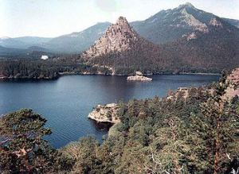Burabay, the resort pearl of Kazakhstan, is a part of the **Kokshetau steppe.** It is a fantastic mountain land harboring mysterious wonders. Gorgeous pine forests, cliffs formed of neat gigantic natural bricks, and fantastical shapes of peaks resembling sometimes exotic, sometimes Egyptian pointed pyramids separated by serene lakes. Although Burabay Park does not have any artifacts on its territory, every rock here has its own legend.

“When God was creating the world, one of the nations received the lands rich of forests, another got fertile fields with large rivers, and the third got the beautiful mountains and blue lakes. But the Kazakh ended up with only feather-grass steppe… This offended him and he asked God to endow him with some natural beauty. God took the mountains, rocks, beautiful pine and deciduous forests, blue lakes with pure water, and emerald fields covered with grasses and flowers from his **korzhyn** and spread them with a bountiful hand into the boundless steppes. It was the appearance of Borovoye; of one of the most picturesque places in Kazakhstan, which for its beauty and rare harmonic combination of mountains, forests, lakes, and unique flora and fauna received the poetic name **“The pearl of Kazakhstan”** [8].

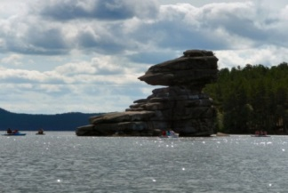 A mysterious rock in the middle of Lake Boroboe in Northern part of Kazakhstan. **Legend** has it that the army of Ablai Khan took an Oirat princess captive and forced her to marry a Kazakh warrior. She fell deeply in love with one warrior but the others were jealous. So she said that she would marry the man who could shoot to the top of a rock outcrop near the lake. All failed the first time, but her love hit it on the second try. The rivals killed him so she flung herself in the lake and became Zhumbaktas (Mysterious Stone) [9].

**Task 3.** Answer the questions

1. Where is Burabay situated?
2. What can you see in Burabay?
3. What legend do you know about Burabay?
4. According to legend what happened with Oirat princess?

Vocabulary for the lesson

**Burabay** – (name of the National park in Kazakhstan)

**Oirat princess** – "oi" (forest) and "ard" (person), the westernmost group of the Mongols whose ancestral home is in the Altai region of western Mongolia.

**Korzhyn** (каз. Қоржын) – saddlebag.

**Ablay Khan** – Khan of the Middle zhuz.

**Task4**

Play the situation.

1.Tourist guides and other

2.Tourists

Tourists must ask different questions and tourist guides

**Lesson 10**

**Text 10**

**Native City.**

Let me tell you a few words about my native city Karaganda. Karaganda is a big city. Exact date of the basis of the city is unknown. There are some legends and versions of the name "Karaganda". Karaganda is one of the largest cities in Kazakhstan and an important industrial and cultural center. It is located in the central part of the country. The name of the city comes from the “karagan” bush, which grows in the surrounding steppes.

Karaganda was founded in the 1930. It quickly became an important center for coal mining and industry. During Soviet times, many people moved here to work.

Nowadays, Karaganda is a modern city. There are universities, schools, and cultural institutions. Also there are several museums, theaters, and parks where people can spend their free time. One of the most famous places in the city is the Eternal Flame monument, dedicated to those who fought in World War II.

The climate in Karaganda is continental, which means hot summers and very cold winters with a lot of snow. Despite this, people enjoy outdoor activities, such as ice skating in winter and walking in the parks in summer.

Transport of the city including buses and taxis. It is also connected to other cities by railway and highways. Karaganda has its own airport, making it easy to travel to other parts of Kazakhstan and beyond.

I really love my native city because it has a rich history, friendly people, and a unique atmosphere. It is a great place to live, study, and work.

**Task 1.**

Answer the questions:

1. What is the origin of the name "Karaganda"?
2. What industry was the city built around?
3. What is the climate like in Karaganda?

**Task 2.**

Find and write down three important facts about Karaganda’s history.

**Task 3.**

Retell the text

**Task 4.**

Tell some information about your native city. Use the text as an example.

**Lesson 11**

**Popular Jobs in Kazakhstan**

Kazakhstan has a growing economy, and many professions are in high demand. Some of the most popular jobs in the country are related to oil and gas, IT, education, and healthcare.

One of the most well-paid and respected jobs in Kazakhstan is an **oil and gas engineer**. The country is rich in natural resources and the oil and gas industry plays a key role in its economy. Engineers working in this field help to extract and process oil and gas, making sure that everything runs safely and efficiently. Many of them work in large cities like Atyrau, Aktau, and Astana, or at offshore drilling sites.

Another popular job is **a software developer**. The IT sector is developing rapidly, and many international and local companies need skilled programmers. Software developers create websites, mobile applications, and various digital solutions. Many young people in Kazakhstan are choosing this career because it offers high salaries and the opportunity to work remotely.

**Teachers and university professors** are also in demand. Education is an important part of Kazakhstan’s development, and good teachers help to prepare future generations. English teachers, in particular, are highly valued, as more people want to learn foreign languages to study and work abroad.

Another respected and necessary profession is **a doctor**. Healthcare specialists, including surgeons, dentists, and general practitioners, play a crucial role in society. Although medical jobs require many years of study, they are rewarding because they help people and save lives.

There are also many opportunities in business, finance, and marketing. Many young people dream of becoming **entrepreneurs** and starting their own companies. Others prefer working as accountants, financial analysts, or marketing specialists in large corporations.

Overall, Kazakhstan offers many career opportunities, and the choice of profession depends on a person’s skills and interests. As technology and industries continue to develop, new jobs will become even more popular in the future.

**Task 1.**

Underline the names of the jobs

Answer the questions:

1. Why is the IT sector growing in Kazakhstan?
2. What profession helps to prepare future generations?
3. Why do some people choose to become entrepreneurs?
4. Why oil and gas engineers are important for Kazakhstan?

**Task 2.**

Make a presentation - Which profession from the text do you think is the best? Why?

**Task 3.**

Write a short paragraph (10 sentences) about your favorite job and why it is important.

**Lesson 12**

**Text 12**

**Jobs Around Us in Kazakhstan**

Kazakhstan is a large and developing country with many different job opportunities. People work in various fields, including industry, education, healthcare, business, and technology. Some jobs are traditional, while others are new and connected to modern technologies.

One of the most important industries in Kazakhstan is oil and gas. Many people work as engineers, geologists, and technicians in this field. Kazakhstan is rich in natural resources, so oil and gas companies provide many jobs. These jobs often require special education and experience, but they also offer high salaries.

Another popular field is education. Teachers and university professors play a key role in preparing young specialists for the future. Many people choose to become English teachers, math teachers, or science teachers because education is important for the country’s development.

Healthcare is also an important sector. Doctors, nurses, and pharmacists help people stay healthy. Many students in Kazakhstan study medicine to become surgeons, dentists, or general practitioners. Although medical education takes a long time, it is a respected and well-paid profession.

The IT industry is growing quickly. Many young people want to become software developers, web designers, or cybersecurity specialists. These jobs allow people to work remotely and earn competitive salaries. Kazakhstan supports the development of digital technologies, so IT specialists are in high demand.

Many people also work in business and finance. Accountants, financial analysts, and marketing specialists help companies grow and succeed. Some people choose to become entrepreneurs and start their own businesses.In addition, there are many other important jobs in Kazakhstan. Farmers grow food, construction workers build houses and roads, and police officers keep the country safe. Every job is important because it helps society function.Kazakhstan offers many career opportunities, and people can choose jobs based on their interests, skills, and education. As the country develops, new jobs will appear, and the job market will continue to grow.

**Task 2.**

1.List three well-paid jobs in Kazakhstan and explain 2.Why they are important?

3.Why do some people choose to become entrepreneurs?

4.Find and write down three jobs that require a university education.

5.Describe how different professions help society.

**Pair work**

**Task 3.**

Compare two professions from the text. How are they similar and different?

**Individual work**

**Task 4.**

Tell to the class What job would you like to have in the future? Why?

**Lesson 13**

**Text 13**

**Daily Routines of Different Professions**

People with different jobs have different daily routines. Some jobs require early mornings, while others involve working at night. Let's look at the daily routines of a doctor, a teacher, and a software developer.

**1. A Doctor’s Daily Routine**

Doctors have very busy schedules. They usually wake up early because hospitals open early in the morning. Their day may look like this:

|  |  |
| --- | --- |
| **Time** | **Activity** |
| 06:00 AM | Wake up and get ready for work |
| 07:00 AM | Arrive at the hospital |
| 08:00 AM - 12:00 PM | Check patients and diagnose illnesses |
| 12:00 PM - 01:00 PM | Lunch break |
| 01:00 PM - 05:00 PM | Perform surgeries or consultations |
| 05:30 PM | Finish work and go home |
| 07:00 PM | Have dinner and relax |
| 10:00 PM | Go to bed |

**2. A Teacher’s Daily Routine**

Teachers have a structured routine because they need to prepare lessons and teach students. Their day often follows this pattern:

|  |  |
| --- | --- |
| **Time** | **Activity** |
| 06:30 AM | Wake up and have breakfast |
| 07:30 AM | Arrive at school |
| 08:00 AM - 02:00 PM | Teach classes |
| 02:00 PM - 03:00 PM | Lunch break |
| 03:00 PM - 05:00 PM | Grade homework and prepare lessons |
| 06:00 PM | Go home and spend time with family |
| 09:00 PM | Relax and go to bed |

**3. A Software Developer’s Daily Routine**

Software developers usually have a more flexible schedule. Some of them work from home, while others work in offices. You can read:

|  |  |
| --- | --- |
| **Time** | **Activity** |
| 08:00 AM | Wake up and have breakfast |
| 09:00 AM | Start work (coding, meetings) |
| 12:30 PM - 01:30 PM | Lunch break |
| 01:30 PM - 06:00 PM | Continue programming |
| 06:30 PM | Exercise or relax |
| 08:00 PM | Spend time with family or hobbies |
| 11:00 PM | Go to bed |

You know each profession has a different daily schedule. Some jobs require long hours, while others allow more flexibility. The best profession depends on a person’s interests and lifestyle.

**Task 1:** Match the profession to the daily routine, you can read the text again

|  |  |
| --- | --- |
| **Profession** | **Daily Activity** |
| Doctor | Teaches students in a classroom |
| Teacher | Writes code and develops applications |
| Software Developer | Checks patients and prescribes medicine |

**Task 2:** Answer the questions:

1. What time does a doctor usually wake up?
2. Where does a teacher work?
3. What do software developers do in their jobs?

**Task 3:** Read the text again if you need and fill in the missing times in the table below:

|  |  |  |  |
| --- | --- | --- | --- |
| **Profession** | **Wakes up** | **Lunch Break** | **Finishes Work** |
| Doctor | ____ AM | ____ PM | ____ PM |
| Teacher | ____ AM | ____ PM | ____ PM |
| Software Developer | ____ AM | ____ PM | ____ PM |

**\**

**Lesson 14**

**Text 14**

**Future Jobs in Kazakhstan**

Kazakhstan is developing rapidly, and the job market is changing. Many traditional jobs are still important, but new professions are appearing due to technology, environmental issues, and economic growth. In the future, some of the most in-demand jobs will be in IT, renewable energy, healthcare, and business innovation.

Nowadays one of the fastest-growing fields is **information technology (IT)**. Many companies need **software developers, data analysts, and cybersecurity specialists**. These professionals create programs, analyze information, and protect businesses from cyberattacks. Since the world is becoming more digital, IT specialists will have many opportunities to work in Kazakhstan and internationally.

Another important area is **renewable energy**. Kazakhstan has large oil and gas reserves, but the government is also investing in **solar and wind energy**. In the future, there will be many jobs for **engineers, scientists, and technicians** who work on green energy projects. These jobs will help reduce pollution and make the country more environmentally friendly.

**Healthcare** will also continue to grow. Doctors and nurses will always be needed, but new medical technologies will create jobs for **biotechnology researchers, telemedicine specialists, and AI-assisted diagnostics experts**. These professionals will use modern equipment and artificial intelligence to improve healthcare services.

Our future trend is **business and entrepreneurship**. Many young people in Kazakhstan want to start their own companies. In the future, there will be more opportunities for **digital marketers, e-commerce specialists, and business consultants**. These professionals will help companies grow in the global market.

The future of work in Kazakhstan will be shaped by technology, sustainability, and innovation. People who develop new skills and adapt to changes will have the best job opportunities.

**Task 2.**

Test.

1. Which field is growing the fastest in Kazakhstan?

a) Agriculture

b) Information Technology (IT)

c) Tourism

2. What kind of energy will be important in the future?

a) Coal and oil

b) Gas and nuclear energy

c) Solar and wind energy

3. Who will use artificial intelligence in their work?

a) Teachers

b) AI-assisted diagnostics experts

c) Farmers

**Task 3.**

Match the profession to its description.

**Task 4.**

Fill in the blanks with the correct words from the text.

1. In the future, many companies will need _________ to protect businesses from cyberattacks.
2. Kazakhstan is investing in _________ and wind energy to reduce pollution.
3. _________ specialists will help businesses sell products online.

**Task 4:** Write T/F

**Lesson 15**

**Text 15**

**Animals Around Us in Kazakhstan**

Kazakhstan is a country with a rich and diverse wildlife. The country has vast steppes, mountains, forests, and deserts, which are home to many different animals. Some of these animals are common, while others are rare and endangered.

One of the most famous animals in Kazakhstan is the saiga antelope. This animal lives in the steppe and is known for its unusual nose. Unfortunately, saigas are endangered because of hunting and climate change. Another well-known animal is the golden eagle. People in Kazakhstan have trained golden eagles for hunting for centuries. These birds are strong and have excellent vision.

In the mountains, you can find the snow leopard, one of the rarest animals in the world. Snow leopards are excellent climbers and can survive in cold weather. The Tian Shan brown bear also lives in the mountains. These bears are large and powerful, but they are shy and usually avoid people.

Kazakhstan is also home to desert animals, such as the goitered gazelle and sand lizards. These animals are well-adapted to hot and dry conditions. In the forests, you can see wolves, foxes, and wild boars. These animals play an important role in the ecosystem.

The government of Kazakhstan is working to protect endangered species by creating national parks and nature reserves. People must take care of nature and protect the animals around us.

**Task 2.**

Match the animal and habitat.

|  |  |
| --- | --- |
| **Animal** | **Habitat** |
| Saiga antelope | Mountains |
| Snow leopard | Steppe |
| Goitered gazelle | Desert |
| Wild boar | Forest |

**Task 3.**

Choose the answer.

1.Which animal is known for its unusual nose?  
a) Golden eagle  
b) Snow leopard  
c) Saiga antelope

2.Where does the Tian Shan brown bear live?  
a) In the desert  
b) In the mountains  
c) In the sea

3.What do people in Kazakhstan train for hunting?  
a) Wolves  
b) Golden eagles  
c) Sand lizards

**Task 4.**

How can you describe your favorite animal in your country? Draw and present

**Lesson 16**

**Text 16**

Nature Wonders of My Country – Kazakhstan

Kazakhstan is a country of breathtaking natural wonders. Its vast territory includes mountains, lakes, deserts, and endless steppes. Many of these places are unique and attract visitors from all over the world.

One of the most famous natural wonders of Kazakhstan is Charyn Canyon. It is often called the "Little Brother of the Grand Canyon" because of its deep valleys and red rock formations. The canyon is about 154 km long, and its beauty attracts many tourists and photographers.

Another amazing place is Lake Kaindy. This lake is famous for its underwater forest. The lake was formed after an earthquake in 1911, which caused a landslide that blocked a river. As a result, the valley was flooded, and trees remained standing in the water. The lake has a bright blue color and is a popular spot for divers.

In the south of Kazakhstan, you can find Big Almaty Lake, a beautiful mountain lake located 2,500 meters above sea level. The lake changes its color depending on the season, from deep blue to emerald green. It is an important source of drinking water for the city of Almaty.

Another natural wonder is the Singing Dune, located in the Altyn-Emel National Park. This dune produces a mysterious sound when the wind moves the sand. The sound is similar to an organ playing or a distant roar. The Singing Dune is one of the most unique attractions in Kazakhstan.

In the west of the country, there is the Bektau-Ata rock formation, a surreal landscape with giant granite stones, caves, and unusual rock shapes. It looks like a scene from another planet and is a great place for hiking and exploration.

Kazakhstan’s natural wonders are not only beautiful but also important for the environment. Many of them are protected as national parks and reserves. People should take care of these amazing places and keep them clean for future generations.

**Task 2.**

Match the natural wonder with its description.

**Task 3.**

Fill in the blanks with words from the text.

1.________ is called the "Little Brother of the Grand Canyon."

2.________ was created after an earthquake and has trees underwater.

3.________ produces a sound that is similar to music.

**Task 4**

Answer the questions in full sentences.

1.Which of Kazakhstan’s natural wonders would you like to visit the most? Why?

2.How do national parks help protect nature?

3.What can people do to take care of these beautiful places?

**Task 5.**

Write a short paragraph (10 sentences) about a natural wonder in Kazakhstan that is not mentioned in the text. Describe its location, why it is special, and why people should visit it.

**Lesson 17**

**Text 17**

**National Parks and Wildlife Reserves in Kazakhstan**

Kazakhstan is a country with diverse landscapes, including mountains, steppes, deserts, and lakes. To protect its unique nature and wildlife, the country has created many national parks and wildlife reserves. These protected areas help to preserve rare animals, plants, and natural wonders.

One of the most famous national parks in Kazakhstan is Altyn-Emel National Park. It is located in the southeast of the country and is famous for the Singing Dune, which makes a mysterious sound when the wind blows. The park is also home to rare animals such as the goitered gazelle, wild kulan, and argali sheep.

Another important park is Katon-Karagay National Park, the largest in Kazakhstan. It is located in the Altai Mountains and has beautiful forests, rivers, and glaciers. This park is home to the snow leopard, Siberian ibex, and brown bear. Many tourists visit this area to enjoy hiking and see amazing landscapes.

Korgalzhyn Nature Reserve, near Astana, is known for its wetlands. It is part of a UNESCO World Heritage Site and is famous for its pink flamingos. The reserve is an important place for migratory birds and is one of the largest bird habitats in Central Asia.

In the south, Aksu-Zhabagly Nature Reserve is the oldest protected area in Kazakhstan. It is famous for its diverse plant life and is home to the rare Tulip Greigii, which grows only in Central Asia. The reserve also has many species of birds, deer, and lynxes.

These national parks and wildlife reserves play a key role in protecting Kazakhstan’s nature. They help endangered animals survive and provide places for people to enjoy nature. It is important to take care of these areas to keep them safe for future generations.

**Task 2.**

Matching

**Task 3.**

Choose the correct answer.

1.What makes a sound in Altyn-Emel National Park?  
a) The wind in the trees  
b) The Singing Dune  
c) A waterfall

2.What animal lives in Katon-Karagay National Park?  
a) Crocodile  
b) Snow leopard  
c) Camel

3.Which nature reserve is famous for flamingos?  
a) Korgalzhyn Nature Reserve  
b) Aksu-Zhabagly Nature Reserve  
c) Altyn-Emel National Park

**Task 4.**

Choose True or False

1.Altyn-Emel National Park is famous for its forests. (___)

2.Katon-Karagay National Park is the largest in Kazakhstan. (___)

3.Wildlife reserves help protect rare animals.

**Task 5**

Write a short paragraph (10 sentences) about another national park or wildlife reserve in Kazakhstan that is not mentioned in the text. Explain why it is important and what can be found there.

**REFERENCES**

1. http://visitkazakhstan.kz/en/about/
2. http://www.advantour.com/kazakhstan/people.htm
3. http://www.advantour.com/kazakhstan/vacation.htm
4. http://visitkazakhstan.kz/en/guide/information/10/9/
5. http://www.kazakhstandiscovery.com/baikonur-cosmodrome-in-kazakhstan.html
6. http://en.tengrinews.kz/opinion/230/
7. http://www.edgekz.com/what-to-do/almaty/shopping/
8. http://www.kazakhstan.orexca.com/national_park_burabay.shtml
9. https://kazakhstanwonders.wordpress.com/2010/03/29/burabay-national-natural-park-the-perl-of-kazakhstan/