Module: II |  |  | School: School-lyceum “Daryn”
Date: 11.10.21 |  |  | Teachers’ names: Zh. A. Mustafayeva
Form: 2 "A" |  |  | Number present: 15 |  | absent: 0
Theme: My best friend
Learning objectives(s) that this lesson is contributing to |  | 2.L3 understand the main points of short, slow and carefully articulated talk on routine and familiar topics features such as introducing friend  2.S3 use a limited range of basic words, phrases and short sentences to describe friends and introducing friends
Lesson objectives |  | All learners will be able to: talk about introducing a friend
Most learners will be able to: talk about friend in details
Some learners will be able to: talk about introducing friend without any support;

Plan
STAGE | time | Teacher |  | Learner |  | Assessment | Resources
BEGINNING THE LESSON | 15 m. | Greeting  -Hello, dear children!  -How are you today?  -What is the day today?  Checking the h/w  Let's make a circle and tell about each other's friend. |  | Greeting  -Good morning , teacher!  -We are fine, thank you.  -Today is Monday.  Learners come to the blackboard, make a circle and then tell about their friend. |  | Well done!  Good job!Try to work better! | Photos
THE MAIN PART | 3m.  7 m.  5 m.  7 m. | Warm-up  Let's play HANGMAN(  Teacher says the task: This is a person with whom you can play)  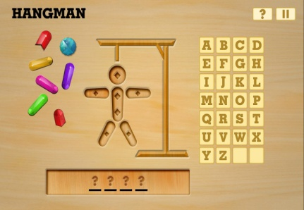  Practice  New vocabulary:  introduce [ɪntrəˈdjuːs]  fine [faɪn]  where [weə]  make friend [meɪk frend]  Together with learners Teacher sets the aims of the lesson.  The eleventh of October  Monday  Classwork  Where are you from?  I' m from Kazakhstan.  Germany Argentina  Teacher presents question and countries which will be used in the dialogue.  Turn on the audio and give the instructions.  Differentiation (for less able learners the words are given)  Task 1  There are 3 sentences. You should write who introduce Greta to Pablo? and who are from Germany and Argentina from?  Task 2  You should fill in the gaps with an appropriate words (for less able students the words are given) |  | Learners try to guess letters , then the word.  The eleventh of October  Monday  Classwork  Learners write the date and phrase down their copybooks  Listen to the audio and complete the sentences.  Learners should listen once and complete the sentences.  Learners are filling the gaps. They will listen 2 times. |  | Very good!  Give smiles!(stickers) | Board  Board  Board  Board  Handout 1, 2  https://learnenglishteens.britishcouncil.org/skills/listening/beginner-a1-listening/introducing-friend
ENDING THE LESSON | 5 m. Reflexion  2 m.  1 m. | Draw your friend and write what does he/she like to do.  (then listen some of the students)  Giving the hometask  Teacher give instructions how to make self-assessment |  | Draw a friend and write some sentences about him/her  Write the hometask  Ex 8 p 36 (answer the questions ?), words by heart  Learners should color the traffic lights (red - if they don't understand anything, yellow - if they have some questions, green - if everything is clear) |  | S | Handout 3  Board  Handout 4, 5  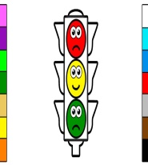

Handout 1
Greta Sumi Pablo | Greta Sumi Pablo
1. _____________ introduces Greta to Pablo.  2._________is from Germany.  3. _________ is from Argentina. | 1. _____________ introduces Greta to Pablo.  2._________is from Germany.  3. _________ is from Argentina.
Greta Sumi Pablo | Greta Sumi Pablo
1. _____________ introduces Greta to Pablo.  2._________is from Germany.  3. _________ is from Argentina. | 1. _____________ introduces Greta to Pablo.  2._________is from Germany.  3. _________ is from Argentina.
Greta Sumi Pablo | Greta Sumi Pablo
1. _____________ introduces Greta to Pablo.  2._________is from Germany.  3. _________ is from Argentina. | 1. _____________ introduces Greta to Pablo.  2._________is from Germany.  3. _________ is from Argentina.
Greta Sumi Pablo | Greta Sumi Pablo
1. _____________ introduces Greta to Pablo.  2._________is from Germany.  3. _________ is from Argentina. | 1. _____________ introduces Greta to Pablo.  2._________is from Germany.  3. _________ is from Argentina.

Greta Sumi Pablo | Greta Sumi Pablo
1. _____________ introduces Greta to Pablo.  2._________is from Germany.  3. _________ is from Argentina. | 1. _____________ introduces Greta to Pablo.  2._________is from Germany.  3. _________ is from Argentina.
Greta Sumi Pablo | Greta Sumi Pablo
1. _____________ introduces Greta to Pablo.  2._________is from Germany.  3. _________ is from Argentina. | 1. _____________ introduces Greta to Pablo.  2._________is from Germany.  3. _________ is from Argentina.
Greta Sumi Pablo | Greta Sumi Pablo
1. _____________ introduces Greta to Pablo.  2._________is from Germany.  3. _________ is from Argentina. | 1. _____________ introduces Greta to Pablo.  2._________is from Germany.  3. _________ is from Argentina.
Greta Sumi Pablo | Greta Sumi Pablo
1. _____________ introduces Greta to Pablo.  2._________is from Germany.  3. _________ is from Argentina. | 1. _____________ introduces Greta to Pablo.  2._________is from Germany.  3. _________ is from Argentina.

Handout 2
Sumi: Hi, Pablo! How are you?  Pablo: Hi, Sumi. I' m ______ , thanks.  Sumi: Pablo, this is Greta.  Pablo: Hi, Greta. _____ Pablo.  Greta: Hi, how are you?  Pablo: I' m fine , thanks. _____ are you from, Greta?  Greta: I' m from Germany. Where are you from?  Pablo: I'm from Argentina. Nice to meet you.  Greta: ______ to meet you too. | Sumi: Hi, Pablo! How are you?  Pablo: Hi, Sumi. I' m ______ , thanks.  Sumi: Pablo, this is Greta.  Pablo: Hi, Greta. _____ Pablo.  Greta: Hi, how are you?  Pablo: I' m fine , thanks. _____ are you from, Greta?  Greta: I' m from Germany. Where are you from?  Pablo: I'm from Argentina. Nice to meet you.  Greta: ______ to meet you too.
Sumi: Hi, Pablo! How are you?  Pablo: Hi, Sumi. I' m ______ , thanks.  Sumi: Pablo, this is Greta.  Pablo: Hi, Greta. _____ Pablo.  Greta: Hi, how are you?  Pablo: I' m fine , thanks. _____ are you from, Greta?  Greta: I' m from Germany. Where are you from?  Pablo: I'm from Argentina. Nice to meet you.  Greta: ______ to meet you too. | Sumi: Hi, Pablo! How are you?  Pablo: Hi, Sumi. I' m ______ , thanks.  Sumi: Pablo, this is Greta.  Pablo: Hi, Greta. _____ Pablo.  Greta: Hi, how are you?  Pablo: I' m fine , thanks. _____ are you from, Greta?  Greta: I' m from Germany. Where are you from?  Pablo: I'm from Argentina. Nice to meet you.  Greta: ______ to meet you too.
Sumi: Hi, Pablo! How are you?  Pablo: Hi, Sumi. I' m ______ , thanks.  Sumi: Pablo, this is Greta.  Pablo: Hi, Greta. _____ Pablo.  Greta: Hi, how are you?  Pablo: I' m fine , thanks. _____ are you from, Greta?  Greta: I' m from Germany. Where are you from?  Pablo: I'm from Argentina. Nice to meet you.  Greta: ______ to meet you too. | Sumi: Hi, Pablo! How are you?  Pablo: Hi, Sumi. I' m ______ , thanks.  Sumi: Pablo, this is Greta.  Pablo: Hi, Greta. _____ Pablo.  Greta: Hi, how are you?  Pablo: I' m fine , thanks. _____ are you from, Greta?  Greta: I' m from Germany. Where are you from?  Pablo: I'm from Argentina. Nice to meet you.  Greta: ______ to meet you too.
Sumi: Hi, Pablo! How are you?  Pablo: Hi, Sumi. I' m ______ , thanks.  Sumi: Pablo, this is Greta.  Pablo: Hi, Greta. _____ Pablo.  Greta: Hi, how are you?  Pablo: I' m fine , thanks. _____ are you from, Greta?  Greta: I' m from Germany. Where are you from?  Pablo: I'm from Argentina. Nice to meet you.  Greta: ______ to meet you too. | Sumi: Hi, Pablo! How are you?  Pablo: Hi, Sumi. I' m ______ , thanks.  Sumi: Pablo, this is Greta.  Pablo: Hi, Greta. _____ Pablo.  Greta: Hi, how are you?  Pablo: I' m fine , thanks. _____ are you from, Greta?  Greta: I' m from Germany. Where are you from?  Pablo: I'm from Argentina. Nice to meet you.  Greta: ______ to meet you too.
Sumi: Hi, Pablo! How are you?  Pablo: Hi, Sumi. I' m ______ , thanks.  Sumi: Pablo, this is Greta.  Pablo: Hi, Greta. _____ Pablo.  Greta: Hi, how are you?  Pablo: I' m fine , thanks. _____ are you from, Greta?  Greta: I' m from Germany. Where are you from?  Pablo: I'm from Argentina. Nice to meet you.  Greta: ______ to meet you too. | Sumi: Hi, Pablo! How are you?  Pablo: Hi, Sumi. I' m ______ , thanks.  Sumi: Pablo, this is Greta.  Pablo: Hi, Greta. _____ Pablo.  Greta: Hi, how are you?  Pablo: I' m fine , thanks. _____ are you from, Greta?  Greta: I' m from Germany. Where are you from?  Pablo: I'm from Argentina. Nice to meet you.  Greta: ______ to meet you too.

Handout 2 (for less able students)
I'm nice fine where | I'm nice fine where
Sumi: Hi, Pablo! How are you?  Pablo: Hi, Sumi. I' m ______ , thanks.  Sumi: Pablo, this is Greta.  Pablo: Hi, Greta. _____ Pablo.  Greta: Hi, how are you?  Pablo: I' m fine , thanks. _____ are you from, Greta?  Greta: I' m from Germany. Where are you from?  Pablo: I'm from Argentina. Nice to meet you.  Greta: ______ to meet you too. | Sumi: Hi, Pablo! How are you?  Pablo: Hi, Sumi. I' m ______ , thanks.  Sumi: Pablo, this is Greta.  Pablo: Hi, Greta. _____ Pablo.  Greta: Hi, how are you?  Pablo: I' m fine , thanks. _____ are you from, Greta?  Greta: I' m from Germany. Where are you from?  Pablo: I'm from Argentina. Nice to meet you.  Greta: ______ to meet you too.
I'm nice fine where | I'm nice fine where
Sumi: Hi, Pablo! How are you?  Pablo: Hi, Sumi. I' m ______ , thanks.  Sumi: Pablo, this is Greta.  Pablo: Hi, Greta. _____ Pablo.  Greta: Hi, how are you?  Pablo: I' m fine , thanks. _____ are you from, Greta?  Greta: I' m from Germany. Where are you from?  Pablo: I'm from Argentina. Nice to meet you.  Greta: ______ to meet you too. | Sumi: Hi, Pablo! How are you?  Pablo: Hi, Sumi. I' m ______ , thanks.  Sumi: Pablo, this is Greta.  Pablo: Hi, Greta. _____ Pablo.  Greta: Hi, how are you?  Pablo: I' m fine , thanks. _____ are you from, Greta?  Greta: I' m from Germany. Where are you from?  Pablo: I'm from Argentina. Nice to meet you.  Greta: ______ to meet you too.
I'm nice fine where | I'm nice fine where
Sumi: Hi, Pablo! How are you?  Pablo: Hi, Sumi. I' m ______ , thanks.  Sumi: Pablo, this is Greta.  Pablo: Hi, Greta. _____ Pablo.  Greta: Hi, how are you?  Pablo: I' m fine , thanks. _____ are you from, Greta?  Greta: I' m from Germany. Where are you from?  Pablo: I'm from Argentina. Nice to meet you.  Greta: ______ to meet you too. | Sumi: Hi, Pablo! How are you?  Pablo: Hi, Sumi. I' m ______ , thanks.  Sumi: Pablo, this is Greta.  Pablo: Hi, Greta. _____ Pablo.  Greta: Hi, how are you?  Pablo: I' m fine , thanks. _____ are you from, Greta?  Greta: I' m from Germany. Where are you from?  Pablo: I'm from Argentina. Nice to meet you.  Greta: ______ to meet you too.
I'm nice fine where | I'm nice fine where
Sumi: Hi, Pablo! How are you?  Pablo: Hi, Sumi. I' m ______ , thanks.  Sumi: Pablo, this is Greta.  Pablo: Hi, Greta. _____ Pablo.  Greta: Hi, how are you?  Pablo: I' m fine , thanks. _____ are you from, Greta?  Greta: I' m from Germany. Where are you from?  Pablo: I'm from Argentina. Nice to meet you.  Greta: ______ to meet you too. | Sumi: Hi, Pablo! How are you?  Pablo: Hi, Sumi. I' m ______ , thanks.  Sumi: Pablo, this is Greta.  Pablo: Hi, Greta. _____ Pablo.  Greta: Hi, how are you?  Pablo: I' m fine , thanks. _____ are you from, Greta?  Greta: I' m from Germany. Where are you from?  Pablo: I'm from Argentina. Nice to meet you.  Greta: ______ to meet you too.

Handout 3
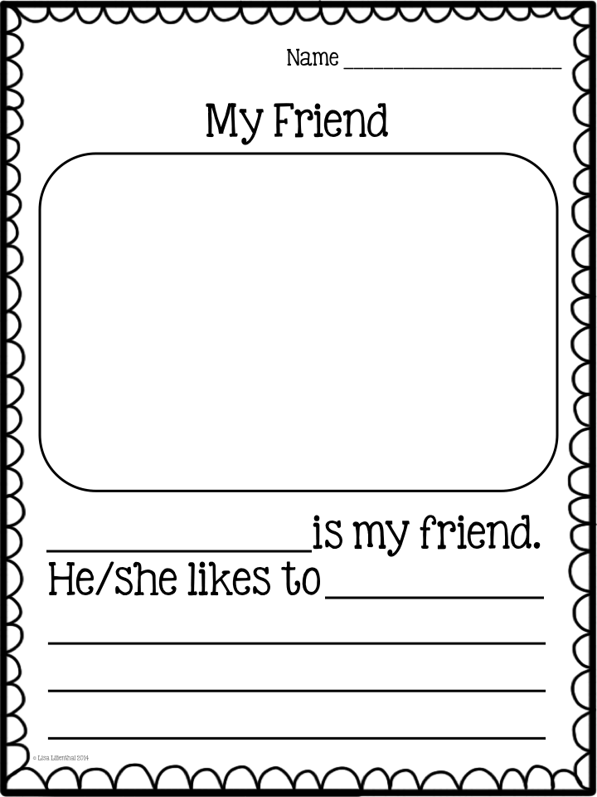

Handout 4
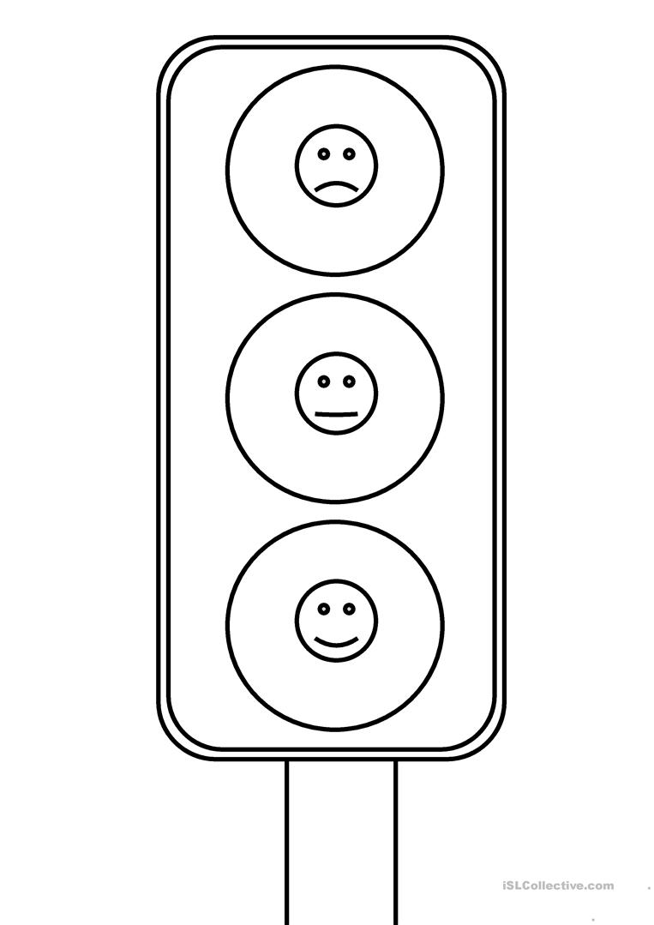

Handout 5
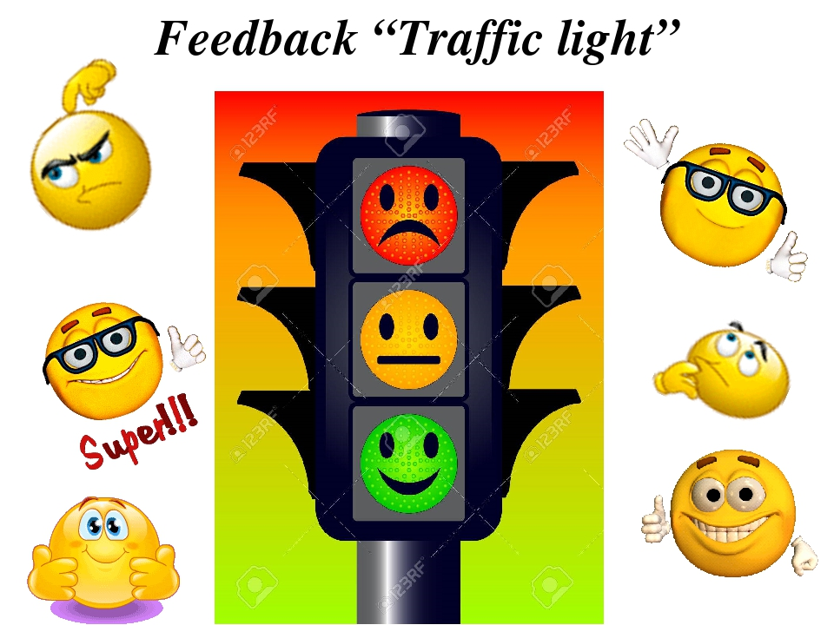
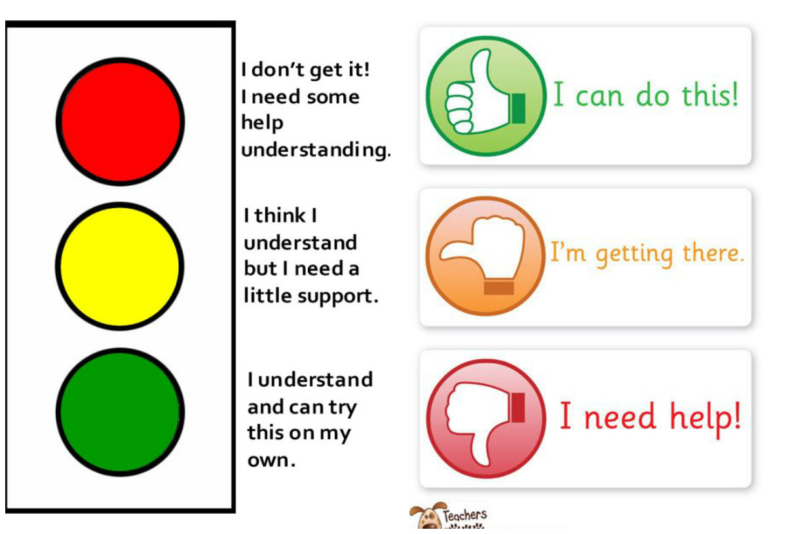
My best friend

Where are you from?
I' m from ....
Kazakhstan
Argentina
Germany

introduce [ɪntrəˈdjuːs]
fine [faɪn]
where [weə]
make friend [meɪk frend]

