School № 7
Plan of the lesson № 16
LESSON: | Exercise and Sport
Teacher name: | Eleusizova A.A.
Date: | 9.10.2023
CLASS: 9 Б | Number present: | Number absent:
Theme of the lesson: | Exercise and Sport
 | Learning objectives(s) that this lesson is contributing to | 9.6.11.1 use an increased variety of reported speech forms for statements, questions and commands, including indirect and embedded questions with know, wonder on a range of familiar general and curricular topics;  9.4.2.1 understand specific information and detail in texts on a range of familiar general and curricular topics, including some extended texts
 | Objectives: | All students will be able to  Understand the context and deduce meanings of words accurately.  Understand all specific information in a talk.  Understand all implied meaning in speech.  Most students will be able to  Recognize some topic vocabulary items in the flow of speech.  Understand some main points in a talk.  Understand some implied meaning in speech.  Some students will be able to  Express their opinion with sufficient reasoning.  Understand the context and attempt to deduce meanings of words.  Understand most specific information in a talk.
stages of the lesson/ stage aims |  | time | Teacher actions | Student actions | assessment | Resources
Lead-in: (to create interest in the topic) |  | 2 | Greeting.  Good morning, boys and girls! I am glad to see you.  Let’s start our lesson.  - What day is it today?  - What day of the week is it today?  - Who is absent?  Look at the screen and try to think about the theme of the lesson  Teacher say the objectives of the lesson | Say the report on duty  Ss understand the theme |  | PPT
 |  | 15 min | Practice reading skills  Pre-reading  What kind of sports do you know? Let’s divide these sports into to groups; Indoor and outdoor activities  How do you think sport is an important part of your education at school?  What is your favourite type of physical education which you like?  Teacher monitors and elicits answers.  Reading  Teacher tells students that they are going to read about school sports. Students work in pairs. Teacher gives out the worksheets with unknown words.  Post-reading  Student are divided into three groups (High level, Middle and low)  High level group have to think about 2 pluses and 2 minuses about sport at school  Middle level group have to complete the sentences  Low level group have to mark sentences True/False or Doesn’t say  Each group assess another one ь | Ss divide sports into two groups  Ss answer the questions  Ss read the text  Ss work in groups and do their own task for each group | Assessment by praising words  Each group assess another one | Handout 1  Handout 2  Handout 3
Dynamic pause |  | 2 min | Let’s have a break.  Play the game “Mime”  Tennis  Horse Riding  Volleyball | Ss try to understand the sport
Follow up task: |  | 18 | Practice grammar rule (Reported speech)  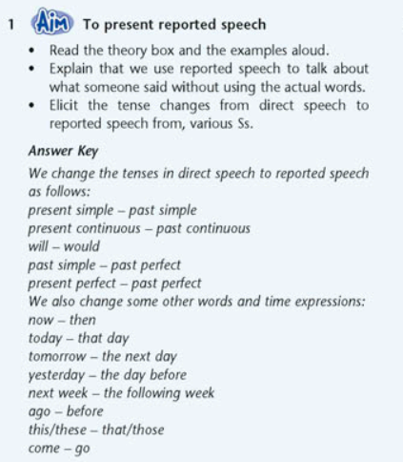  Formative assessment using gr/rule | Ss answer the questions according to the grammar rule  Ss answer about changing words by wordwall  Ss do the task | Formative assessment | Handout 4
Reflection |  | 2 min | Learners give feedback about what they have learned today.  What have we learned today?  What skills have you improved? (reading)  What subject can we relate the topic?
Conclusion, giving Homework |  | 1 min | You’ve worked hard today? I liked your answers, the way you have worked. I think you have done your best. I give you all excellent marks.  Thank you for the lesson.  Now open your dairies and I want you to write down your home work for the next lesson  - Homework: write down Review Grammar rule S/B p 20 ex 1  - S/B p 22 ex 1-2 Read and translate the text
self-evaluation of the lesson |  | Summary evaluation  What two things went really well (consider both teaching and learning)?  1:  2:  What two things would have improved the lesson (consider both teaching and learning)?  1:  2:  What have I learned from this lesson about the class or individuals that will inform my next lesson?

